**📘 Java Functional Programming, Lambda Expressions, and Stream API**

**Functional Programing**

**What is Functional Programming?**

Functional programming (FP) is a programming paradigm in which:

1. **Functions are “first-class citizens.”** You can pass functions as arguments, return them from other functions, and store them in data structures.
2. **Emphasis on “pure” functions.** A pure function’s output depends solely on its input and has no side effects—meaning it doesn’t modify external state.
3. **Immutable data.** Variables (or data structures) are generally not modified after they’re created; instead, you create new instances with updated values.
4. **Declarative style.** You focus on *what* needs to be done, rather than detailing *how* to do it step by step.

**Functional Programming in Java**

Although Java is predominantly an OOP language, since Java 8 it has introduced several features to support a functional style:

* **Lambda Expressions**: Compact syntax to create instances of functional interfaces (e.g., Predicate<T>, Function<T,R>).
* **Method References**: A shorthand for referencing existing methods as lambdas.
* **Stream API**: Enables a functional, pipeline-based approach to manipulate and process data collections (filter, map, reduce).
* **Functional Interfaces**: Interfaces with a single abstract method (SAM). Common examples include Predicate<T>, Function<T,R>, Consumer<T>, and Supplier<T>.

**When to Use Which Paradigm?**

* **Traditional OOP** fits well where your domain naturally models real-world objects with varying states—like building complex enterprise systems with well-defined entities.
* **Functional Programming** excels in scenarios involving heavy data transformations, concurrency, or parallelization. By leveraging pure functions and immutability, you reduce the risk of hidden side effects that can lead to bugs.

Modern Java applications often blend both paradigms:

* Use OOP constructs (classes and objects) to model your domain.
* Use functional concepts (lambdas, streams, immutable data structures) for data processing tasks or whenever side-effect-free operations make code simpler and safer.

**Summary**

Functional programming in Java brings a new perspective to writing cleaner, more predictable, and often more concise code. While Java remains fundamentally object-oriented, its functional features (lambda expressions, Stream API, and functional interfaces) enable developers to mix FP with OOP. Understanding the differences—especially around immutability, side effects, and the declarative style—can help you choose the most appropriate approach for each part of your application.

**📘 Java Functional Programming, Lambda Expressions, and Stream API**

This document provides **comprehensive notes** with a **step-by-step learning path** for understanding **Java Functional Programming**, **Lambda Expressions**, and **Stream API**. The notes include **pre-requisite concepts**, detailed explanations, and **examples for each topic**.

**🧩 Learning Path and Priority**

**✅ Step 1: Lambda Expressions**

* Pre-requisites: **Anonymous Classes**, **Functional Interfaces**
* Core concept for functional programming in Java.

**✅ Step 2: Functional Programming**

* Builds on **Lambda Expressions** to introduce the functional programming paradigm.

**✅ Step 3: Stream API**

* Uses **functional programming concepts** to process collections of data efficiently.

**📘 Step 1: Understanding Lambda Expressions**

Before diving into **Lambda Expressions**, let’s first understand **Anonymous Classes** and **Functional Interfaces**.

**Pre-Requisite 1: Anonymous Classes**

**🔧 What is an Anonymous Class?**

An **Anonymous Class** is a class without a name. It is often used to create an **implementation of an interface or abstract class** on the fly.

**✅ Why Do We Need Anonymous Classes?**

* To create **quick implementations** of interfaces or abstract classes.
* To avoid creating **separate class files** for simple tasks.

**🖥️ Example Without Anonymous Class:**

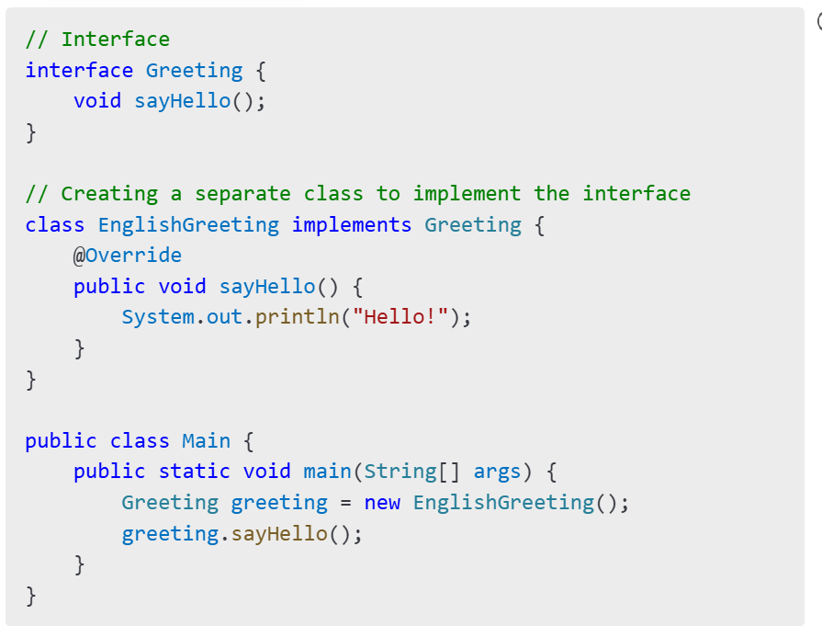

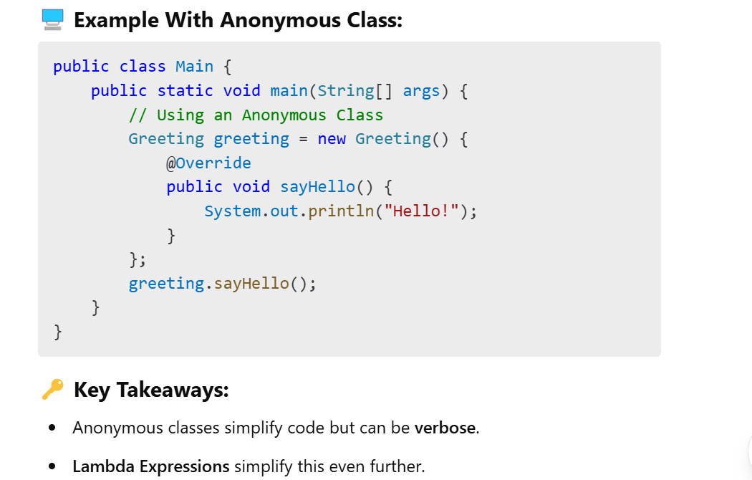

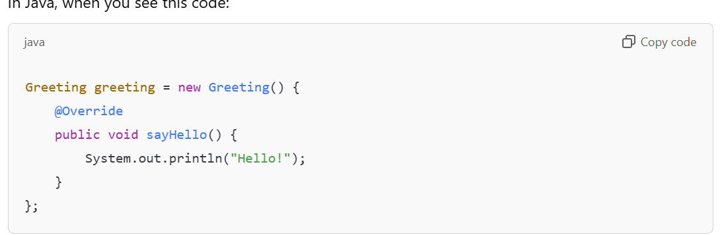

It **looks like you're creating an object of the Greeting interface**, but you’re actually creating an instance of a **class that implements the interface** on the fly. Let me clarify this step by step.

**🔍 How is it possible to create an object of an interface?**

By itself, **an interface cannot be instantiated**.  
However, **you can create an object of an anonymous class that implements the interface**.  
In this case, you're creating a **nameless class that implements the Greeting interface** and providing an implementation for the sayHello() method.

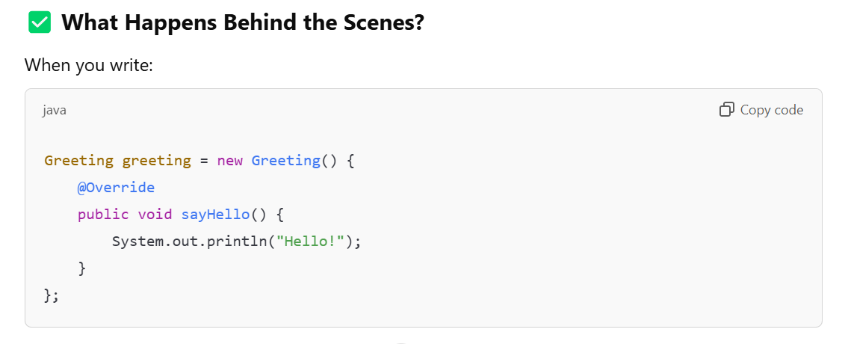

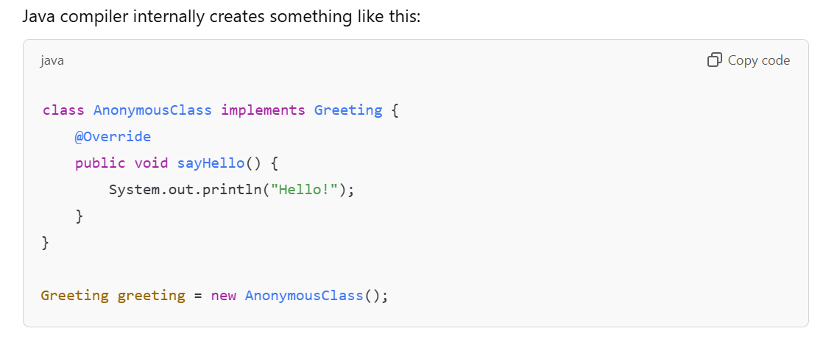

**✅ Why Do We Use Anonymous Classes?**

1. **Quick Implementation:**  
   You don't need to create a separate class file to implement a simple interface.
2. **One-Time Use:**  
   It's useful when you need a **one-time implementation** of an interface or abstract class.

**🔎 Summary:**

* **Anonymous Class:** A **nameless class** created to implement an interface or extend a class.
* **Why It Looks Like We’re Creating an Object of an Interface:**  
  We’re actually creating an object of an **anonymous class** that implements the interface.

✅ **Example: Adding Two Integers Using Anonymous Class**

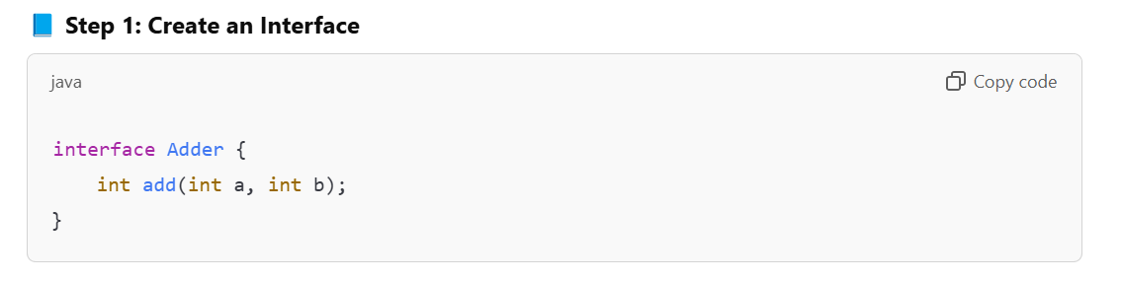

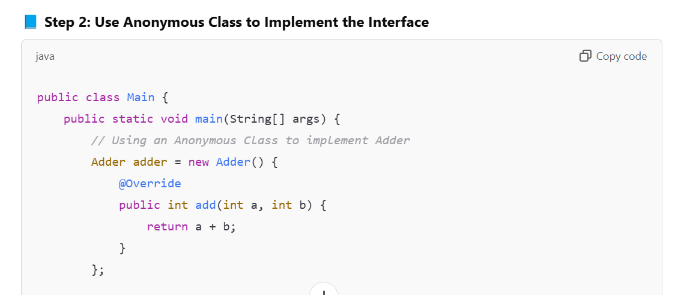

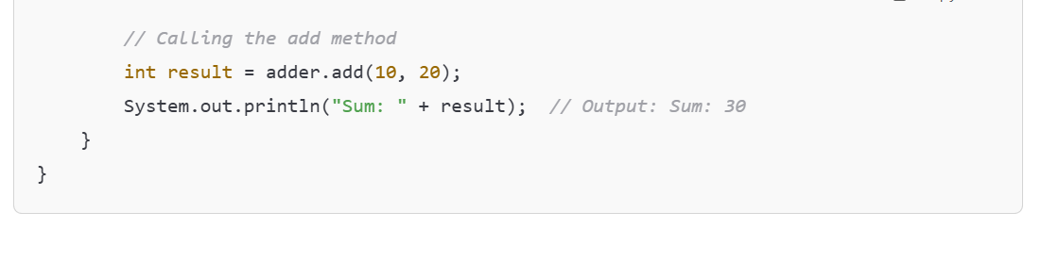

**✅ Breaking It Down:**

1. **Interface Adder:**
   * It has a single abstract method add(int a, int b).
2. **Anonymous Class:**
   * Instead of creating a separate class to implement Adder, we create an **anonymous class** that provides an **implementation for the add() method** directly inside the main() method.
3. **Calling the Method:**
   * We call adder.add(10, 20) to get the sum of two numbers.

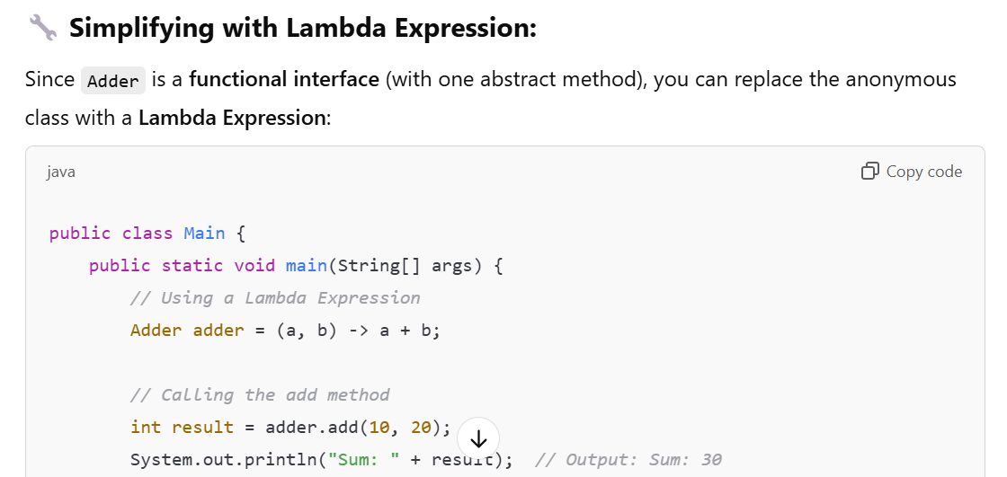

**🔎 Pre-Requisite 2: Functional Interfaces**

**🔧 What is a Functional Interface?**

A **Functional Interface** is an interface that has **exactly one abstract method**. It can have **default** and **static methods**, but only **one abstract method**.

**✅ Why Functional Interfaces?**

* Functional Interfaces are the foundation of **Lambda Expressions**.
* They allow you to pass **functions as arguments** in Java.

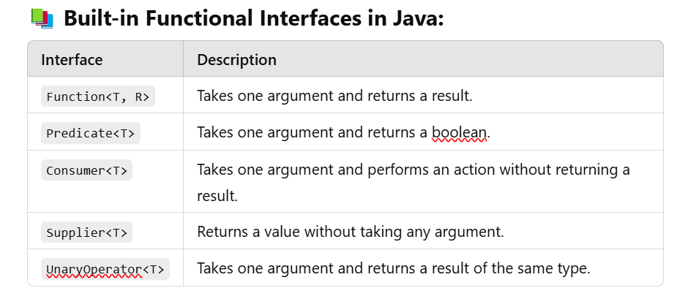

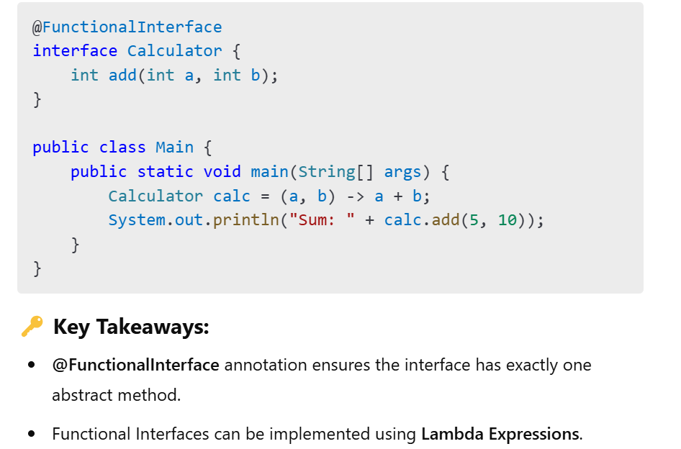

**📘 Java Lambda Expressions**

**🔎 What is a Lambda Expression?**

A **Lambda Expression** is a way to represent an **anonymous function** in Java. It allows you to pass **functions as arguments** to methods and write more concise, readable code.

**🔧 1. Java Lambdas and the Single Method Interface**

A **Functional Interface** is an interface that has **exactly one abstract method**. Lambda expressions can be used to implement functional interfaces.

**🖥️ Example:**

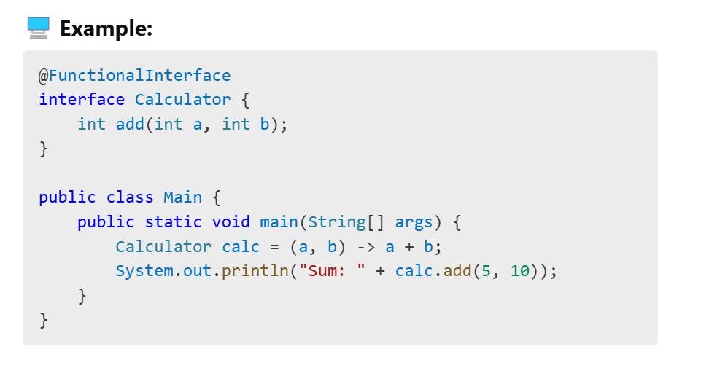

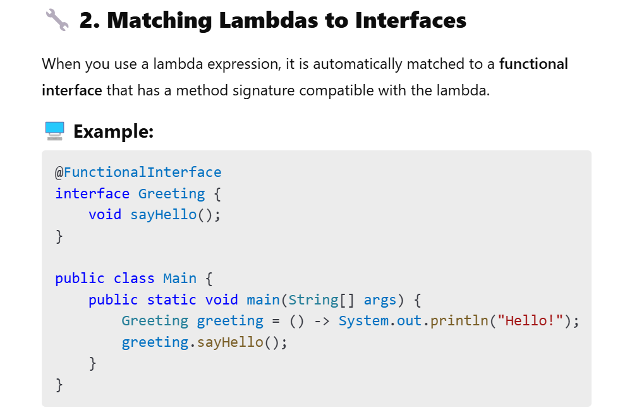

**🔧 3. Interfaces with Default and Static Methods**

Functional Interfaces can have **default** and **static methods**. These methods do not affect the lambda compatibility because they are not abstract methods.

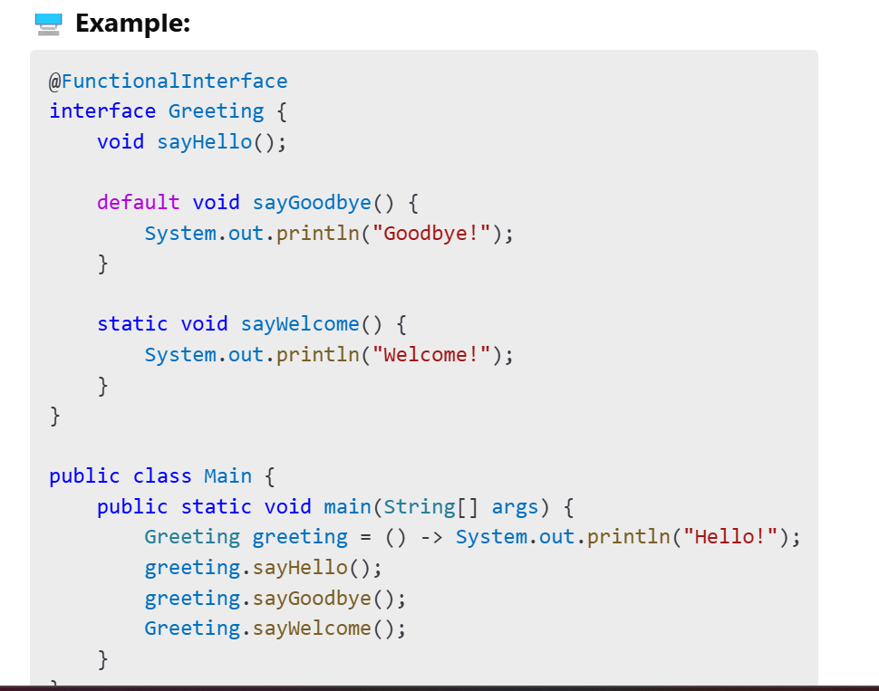

**🔧 4. Lambda Expressions vs. Anonymous Interface Implementations**

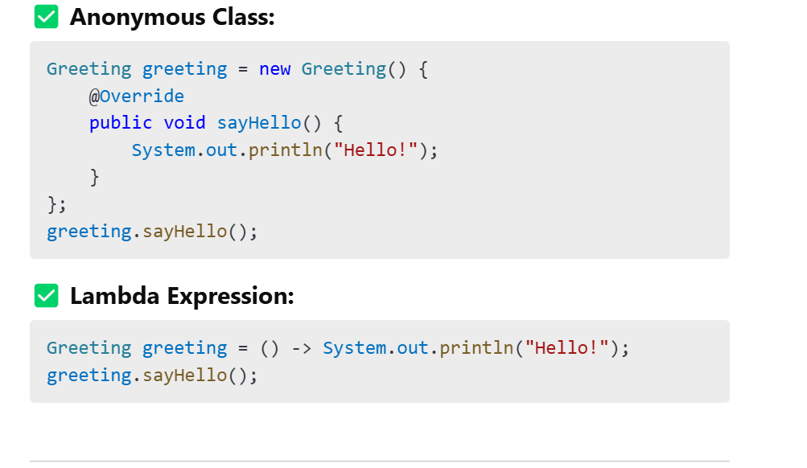

**🔧 5. Lambda Type Inference**

Java infers the **data types** of parameters automatically from the context, so you don’t need to specify them explicitly.

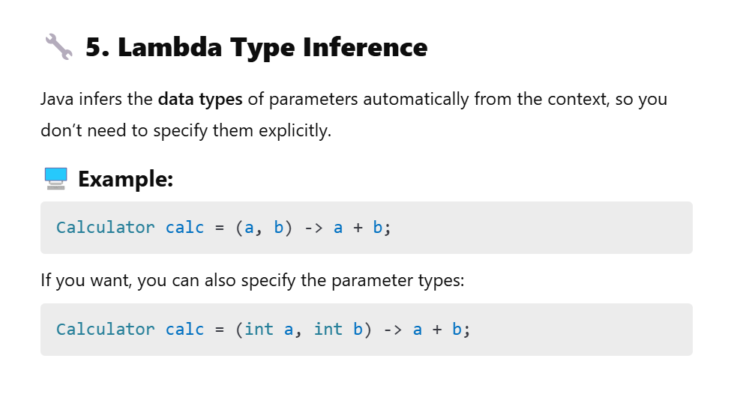

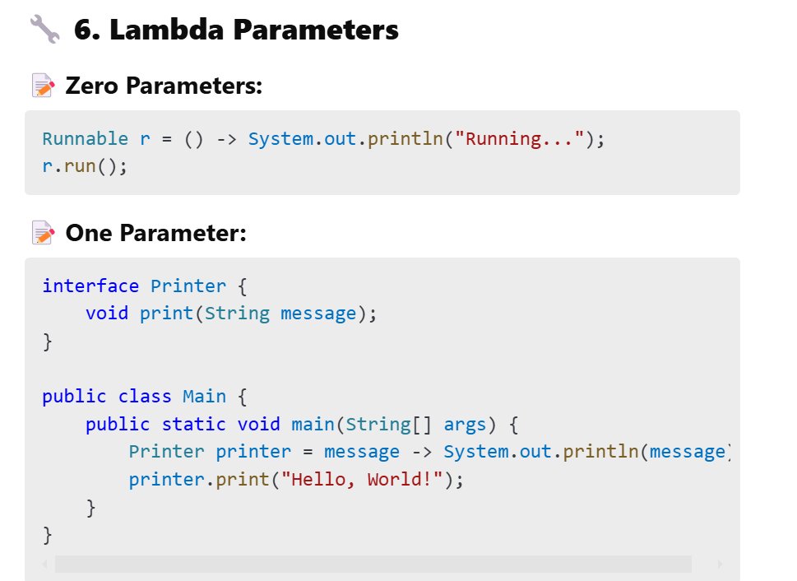

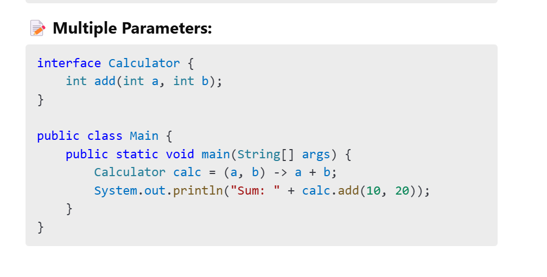

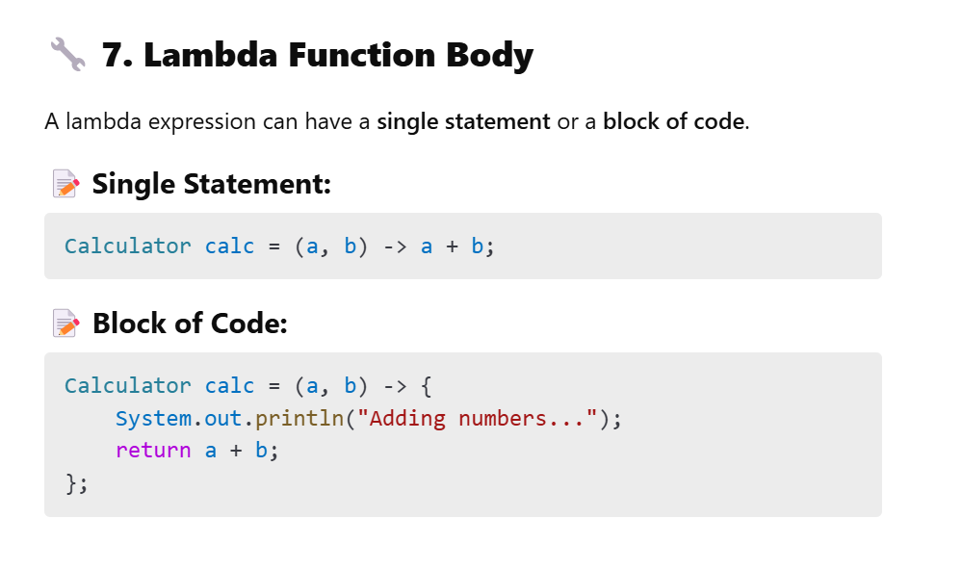

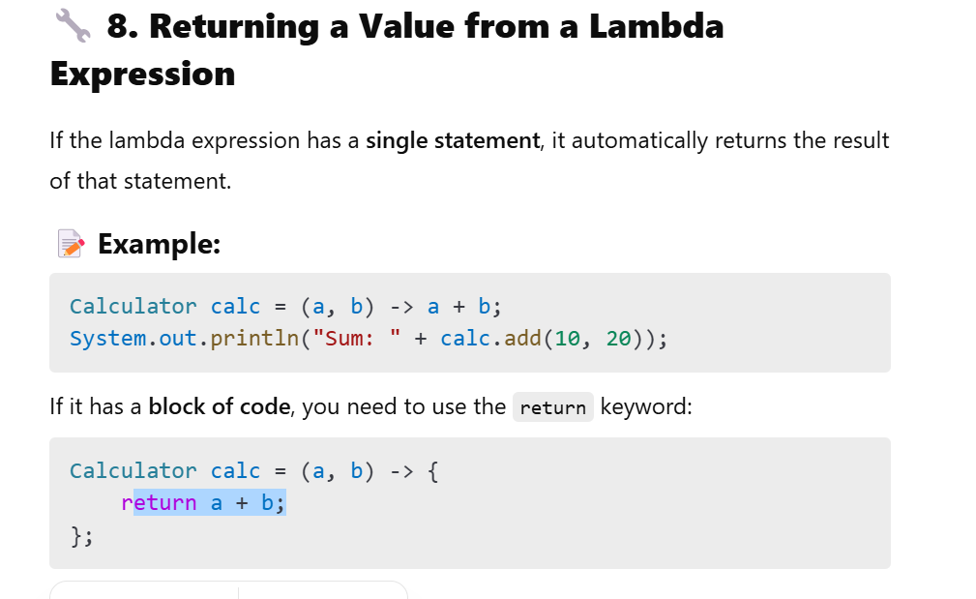

Let's go through **Functional Programming Concepts** with detailed explanations and examples.

**📘 1. Functional Programming Basics**

**Functional Programming (FP)** is a programming paradigm where you treat **functions as first-class citizens**. This means functions can be:

* **Assigned to variables**
* **Passed as arguments**
* **Returned from other functions**

FP focuses on **writing clean, predictable, and side-effect-free code** by using **pure functions** and **immutable data**.

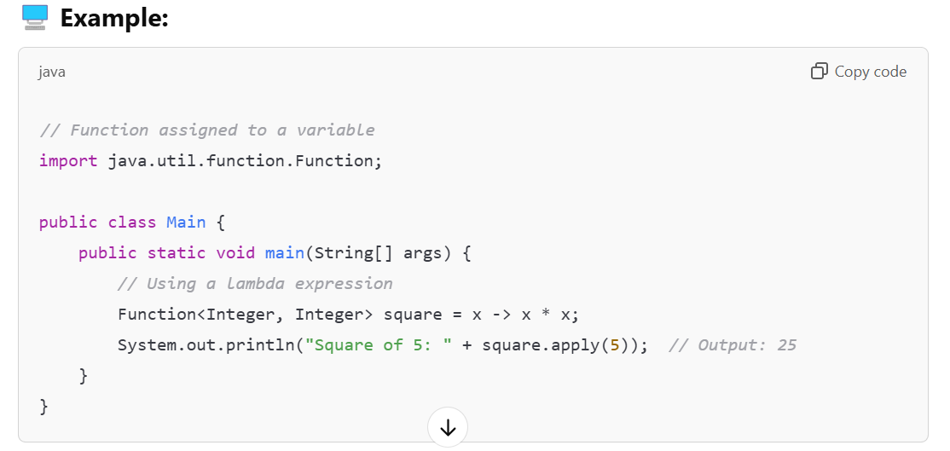

**📘 2. Functions as First-Class Objects**

In Java, **functions are treated as first-class objects**. This means:

* Functions can be **assigned to variables**.
* Functions can be **passed as arguments** to other functions.
* Functions can be **returned from other functions**.

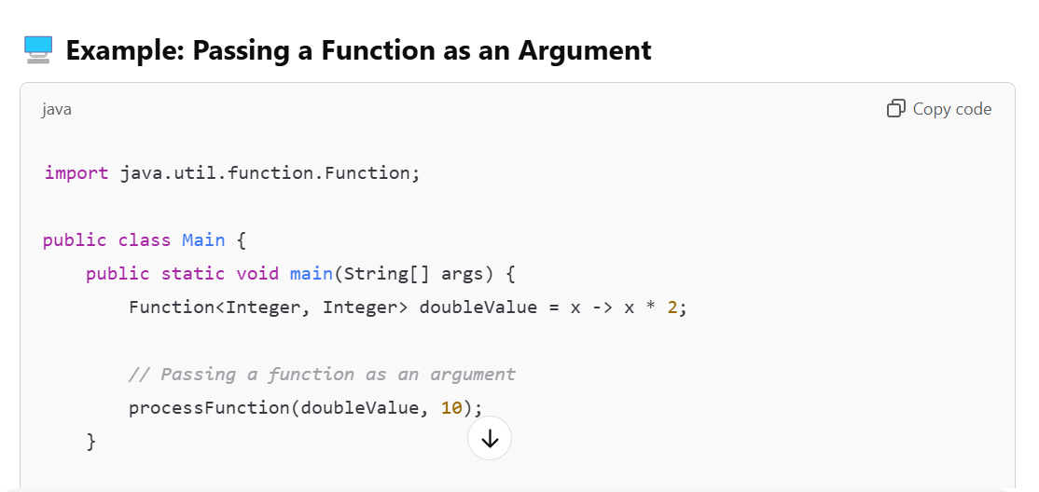

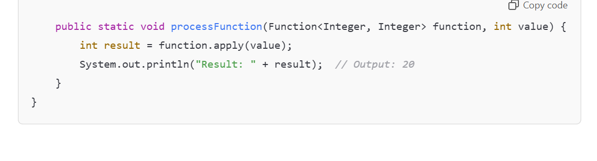

**📘 3. Pure Functions**

A **pure function** is a function that:

* **Always returns the same result** for the same inputs.
* **Has no side effects** (does not modify external state).

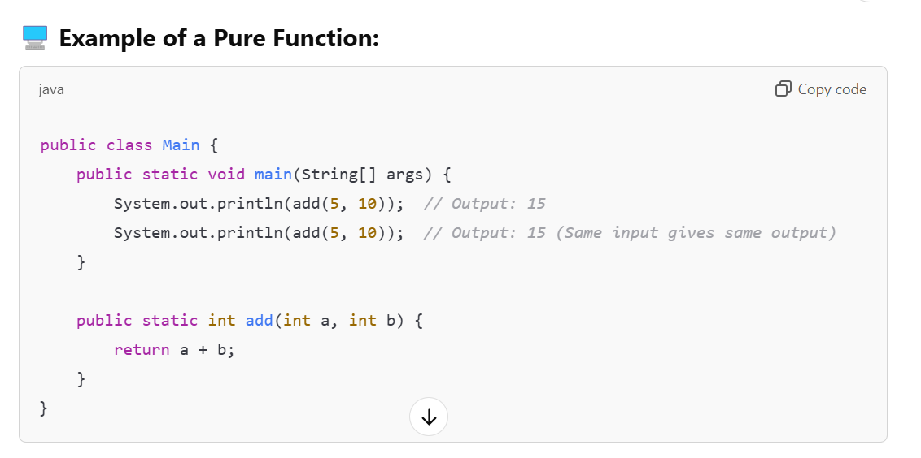

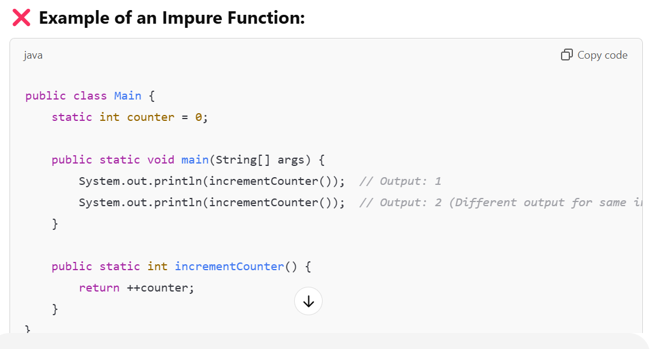

**📘 4. Higher-Order Functions**

A **Higher-Order Function** is a function that:

* **Takes another function as an argument**.
* **Returns another function as a result**.

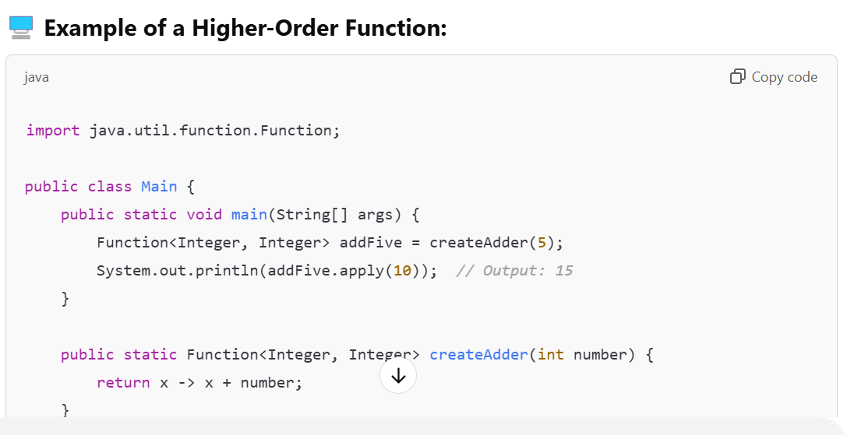

**📘 5. No State**

In functional programming, functions should be **stateless**. This means they should not rely on any external state that can change.

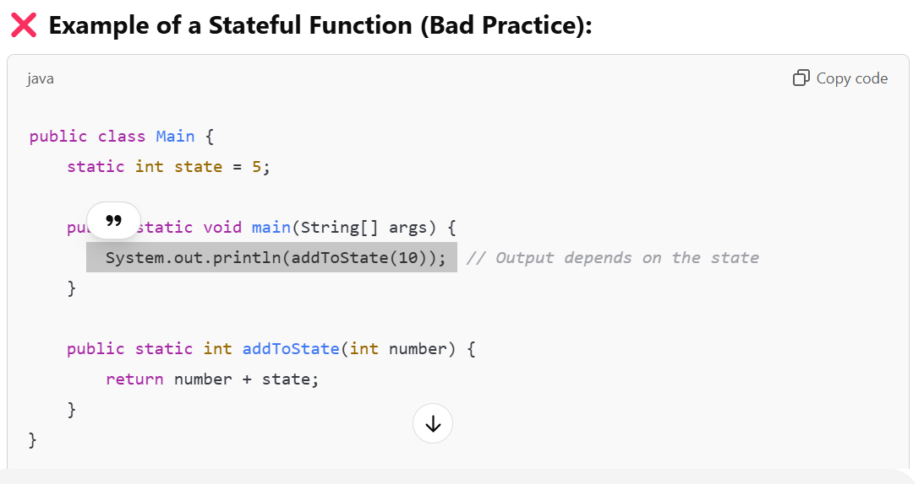

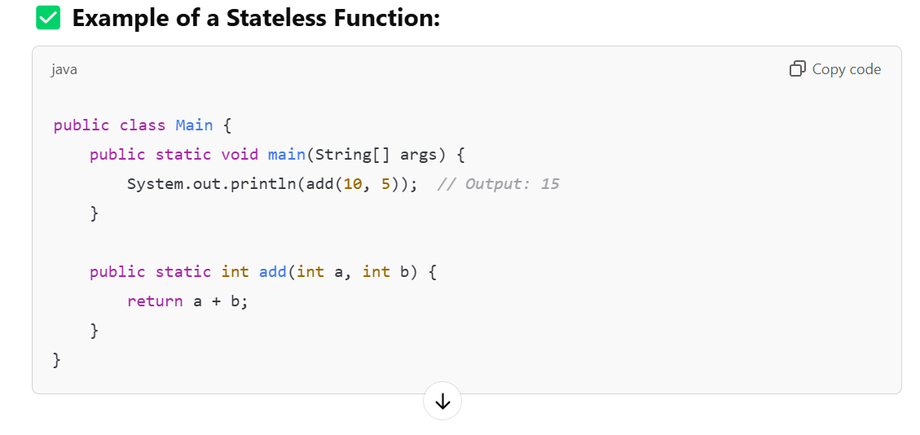

**📘 6. No Side Effects**

A **side effect** occurs when a function modifies an external state or interacts with the outside world (e.g., changing a global variable or writing to a file).

Functional programming aims to write functions with **no side effects**.

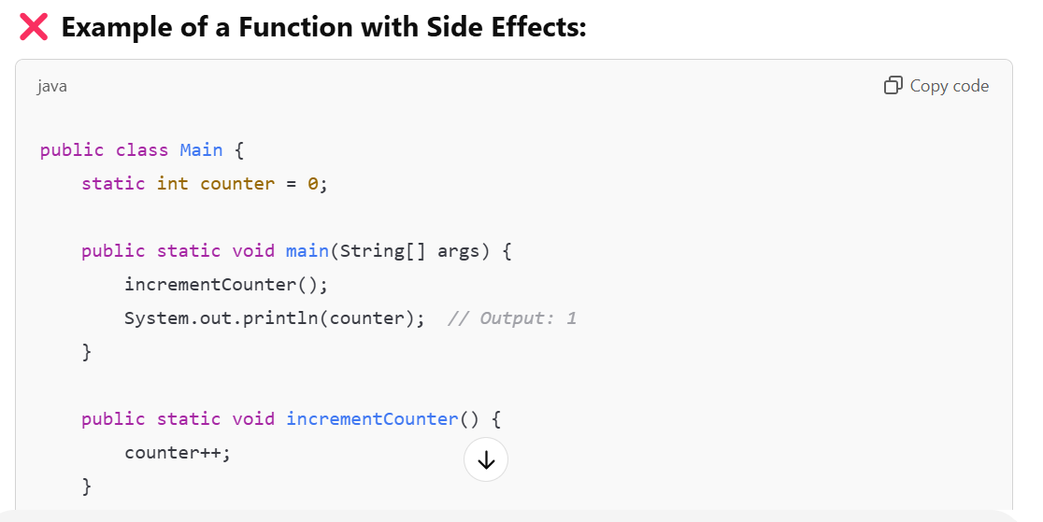

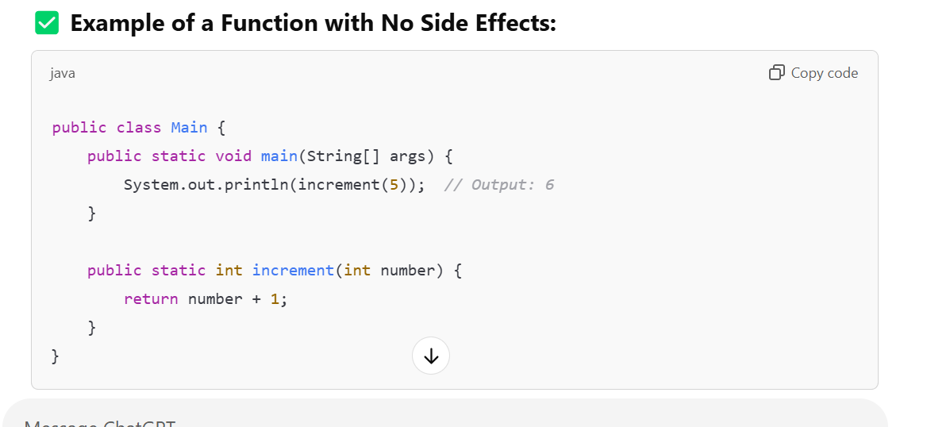

**📘 7. Immutable Variables**

In functional programming, **immutability** means that once a variable is created, its value cannot be changed.

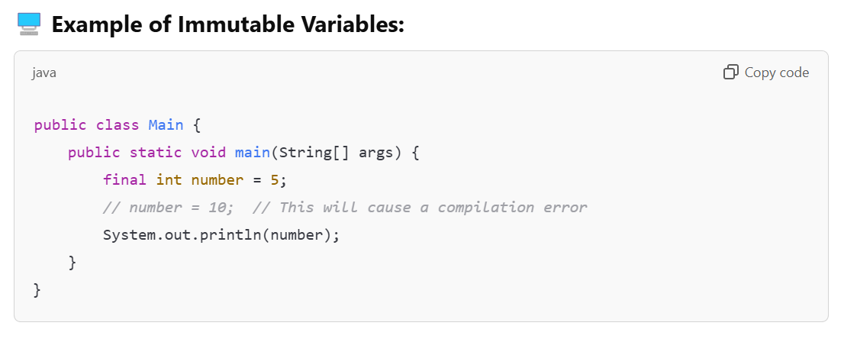

**📘 8. Favour Recursion Over Looping**

Functional programming favours **recursion** instead of **loops** for repetitive tasks.

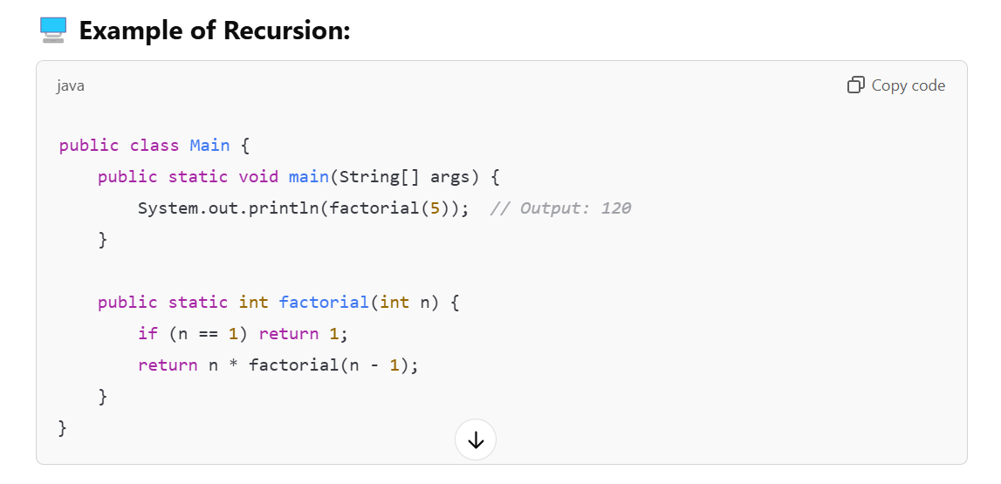

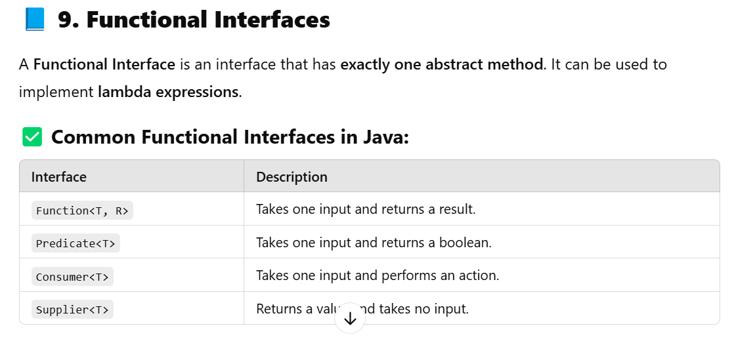

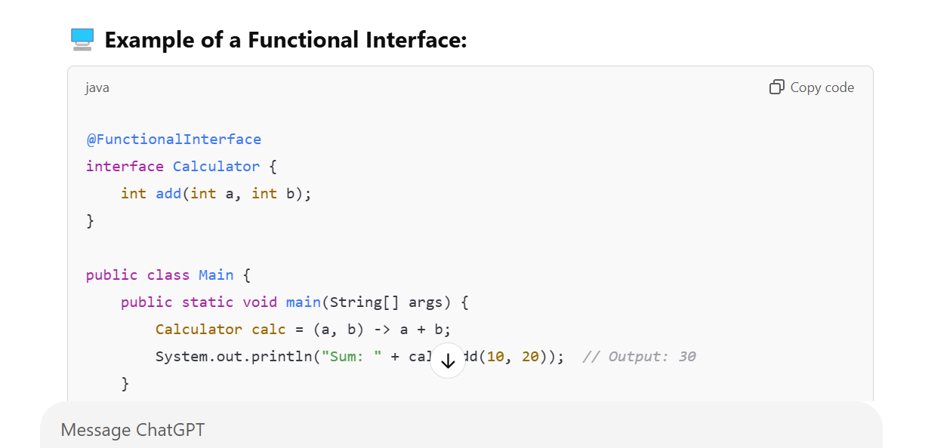

**📘 Java Stream API Tutorial**

The **Java Stream API** is introduced in **Java 8** to processs collections of data in a **declarative way**. It allows you to perform **filtering**, **mapping**, **reducing**, and other operations on collections like **Lists**, **Sets**, and **Maps**.

**✅ Java Stream Definition**

A **Stream** is a sequence of **elements** that can be processed in parallel or sequentially. It **does not store data** but provides a way to perform computations on data in a functional programming style.

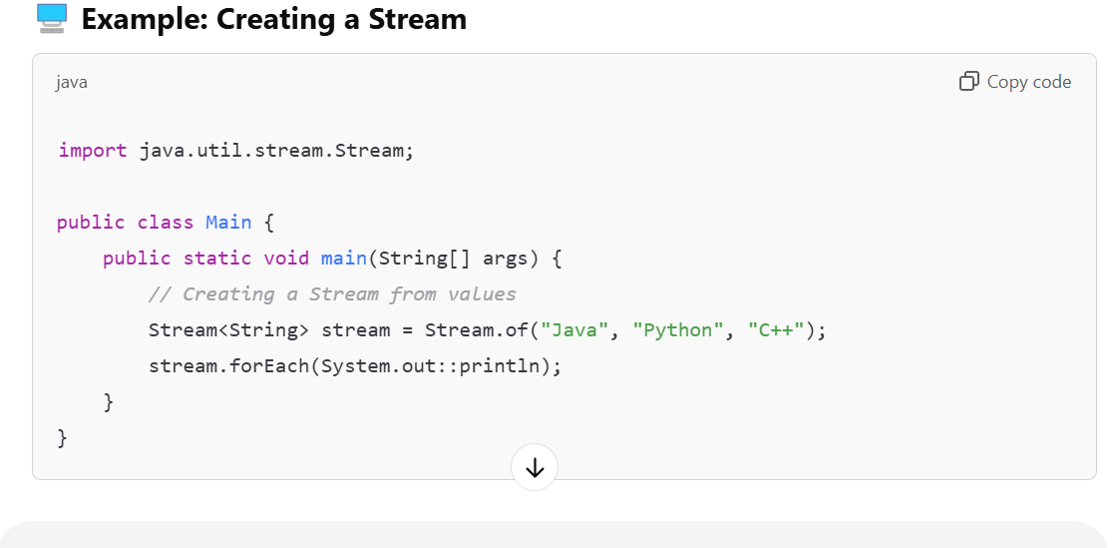

**✅ Stream Processing**

Stream processing involves **creating**, **modifying**, and **consuming** streams using various **operations**.

There are two types of stream operations:

1. **Non-Terminal Operations** (Intermediate Operations)
   * Return a new stream and are **lazy**.
2. **Terminal Operations**
   * Return a **result** (like a list, count, or boolean) and **consume the stream**.

**✅ How to Obtain a Stream**

You can obtain a stream in various ways:

1. **From a Collection**
2. **From Arrays**
3. **From Values**
4. **From Files**
5. **From a Builder**

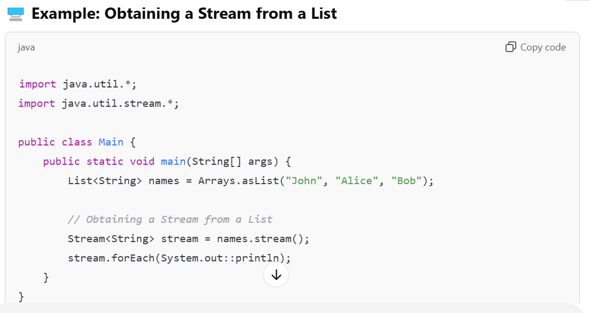

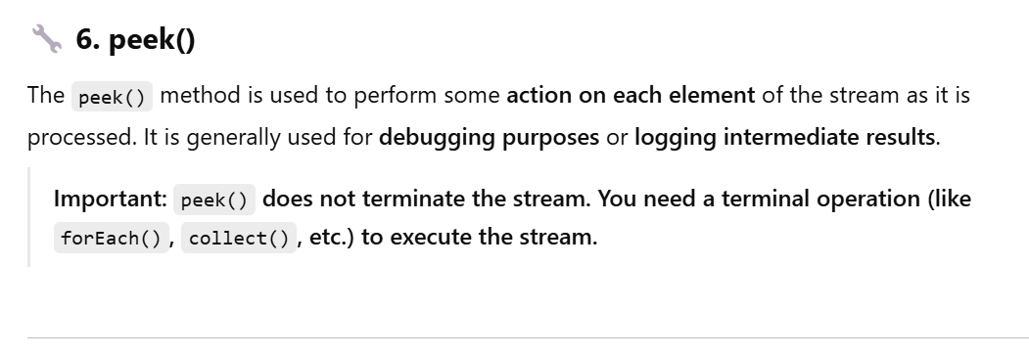

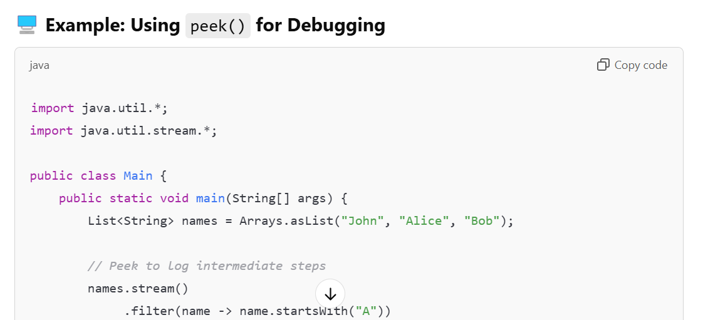

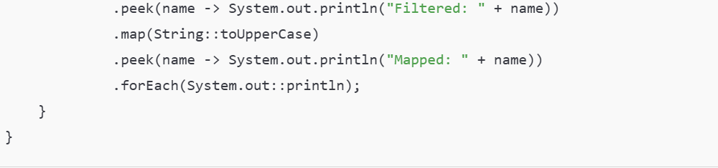

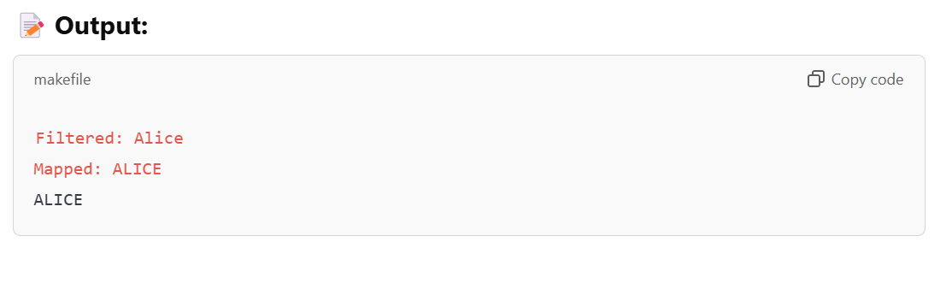

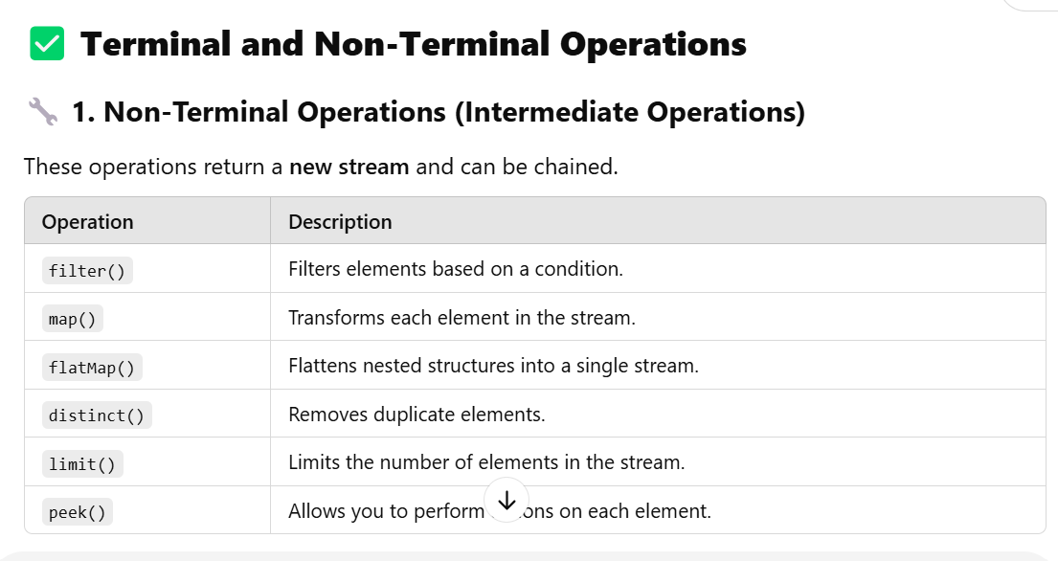

**Java Stream Non-Terminal Operations - Complete Interview Guide**

**1. FILTER METHOD**

**What is Filter Method?**

The filter() method is an intermediate operation that returns a new stream containing only the elements that match the given predicate condition. It takes a Predicate<T> functional interface as parameter.

**Method Signature:**

java

Stream<T> filter(Predicate<? super T> predicate)

**When to Use Filter?**

* To remove unwanted elements from a stream
* To apply conditional logic on stream elements
* To create a subset of data based on criteria
* When you need to implement search functionality

**5 Interview-Focused Filter Examples:**

**Example 1: Filter Even Numbers**

java

import java.util.*;

import java.util.stream.*;

public class FilterExample1 {

public static void main(String[] args) {

List<Integer> numbers = Arrays.asList(1, 2, 3, 4, 5, 6, 7, 8, 9, 10);

List<Integer> evenNumbers = numbers.stream()

.filter(n -> n % 2 == 0)

.collect(Collectors.toList());

System.out.println("Original: " + numbers);

System.out.println("Even Numbers: " + evenNumbers);

}

}

**Output:**

Original: [1, 2, 3, 4, 5, 6, 7, 8, 9, 10]

Even Numbers: [2, 4, 6, 8, 10]

**Example 2: Filter Employees by Salary**

java

import java.util.*;

import java.util.stream.*;

class Employee {

private String name;

private double salary;

public Employee(String name, double salary) {

this.name = name;

this.salary = salary;

}

public String getName() { return name; }

public double getSalary() { return salary; }

@Override

public String toString() {

return name + ": $" + salary;

}

}

public class FilterExample2 {

public static void main(String[] args) {

List<Employee> employees = Arrays.asList(

new Employee("John", 50000),

new Employee("Jane", 75000),

new Employee("Bob", 45000),

new Employee("Alice", 80000)

);

List<Employee> highSalaryEmployees = employees.stream()

.filter(emp -> emp.getSalary() > 60000)

.collect(Collectors.toList());

System.out.println("High Salary Employees (>60k):");

highSalaryEmployees.forEach(System.out::println);

}

}

**Output:**

High Salary Employees (>60k):

Jane: $75000.0

Alice: $80000.0

**Example 3: Filter Strings by Length and Content**

java

import java.util.*;

import java.util.stream.*;

public class FilterExample3 {

public static void main(String[] args) {

List<String> words = Arrays.asList("apple", "banana", "cherry", "date", "elderberry");

List<String> filteredWords = words.stream()

.filter(word -> word.length() > 5 && word.contains("e"))

.collect(Collectors.toList());

System.out.println("Words with length > 5 and containing 'e':");

filteredWords.forEach(System.out::println);

}

}

**Output:**

Words with length > 5 and containing 'e':

cherry

elderberry

**Example 4: Filter Non-Null and Non-Empty Strings**

java

import java.util.*;

import java.util.stream.*;

public class FilterExample4 {

public static void main(String[] args) {

List<String> strings = Arrays.asList("hello", "", null, "world", " ", "java");

List<String> validStrings = strings.stream()

.filter(s -> s != null && !s.trim().isEmpty())

.collect(Collectors.toList());

System.out.println("Original: " + strings);

System.out.println("Valid Strings: " + validStrings);

}

}

**Output:**

Original: [hello, , null, world, , java]

Valid Strings: [hello, world, java]

**Example 5: Filter Objects with Multiple Conditions**

java

import java.util.*;

import java.util.stream.*;

class Product {

private String name;

private double price;

private String category;

public Product(String name, double price, String category) {

this.name = name;

this.price = price;

this.category = category;

}

public String getName() { return name; }

public double getPrice() { return price; }

public String getCategory() { return category; }

@Override

public String toString() {

return name + " ($" + price + ") - " + category;

}

}

public class FilterExample5 {

public static void main(String[] args) {

List<Product> products = Arrays.asList(

new Product("Laptop", 999.99, "Electronics"),

new Product("Book", 15.99, "Education"),

new Product("Phone", 699.99, "Electronics"),

new Product("Pen", 2.99, "Stationery")

);

List<Product> expensiveElectronics = products.stream()

.filter(p -> p.getCategory().equals("Electronics") && p.getPrice() > 500)

.collect(Collectors.toList());

System.out.println("Expensive Electronics (>$500):");

expensiveElectronics.forEach(System.out::println);

}

}

**Output:**

Expensive Electronics (>$500):

Laptop ($999.99) - Electronics

Phone ($699.99) - Electronics

**Common Interview Questions for Filter:**

1. What happens when filter condition returns false for all elements?
2. Can you chain multiple filter operations?
3. What's the difference between filter() and findFirst()?
4. How does filter() handle null elements?
5. What's the performance impact of multiple filter operations?

**2. MAP METHOD**

**What is Map Method?**

The map() method is an intermediate operation that transforms each element of the stream by applying a given function. It returns a new stream with transformed elements.

**Method Signature:**

java

<R> Stream<R> map(Function<? super T, ? extends R> mapper)

**When to Use Map?**

* To transform elements from one type to another
* To extract specific fields from objects
* To apply calculations or formatting
* To convert data structure formats

**5 Interview-Focused Map Examples:**

**Example 1: Transform Numbers to Their Squares**

java

import java.util.*;

import java.util.stream.*;

public class MapExample1 {

public static void main(String[] args) {

List<Integer> numbers = Arrays.asList(1, 2, 3, 4, 5);

List<Integer> squares = numbers.stream()

.map(n -> n * n)

.collect(Collectors.toList());

System.out.println("Original: " + numbers);

System.out.println("Squares: " + squares);

}

}

**Output:**

Original: [1, 2, 3, 4, 5]

Squares: [1, 4, 9, 16, 25]

**Example 2: Extract Employee Names**

java

import java.util.*;

import java.util.stream.*;

public class MapExample2 {

public static void main(String[] args) {

List<Employee> employees = Arrays.asList(

new Employee("John", 50000),

new Employee("Jane", 75000),

new Employee("Bob", 45000)

);

List<String> employeeNames = employees.stream()

.map(Employee::getName)

.collect(Collectors.toList());

System.out.println("Employee Names: " + employeeNames);

}

}

**Output:**

Employee Names: [John, Jane, Bob]

**Example 3: Convert Strings to Uppercase**

java

import java.util.*;

import java.util.stream.*;

public class MapExample3 {

public static void main(String[] args) {

List<String> words = Arrays.asList("hello", "world", "java", "stream");

List<String> upperCaseWords = words.stream()

.map(String::toUpperCase)

.collect(Collectors.toList());

System.out.println("Original: " + words);

System.out.println("Uppercase: " + upperCaseWords);

}

}

**Output:**

Original: [hello, world, java, stream]

Uppercase: [HELLO, WORLD, JAVA, STREAM]

**Example 4: Transform Objects to Different Type**

java

import java.util.*;

import java.util.stream.*;

class Person {

private String name;

private int age;

public Person(String name, int age) {

this.name = name;

this.age = age;

}

public String getName() { return name; }

public int getAge() { return age; }

}

class PersonDTO {

private String fullName;

private String ageCategory;

public PersonDTO(String fullName, String ageCategory) {

this.fullName = fullName;

this.ageCategory = ageCategory;

}

@Override

public String toString() {

return fullName + " (" + ageCategory + ")";

}

}

public class MapExample4 {

public static void main(String[] args) {

List<Person> persons = Arrays.asList(

new Person("John Doe", 25),

new Person("Jane Smith", 17),

new Person("Bob Johnson", 65)

);

List<PersonDTO> personDTOs = persons.stream()

.map(p -> new PersonDTO(

p.getName(),

p.getAge() < 18 ? "Minor" : p.getAge() > 60 ? "Senior" : "Adult"

))

.collect(Collectors.toList());

System.out.println("Person DTOs:");

personDTOs.forEach(System.out::println);

}

}

**Output:**

Person DTOs:

John Doe (Adult)

Jane Smith (Minor)

Bob Johnson (Senior)

**Example 5: Complex Object Transformation**

java

import java.util.*;

import java.util.stream.*;

class Order {

private int id;

private double amount;

private String customer;

public Order(int id, double amount, String customer) {

this.id = id;

this.amount = amount;

this.customer = customer;

}

public int getId() { return id; }

public double getAmount() { return amount; }

public String getCustomer() { return customer; }

}

public class MapExample5 {

public static void main(String[] args) {

List<Order> orders = Arrays.asList(

new Order(1, 100.50, "Alice"),

new Order(2, 250.75, "Bob"),

new Order(3, 75.25, "Charlie")

);

*// Transform to formatted strings*

List<String> orderSummaries = orders.stream()

.map(o -> String.format("Order #%d: $%.2f for %s",

o.getId(), o.getAmount(), o.getCustomer()))

.collect(Collectors.toList());

System.out.println("Order Summaries:");

orderSummaries.forEach(System.out::println);

}

}

**Output:**

Order Summaries:

Order #1: $100.50 for Alice

Order #2: $250.75 for Bob

Order #3: $75.25 for Charlie

**Common Interview Questions for Map:**

1. What's the difference between map() and flatMap()?
2. Can map() change the size of the stream?
3. What happens if the mapper function returns null?
4. How does map() handle primitive types?
5. Can you use map() to convert between different collection types?

**3. FLATMAP METHOD**

**What is FlatMap Method?**

The flatMap() method is an intermediate operation that transforms each element into a stream and then flattens all the streams into a single stream. It's used when you have nested structures that need to be flattened.

**Method Signature:**

java

<R> Stream<R> flatMap(Function<? super T, ? extends Stream<? extends R>> mapper)

**When to Use FlatMap?**

* To flatten nested collections or arrays
* To transform one-to-many relationships
* To process nested data structures
* To combine multiple streams into one

**5 Interview-Focused FlatMap Examples:**

**Example 1: Flatten List of Lists**

java

import java.util.*;

import java.util.stream.*;

public class FlatMapExample1 {

public static void main(String[] args) {

List<List<Integer>> nestedList = Arrays.asList(

Arrays.asList(1, 2, 3),

Arrays.asList(4, 5, 6),

Arrays.asList(7, 8, 9)

);

List<Integer> flattenedList = nestedList.stream()

.flatMap(List::stream)

.collect(Collectors.toList());

System.out.println("Nested List: " + nestedList);

System.out.println("Flattened List: " + flattenedList);

}

}

**Output:**

Nested List: [[1, 2, 3], [4, 5, 6], [7, 8, 9]]

Flattened List: [1, 2, 3, 4, 5, 6, 7, 8, 9]

**Example 2: Flatten Array of Arrays**

java

import java.util.*;

import java.util.stream.*;

public class FlatMapExample2 {

public static void main(String[] args) {

String[][] arrays = {

{"a", "b", "c"},

{"d", "e", "f"},

{"g", "h", "i"}

};

List<String> flattenedArray = Arrays.stream(arrays)

.flatMap(Arrays::stream)

.collect(Collectors.toList());

System.out.println("Flattened Array: " + flattenedArray);

}

}

**Output:**

Flattened Array: [a, b, c, d, e, f, g, h, i]

**Example 3: Extract All Skills from Employees**

java

import java.util.*;

import java.util.stream.*;

class EmployeeWithSkills {

private String name;

private List<String> skills;

public EmployeeWithSkills(String name, List<String> skills) {

this.name = name;

this.skills = skills;

}

public String getName() { return name; }

public List<String> getSkills() { return skills; }

}

public class FlatMapExample3 {

public static void main(String[] args) {

List<EmployeeWithSkills> employees = Arrays.asList(

new EmployeeWithSkills("Alice", Arrays.asList("Java", "Python", "SQL")),

new EmployeeWithSkills("Bob", Arrays.asList("JavaScript", "React", "Node.js")),

new EmployeeWithSkills("Charlie", Arrays.asList("Java", "Spring", "Hibernate"))

);

List<String> allSkills = employees.stream()

.flatMap(emp -> emp.getSkills().stream())

.distinct()

.collect(Collectors.toList());

System.out.println("All Unique Skills: " + allSkills);

}

}

**Output:**

All Unique Skills: [Java, Python, SQL, JavaScript, React, Node.js, Spring, Hibernate]

**Example 4: Split Sentences into Words**

java

import java.util.*;

import java.util.stream.*;

public class FlatMapExample4 {

public static void main(String[] args) {

List<String> sentences = Arrays.asList(

"Hello world from Java",

"Streams are powerful",

"FlatMap flattens nested structures"

);

List<String> words = sentences.stream()

.flatMap(sentence -> Arrays.stream(sentence.split(" ")))

.collect(Collectors.toList());

System.out.println("All Words: " + words);

*// Count word frequency*

Map<String, Long> wordCount = sentences.stream()

.flatMap(sentence -> Arrays.stream(sentence.split(" ")))

.collect(Collectors.groupingBy(

String::toLowerCase,

Collectors.counting()

));

System.out.println("Word Count: " + wordCount);

}

}

**Output:**

All Words: [Hello, world, from, Java, Streams, are, powerful, FlatMap, flattens, nested, structures]

Word Count: {hello=1, world=1, from=1, java=1, streams=1, are=1, powerful=1, flatmap=1, flattens=1, nested=1, structures=1}

**Example 5: Complex Nested Structure Flattening**

java

import java.util.*;

import java.util.stream.*;

class Department {

private String name;

private List<Employee> employees;

public Department(String name, List<Employee> employees) {

this.name = name;

this.employees = employees;

}

public String getName() { return name; }

public List<Employee> getEmployees() { return employees; }

}

public class FlatMapExample5 {

public static void main(String[] args) {

List<Department> departments = Arrays.asList(

new Department("IT", Arrays.asList(

new Employee("John", 75000),

new Employee("Jane", 80000)

)),

new Department("HR", Arrays.asList(

new Employee("Bob", 60000),

new Employee("Alice", 65000)

)),

new Department("Finance", Arrays.asList(

new Employee("Charlie", 70000)

))

);

*// Get all employees across all departments*

List<Employee> allEmployees = departments.stream()

.flatMap(dept -> dept.getEmployees().stream())

.collect(Collectors.toList());

System.out.println("All Employees:");

allEmployees.forEach(System.out::println);

*// Calculate average salary across all departments*

double avgSalary = departments.stream()

.flatMap(dept -> dept.getEmployees().stream())

.mapToDouble(Employee::getSalary)

.average()

.orElse(0.0);

System.out.println("Average Salary: $" + avgSalary);

}

}

**Output:**

All Employees:

John: $75000.0

Jane: $80000.0

Bob: $60000.0

Alice: $65000.0

Charlie: $70000.0

Average Salary: $70000.0

**Common Interview Questions for FlatMap:**

1. What's the key difference between map() and flatMap()?
2. When would you use flatMap() over map()?
3. Can flatMap() be used with Optional?
4. How does flatMap() handle empty streams?
5. What's the performance implication of using flatMap()?

**4. DISTINCT METHOD**

**What is Distinct Method?**

The distinct() method is an intermediate operation that returns a stream with duplicate elements removed. It uses the equals() method to determine equality.

**Method Signature:**

java

Stream<T> distinct()

**When to Use Distinct?**

* To remove duplicate elements from a stream
* To get unique values from a collection
* To eliminate redundant data
* To create sets from lists

**5 Interview-Focused Distinct Examples:**

**Example 1: Remove Duplicate Numbers**

java

import java.util.*;

import java.util.stream.*;

public class DistinctExample1 {

public static void main(String[] args) {

List<Integer> numbers = Arrays.asList(1, 2, 2, 3, 3, 3, 4, 4, 5);

List<Integer> uniqueNumbers = numbers.stream()

.distinct()

.collect(Collectors.toList());

System.out.println("Original: " + numbers);

System.out.println("Unique: " + uniqueNumbers);

}

}

**Output:**

Original: [1, 2, 2, 3, 3, 3, 4, 4, 5]

Unique: [1, 2, 3, 4, 5]

**Example 2: Remove Duplicate Strings**

java

import java.util.*;

import java.util.stream.*;

public class DistinctExample2 {

public static void main(String[] args) {

List<String> words = Arrays.asList("apple", "banana", "apple", "cherry", "banana", "date");

List<String> uniqueWords = words.stream()

.distinct()

.sorted()

.collect(Collectors.toList());

System.out.println("Original: " + words);

System.out.println("Unique (sorted): " + uniqueWords);

}

}

**Output:**

Original: [apple, banana, apple, cherry, banana, date]

Unique (sorted): [apple, banana, cherry, date]

**Common Interview Questions for Distinct:**

1. How does distinct() determine equality?
2. What's the performance complexity of distinct()?
3. How do you make distinct() work with custom objects?
4. Can you get distinct elements based on a specific property?
5. What's the difference between distinct() and collecting to a Set?

**PEEK METHOD**

**What is Peek Method?**

The peek() method is an intermediate operation that performs an action on each element of the stream without modifying the stream itself. It's primarily designed for **debugging purposes** and **side effects** during stream processing. The peek operation returns a stream consisting of the elements of the original stream, after applying the provided action to each element.

**Method Signature:**

java

Stream<T> peek(Consumer<? super T> action)

**Overloaded Methods:**

The peek() method does not have overloaded versions. It only accepts a single Consumer<? super T> functional interface parameter.

**When to Use Peek?**

* **Debugging**: Inspecting elements as they pass through the stream pipeline
* **Logging**: Recording information about stream processing
* **Side Effects**: Performing actions that don't modify the stream elements
* **Monitoring**: Tracking stream processing progress
* **Validation**: Checking conditions during stream processing
* **Performance Analysis**: Measuring timing or counting elements

**⚠️ Important Notes:**

1. **Peek is primarily for debugging** - avoid using it for business logic
2. **Lazy evaluation** - peek actions may not execute if no terminal operation is called
3. **Side effects** - should be used carefully as it can introduce side effects
4. **Not guaranteed execution** - in optimized streams, peek might be skipped

**5 Interview-Focused PEEK Examples:**

**Example 1: Basic Debugging with Peek**

java

import java.util.*;

import java.util.stream.*;

public class PeekExample1 {

public static void main(String[] args) {

List<Integer> numbers = Arrays.asList(1, 2, 3, 4, 5, 6, 7, 8, 9, 10);

System.out.println("=== Debugging Stream Processing ===");

List<Integer> result = numbers.stream()

.peek(n -> System.out.println("Original: " + n))

.filter(n -> n % 2 == 0)

.peek(n -> System.out.println("After filter (even): " + n))

.map(n -> n * n)

.peek(n -> System.out.println("After map (squared): " + n))

.collect(Collectors.toList());

System.out.println("\nFinal Result: " + result);

System.out.println("\n=== Without Terminal Operation ===");

*// This will NOT execute peek actions because there's no terminal operation*

Stream<Integer> streamWithoutTerminal = numbers.stream()

.peek(n -> System.out.println("This won't print: " + n))

.filter(n -> n > 5);

System.out.println("Stream created but peek won't execute without terminal operation");

*// Now execute with terminal operation*

System.out.println("\n=== With Terminal Operation ===");

streamWithoutTerminal.forEach(n -> System.out.println("Terminal operation result: " + n));

}

}

**Output:**

=== Debugging Stream Processing ===

Original: 1

Original: 2

After filter (even): 2

After map (squared): 4

Original: 3

Original: 4

After filter (even): 4

After map (squared): 16

Original: 5

Original: 6

After filter (even): 6

After map (squared): 36

Original: 7

Original: 8

After filter (even): 8

After map (squared): 64

Original: 9

Original: 10

After filter (even): 10

After map (squared): 100

Final Result: [4, 16, 36, 64, 100]

=== Without Terminal Operation ===

Stream created but peek won't execute without terminal operation

=== With Terminal Operation ===

Terminal operation result: 6

Terminal operation result: 7

Terminal operation result: 8

Terminal operation result: 9

Terminal operation result: 10

**Understanding Stream Terminal Operations and peek()**

The behavior you're observing is fundamental to how Java streams work. Let me explain the key differences between the two cases in your code.

Key Concept: Streams are Lazy

Java streams are designed to be **lazy** - they don't perform any operations until a terminal operation is invoked. This is why you see different behavior in your two examples.

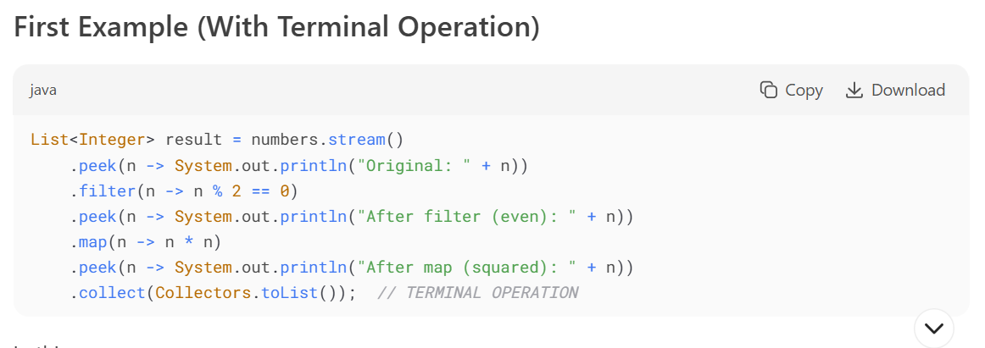

In this case:

1. The entire pipeline is defined (peek, filter, peek, map, peek)
2. The terminal operation collect() triggers the actual processing
3. All intermediate operations (including peek()) are executed as part of this processing
4. The peek() calls print their messages because the stream is actually being processed

## Second Example (Without Terminal Operation Initially)

Second Example (Without Terminal Operation Initially)

In this case:

1. You create a stream pipeline (peek, filter) but don't invoke a terminal operation immediately
2. At this point, **nothing is executed** - the stream is just "defined"
3. The message about peek not executing is correct at this point
4. When you later add forEach() (a terminal operation), then the processing happens and peek() executes

Why the Difference?

The critical point is that **stream operations don't execute until a terminal operation is called**. In your first example, you immediately call collect(), so everything executes. In the second example, you create the stream but don't process it until later when you call forEach().

Important Notes About peek()

1. peek() is an **intermediate operation** (like filter, map, etc.)
2. Intermediate operations are lazy - they just modify the stream definition
3. Only terminal operations (like collect, forEach, count) actually trigger processing
4. Even though peek() has a side-effect (printing), it won't execute until the terminal operation is called.

**Example 2: Logging and Monitoring Employee Processing**

java

import java.util.*;

import java.util.stream.*;

import java.util.concurrent.atomic.AtomicInteger;

class Employee {

private String name;

private double salary;

private String department;

private int experience;

public Employee(String name, double salary, String department, int experience) {

this.name = name;

this.salary = salary;

this.department = department;

this.experience = experience;

}

public String getName() { return name; }

public double getSalary() { return salary; }

public String getDepartment() { return department; }

public int getExperience() { return experience; }

public void setSalary(double salary) { this.salary = salary; }

@Override

public String toString() {

return String.format("%s: $%.2f (%s, %d yrs)", name, salary, department, experience);

}

}

public class PeekExample2 {

public static void main(String[] args) {

List<Employee> employees = Arrays.asList(

new Employee("Alice", 75000, "IT", 5),

new Employee("Bob", 45000, "HR", 2),

new Employee("Charlie", 85000, "IT", 8),

new Employee("Diana", 55000, "Finance", 3),

new Employee("Eve", 65000, "IT", 4)

);

AtomicInteger processedCount = new AtomicInteger(0);

AtomicInteger filteredCount = new AtomicInteger(0);

System.out.println("=== Employee Salary Increase Processing ===");

List<Employee> updatedEmployees = employees.stream()

.peek(emp -> {

processedCount.incrementAndGet();

System.out.println("Processing: " + emp);

})

.filter(emp -> emp.getDepartment().equals("IT"))

.peek(emp -> {

filteredCount.incrementAndGet();

System.out.println(" -> IT Employee found: " + emp.getName());

})

.filter(emp -> emp.getExperience() >= 4)

.peek(emp -> System.out.println(" -> Experienced IT Employee: " + emp.getName()))

.peek(emp -> {

double oldSalary = emp.getSalary();

emp.setSalary(oldSalary * 1.10); *// 10% increase*

System.out.println(" -> Salary increased from $" + oldSalary + " to $" + emp.getSalary());

})

.collect(Collectors.toList());

System.out.println("\n=== Summary ===");

System.out.println("Total employees processed: " + processedCount.get());

System.out.println("IT employees found: " + filteredCount.get());

System.out.println("Employees who got salary increase: " + updatedEmployees.size());

System.out.println("\nUpdated Employees:");

updatedEmployees.forEach(System.out::println);

}

}

**Output:**

=== Employee Salary Increase Processing ===

Processing: Alice: $75000.00 (IT, 5 yrs)

-> IT Employee found: Alice

-> Experienced IT Employee: Alice

-> Salary increased from $75000.0 to $82500.0

Processing: Bob: $45000.00 (HR, 2 yrs)

Processing: Charlie: $85000.00 (IT, 8 yrs)

-> IT Employee found: Charlie

-> Experienced IT Employee: Charlie

-> Salary increased from $85000.0 to $93500.0

Processing: Diana: $55000.00 (Finance, 3 yrs)

Processing: Eve: $65000.00 (IT, 4 yrs)

-> IT Employee found: Eve

-> Experienced IT Employee: Eve

-> Salary increased from $65000.0 to $71500.0

=== Summary ===

Total employees processed: 5

IT employees found: 3

Employees who got salary increase: 3

Updated Employees:

Alice: $82500.00 (IT, 5 yrs)

Charlie: $93500.00 (IT, 8 yrs)

Eve: $71500.00 (IT, 4 yrs)

**Example 3: Performance Monitoring and Timing**

java

import java.util.*;

import java.util.stream.*;

import java.time.LocalDateTime;

import java.time.temporal.ChronoUnit;

public class PeekExample3 {

public static void main(String[] args) {

List<Integer> numbers = Arrays.asList(1, 2, 3, 4, 5, 6, 7, 8, 9, 10);

System.out.println("=== Performance Monitoring with Peek ===");

LocalDateTime startTime = LocalDateTime.now();

List<Integer> result = numbers.stream()

.peek(n -> {

System.out.println("Processing number: " + n + " at " + LocalDateTime.now());

*// Simulate some processing time*

try {

Thread.sleep(100);

} catch (InterruptedException e) {

Thread.currentThread().interrupt();

}

})

.filter(n -> n % 2 == 0)

.peek(n -> System.out.println(" -> Filtered (even): " + n))

.map(n -> {

int result_inner = n * n;

System.out.println(" -> Mapped " + n + " to " + result_inner);

return result_inner;

})

.peek(n -> System.out.println(" -> Final value: " + n))

.collect(Collectors.toList());

LocalDateTime endTime = LocalDateTime.now();

long duration = ChronoUnit.MILLIS.between(startTime, endTime);

System.out.println("\n=== Results ===");

System.out.println("Processed numbers: " + result);

System.out.println("Total processing time: " + duration + " ms");

System.out.println("Average time per element: " + (duration / numbers.size()) + " ms");

*// Demonstrate counting with peek*

System.out.println("\n=== Counting Elements at Each Stage ===");

Map<String, Integer> counters = new HashMap<>();

counters.put("original", 0);

counters.put("filtered", 0);

counters.put("mapped", 0);

numbers.stream()

.peek(n -> counters.put("original", counters.get("original") + 1))

.filter(n -> n > 5)

.peek(n -> counters.put("filtered", counters.get("filtered") + 1))

.map(n -> n * 2)

.peek(n -> counters.put("mapped", counters.get("mapped") + 1))

.forEach(n -> {}); *// Empty consumer to trigger stream processing*

System.out.println("Stage counters: " + counters);

}

}

**Output:**

=== Performance Monitoring with Peek ===

Processing number: 1 at 2024-01-23T10:15:20.123

Processing number: 2 at 2024-01-23T10:15:20.225

-> Filtered (even): 2

-> Mapped 2 to 4

-> Final value: 4

Processing number: 3 at 2024-01-23T10:15:20.327

Processing number: 4 at 2024-01-23T10:15:20.429

-> Filtered (even): 4

-> Mapped 4 to 16

-> Final value: 16

...

=== Results ===

Processed numbers: [4, 16, 36, 64, 100]

Total processing time: 1050 ms

Average time per element: 105 ms

=== Counting Elements at Each Stage ===

Stage counters: {original=10, filtered=5, mapped=5}

**LIMIT METHOD**

**What is Limit Method?**

The limit() method is an intermediate operation that returns a stream with at most the specified number of elements. It truncates the stream to contain no more than the given number of elements. This is a **stateful intermediate operation** that maintains state about how many elements have been processed.

**Method Signature:**

java

Stream<T> limit(long maxSize)

**Overloaded Methods:**

The limit() method does not have overloaded versions. It only accepts a single long parameter representing the maximum number of elements.

**When to Use Limit?**

* **Pagination**: Implementing page-based data retrieval
* **Top N Results**: Getting the first N elements after sorting
* **Performance Optimization**: Preventing processing of unnecessary elements
* **Sampling**: Creating samples from large datasets
* **Memory Management**: Avoiding memory issues with infinite streams
* **Testing**: Creating smaller datasets for testing purposes

**5 Interview-Focused LIMIT Examples:**

**Example 1: Basic Limit - Get First N Elements**

java

import java.util.*;

import java.util.stream.*;

public class LimitExample1 {

public static void main(String[] args) {

List<Integer> numbers = Arrays.asList(1, 2, 3, 4, 5, 6, 7, 8, 9, 10);

List<Integer> firstFive = numbers.stream()

.limit(5)

.collect(Collectors.toList());

System.out.println("Original: " + numbers);

System.out.println("First 5: " + firstFive);

*// What happens with limit greater than stream size?*

List<Integer> firstFifteen = numbers.stream()

.limit(15)

.collect(Collectors.toList());

System.out.println("First 15 (more than available): " + firstFifteen);

*// What happens with limit 0?*

List<Integer> firstZero = numbers.stream()

.limit(0)

.collect(Collectors.toList());

System.out.println("First 0: " + firstZero);

}

}

**Output:**

Original: [1, 2, 3, 4, 5, 6, 7, 8, 9, 10]

First 5: [1, 2, 3, 4, 5]

First 15 (more than available): [1, 2, 3, 4, 5, 6, 7, 8, 9, 10]

First 0: []

**Example 2: Top N Highest Salaries (Most Common Interview Question)**

java

import java.util.*;

import java.util.stream.*;

class Employee {

private String name;

private double salary;

private String department;

public Employee(String name, double salary, String department) {

this.name = name;

this.salary = salary;

this.department = department;

}

public String getName() { return name; }

public double getSalary() { return salary; }

public String getDepartment() { return department; }

@Override

public String toString() {

return name + ": $" + salary + " (" + department + ")";

}

}

public class LimitExample2 {

public static void main(String[] args) {

List<Employee> employees = Arrays.asList(

new Employee("John", 50000, "IT"),

new Employee("Jane", 75000, "IT"),

new Employee("Bob", 45000, "HR"),

new Employee("Alice", 80000, "Finance"),

new Employee("Charlie", 65000, "IT"),

new Employee("Diana", 70000, "HR"),

new Employee("Eve", 90000, "Finance")

);

*// Top 3 highest paid employees*

System.out.println("Top 3 Highest Paid Employees:");

employees.stream()

.sorted((e1, e2) -> Double.compare(e2.getSalary(), e1.getSalary()))

.limit(3)

.forEach(System.out::println);

*// Top 2 highest paid employees in IT department*

System.out.println("\nTop 2 Highest Paid IT Employees:");

employees.stream()

.filter(e -> "IT".equals(e.getDepartment()))

.sorted((e1, e2) -> Double.compare(e2.getSalary(), e1.getSalary()))

.limit(2)

.forEach(System.out::println);

}

}

**Output:**

Top 3 Highest Paid Employees:

Eve: $90000.0 (Finance)

Alice: $80000.0 (Finance)

Jane: $75000.0 (IT)

Top 2 Highest Paid IT Employees:

Jane: $75000.0 (IT)

Charlie: $65000.0 (IT)

**Example 3: Pagination Implementation (Critical Interview Topic)**

java

import java.util.*;

import java.util.stream.*;

public class LimitExample3 {

public static void main(String[] args) {

*// Create a list of 100 items*

List<String> items = IntStream.rangeClosed(1, 100)

.mapToObj(i -> "Item " + i)

.collect(Collectors.toList());

int pageSize = 10;

*// Method to get specific page*

System.out.println("=== Pagination Demo ===");

for (int page = 0; page < 3; page++) {

List<String> pageItems = getPage(items, page, pageSize);

System.out.println("Page " + (page + 1) + ": " + pageItems);

}

*// Advanced pagination with total count*

PaginationResult<String> result = getPaginatedResult(items, 2, pageSize);

System.out.println("\nAdvanced Pagination:");

System.out.println("Page: " + result.getCurrentPage());

System.out.println("Page Size: " + result.getPageSize());

System.out.println("Total Elements: " + result.getTotalElements());

System.out.println("Total Pages: " + result.getTotalPages());

System.out.println("Items: " + result.getContent());

}

public static <T> List<T> getPage(List<T> items, int pageNumber, int pageSize) {

return items.stream()

.skip((long) pageNumber * pageSize)

.limit(pageSize)

.collect(Collectors.toList());

}

public static <T> PaginationResult<T> getPaginatedResult(List<T> items, int pageNumber, int pageSize) {

List<T> content = items.stream()

.skip((long) pageNumber * pageSize)

.limit(pageSize)

.collect(Collectors.toList());

return new PaginationResult<>(content, pageNumber, pageSize, items.size());

}

}

class PaginationResult<T> {

private List<T> content;

private int currentPage;

private int pageSize;

private long totalElements;

public PaginationResult(List<T> content, int currentPage, int pageSize, long totalElements) {

this.content = content;

this.currentPage = currentPage;

this.pageSize = pageSize;

this.totalElements = totalElements;

}

public List<T> getContent() { return content; }

public int getCurrentPage() { return currentPage; }

public int getPageSize() { return pageSize; }

public long getTotalElements() { return totalElements; }

public long getTotalPages() { return (totalElements + pageSize - 1) / pageSize; }

}

**Output:**

=== Pagination Demo ===

Page 1: [Item 1, Item 2, Item 3, Item 4, Item 5, Item 6, Item 7, Item 8, Item 9, Item 10]

Page 2: [Item 11, Item 12, Item 13, Item 14, Item 15, Item 16, Item 17, Item 18, Item 19, Item 20]

Page 3: [Item 21, Item 22, Item 23, Item 24, Item 25, Item 26, Item 27, Item 28, Item 29, Item 30]

Advanced Pagination:

Page: 2

Page Size: 10

Total Elements: 100

Total Pages: 10

Items: [Item 21, Item 22, Item 23, Item 24, Item 25, Item 26, Item 27, Item 28, Item 29, Item 30]

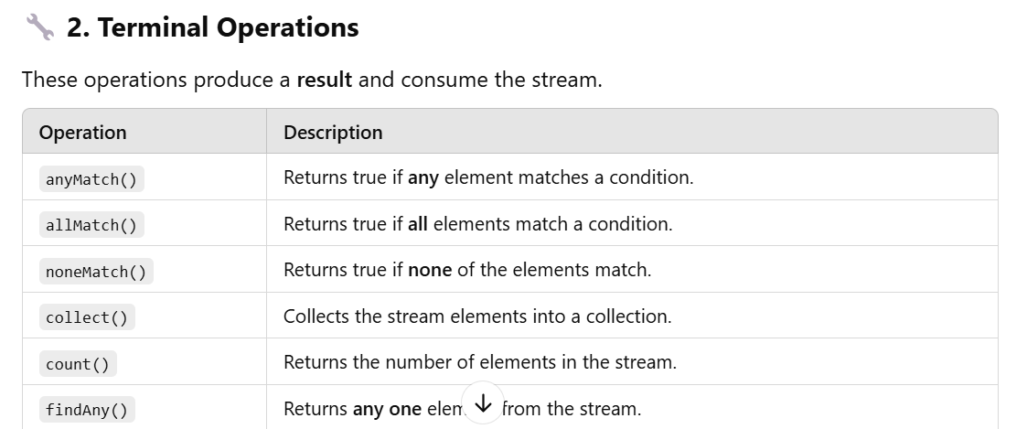

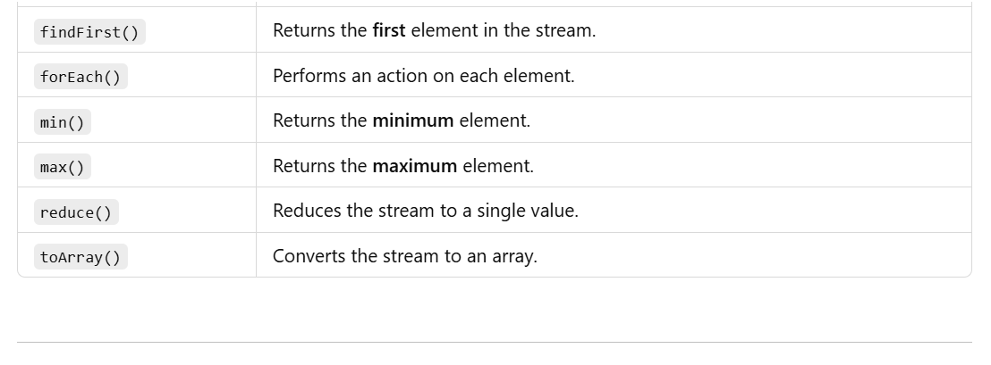

**✅ Terminal Operations with Examples**

**🔧 1. anyMatch()**

**The anyMatch() method returns true if any one element in the stream matches a given condition.**

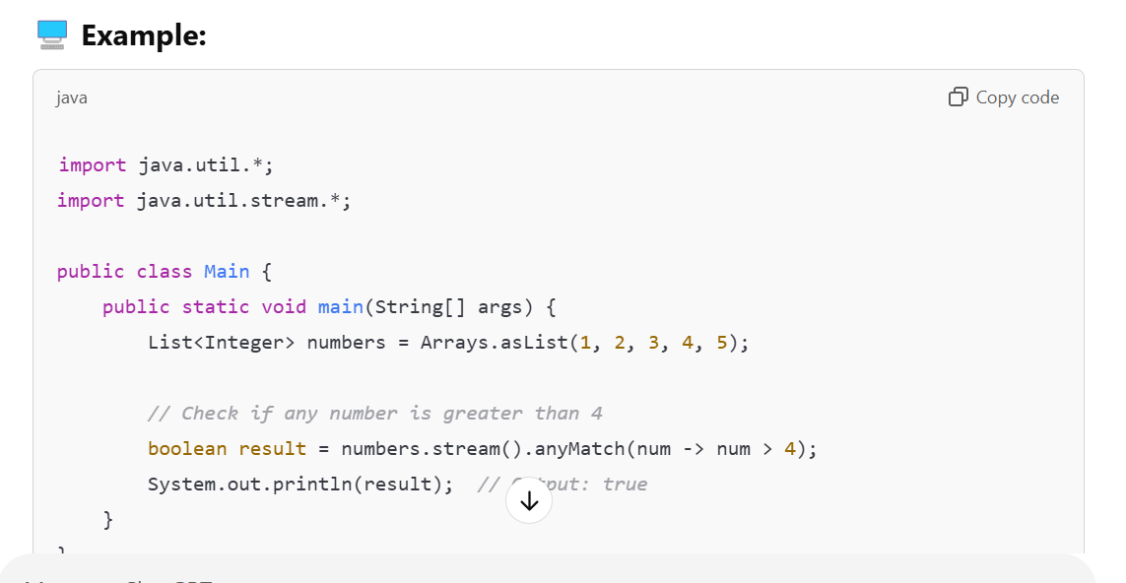

**Purpose:** Returns true if at least one element in the stream matches the given predicate.

**Syntax:** boolean anyMatch(Predicate<? super T> predicate)

**Example 1 -** Built-in Collection:

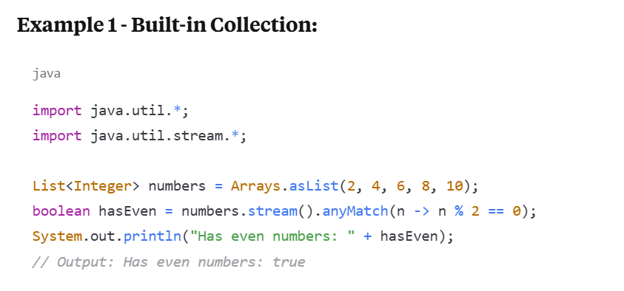

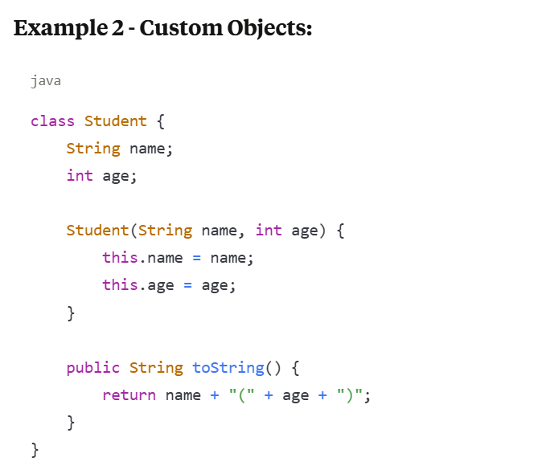

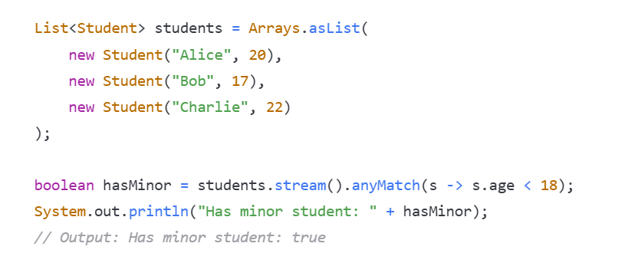

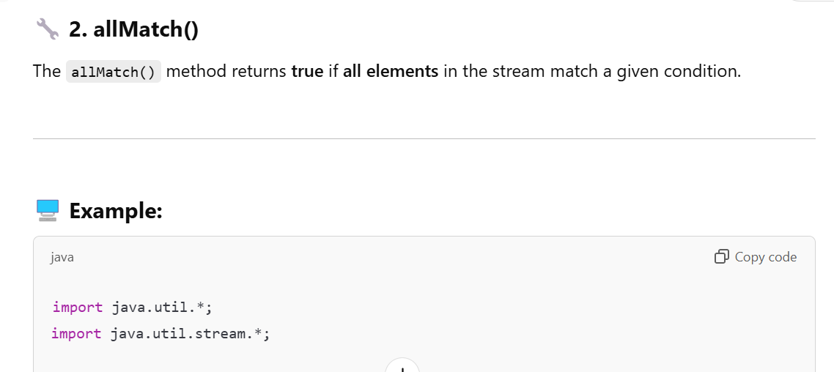

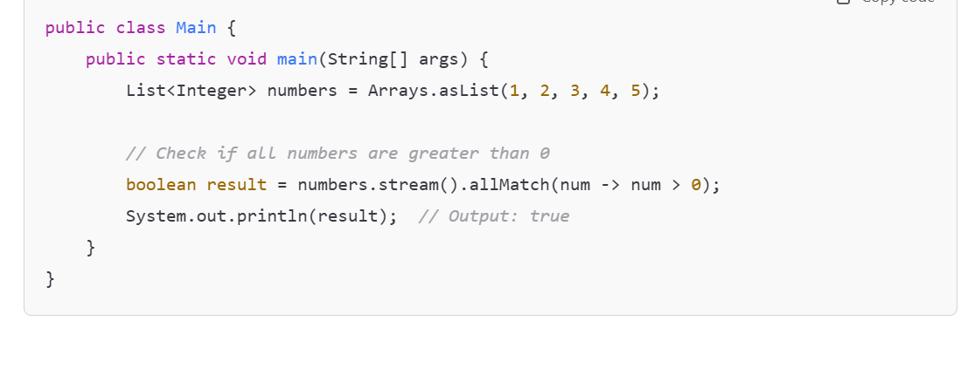

**Purpose: Returns true if all elements in the stream match the given predicate.**

**Syntax: boolean allMatch(Predicate<? super T> predicate)**

**Example 1 - Built-in Collection:**

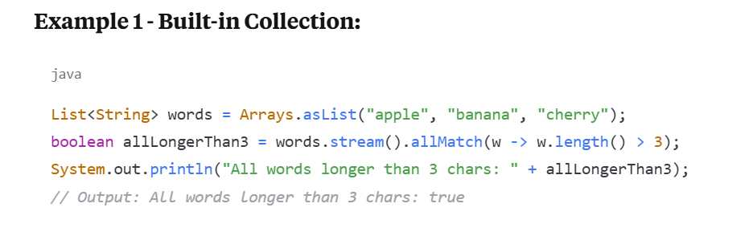

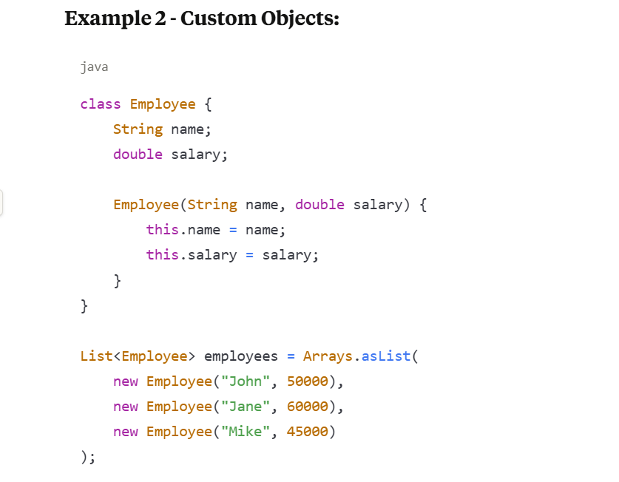

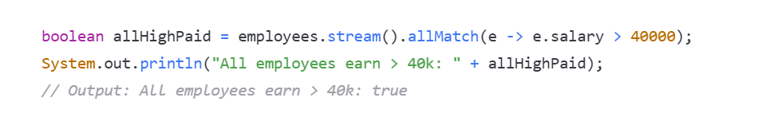

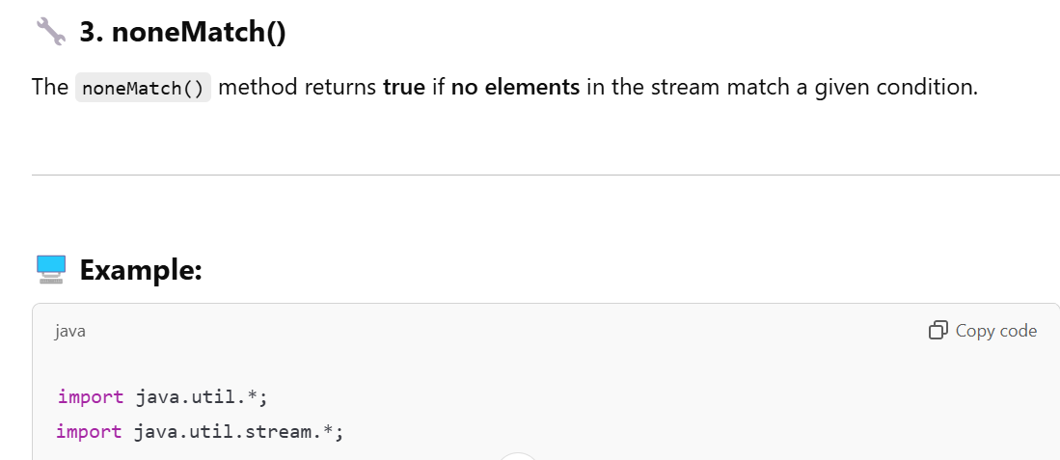

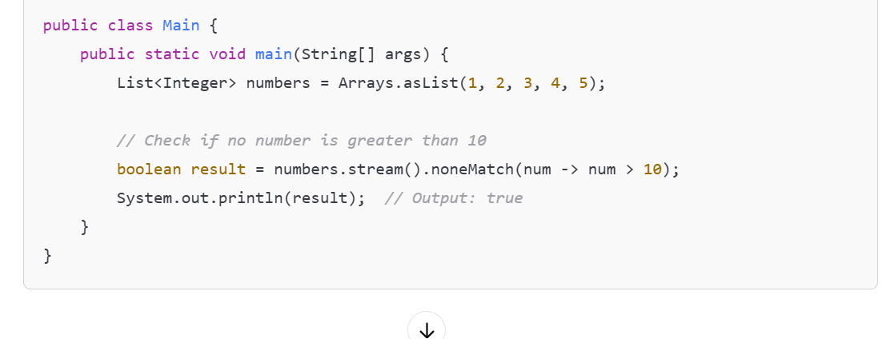

**Purpose: Returns true if no elements in the stream match the given predicate.**

**Syntax: boolean noneMatch(Predicate<? super T> predicate)**

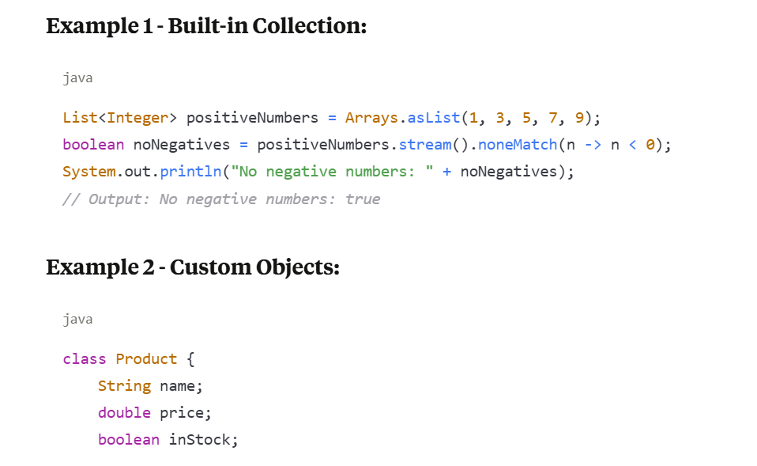

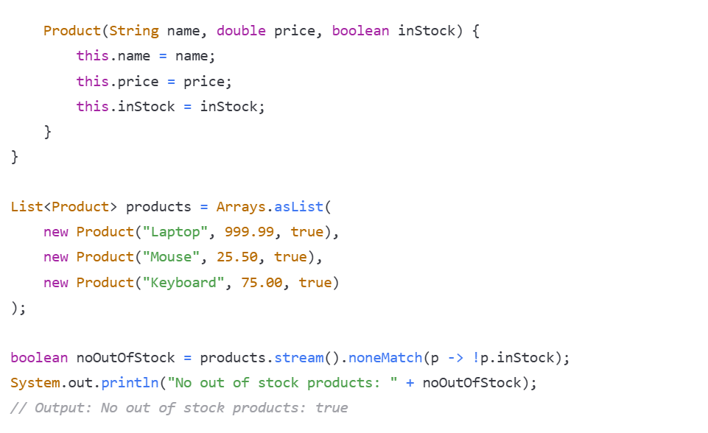

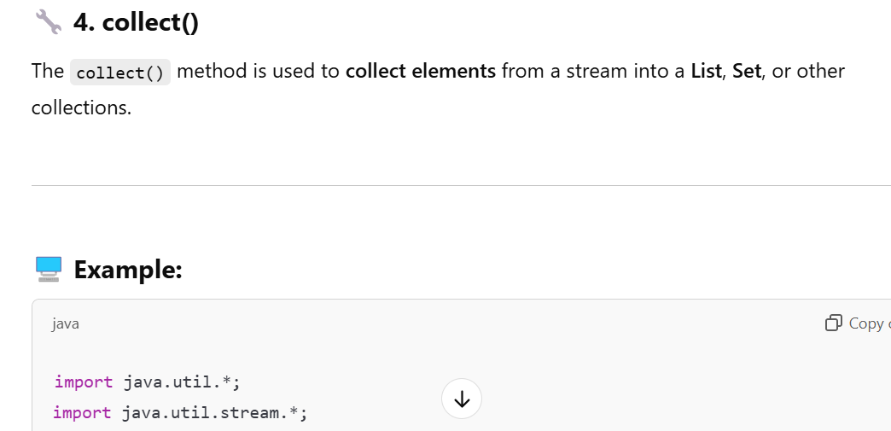

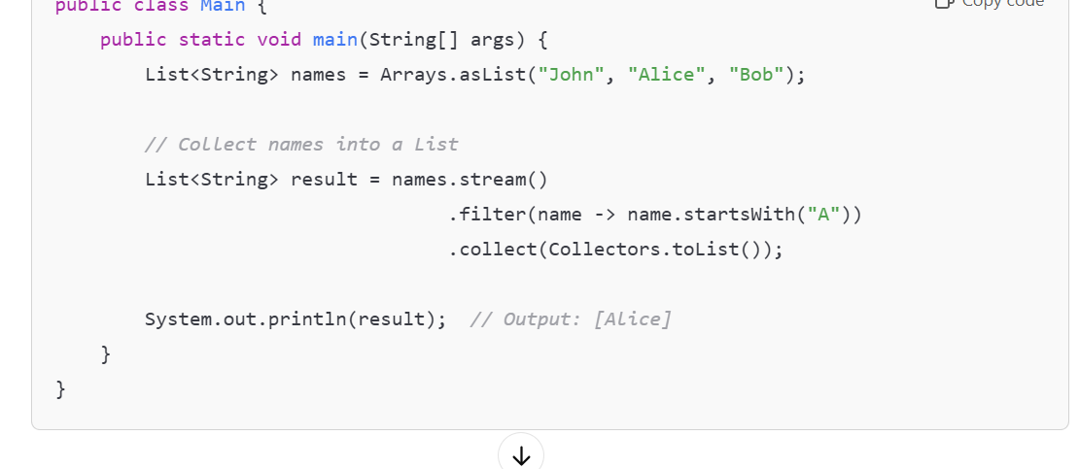

**Purpose: Performs a mutable reduction operation on the stream elements.**

**Syntax: <R> R collect(Collector<? super T, A, R> collector)**

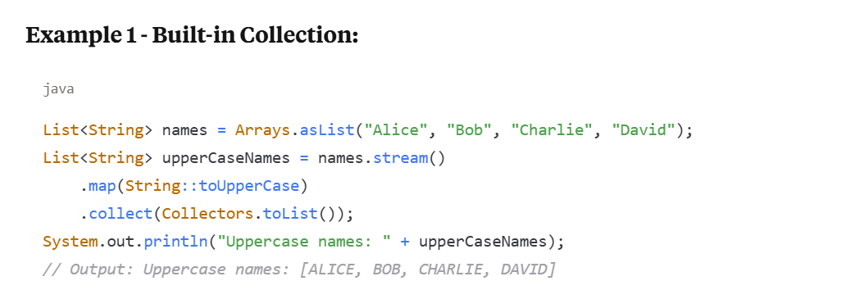

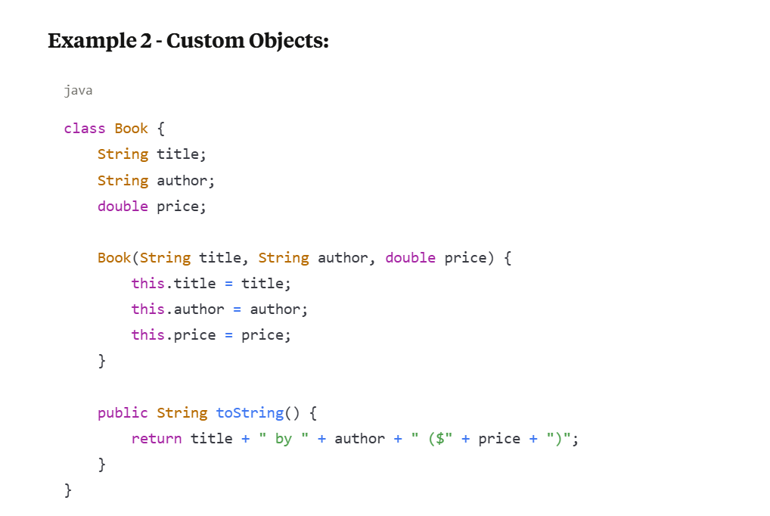

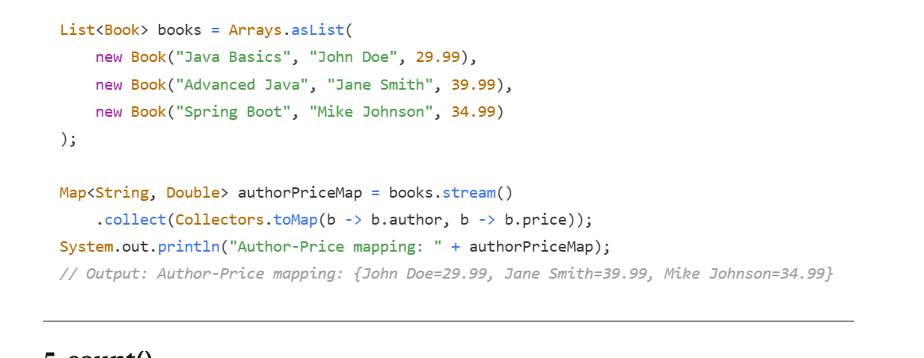

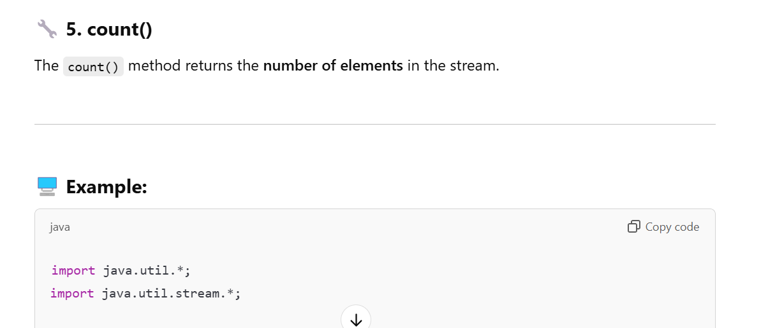

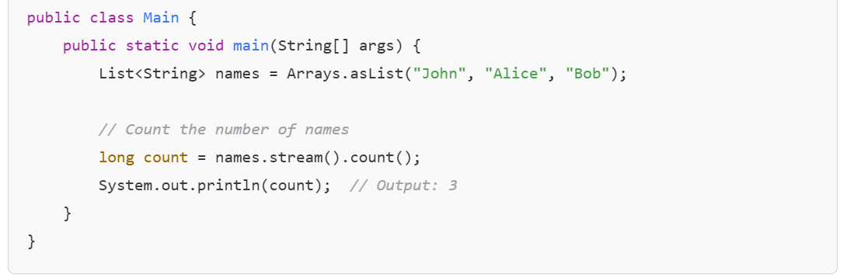

**Purpose: Returns the count of elements in the stream as a long.**

**Syntax: long count()**

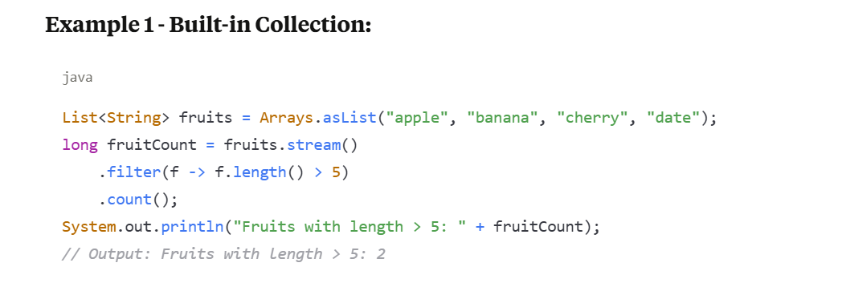

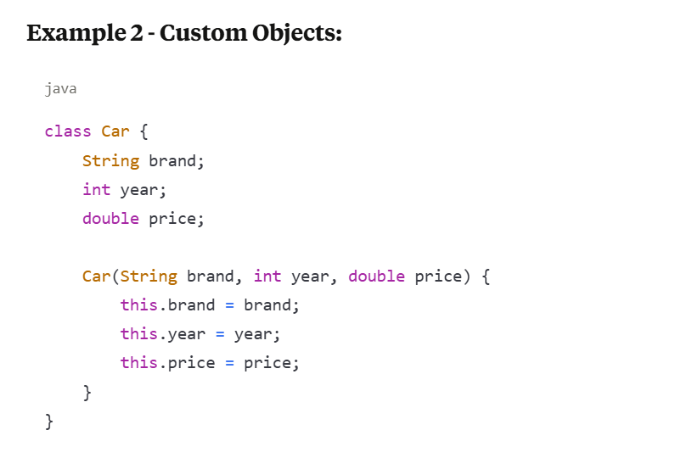

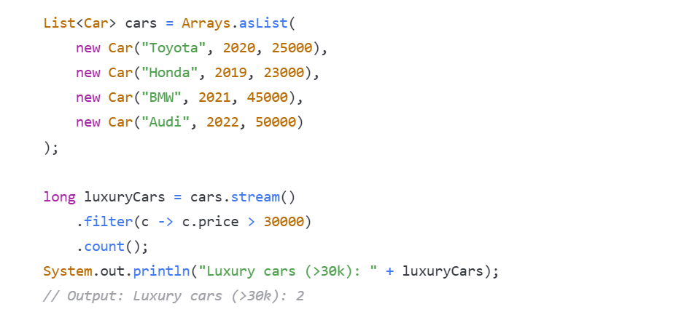

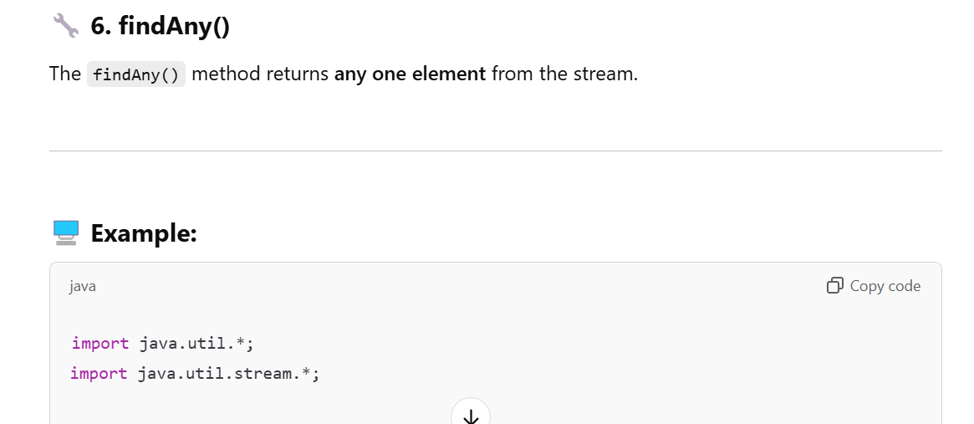

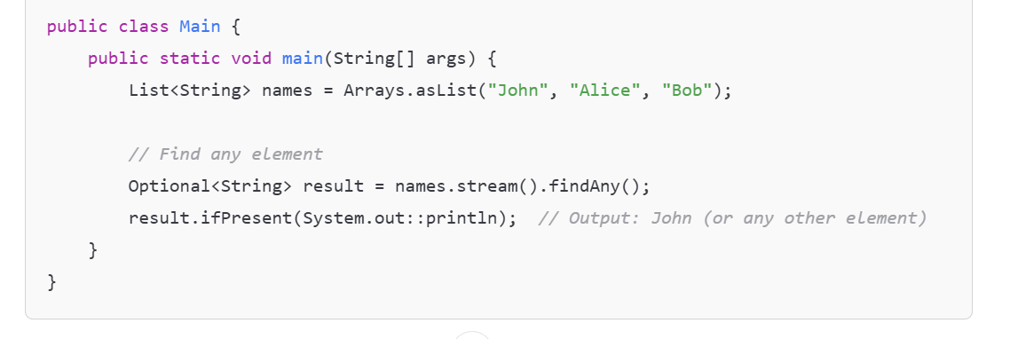

**Purpose: Returns an Optional describing some element of the stream, or empty Optional if stream is empty.**

**Syntax: Optional<T> findAny()**

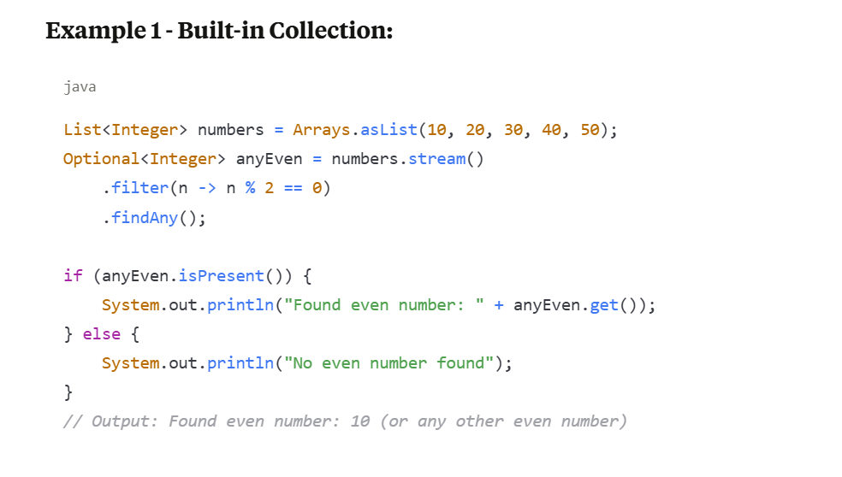

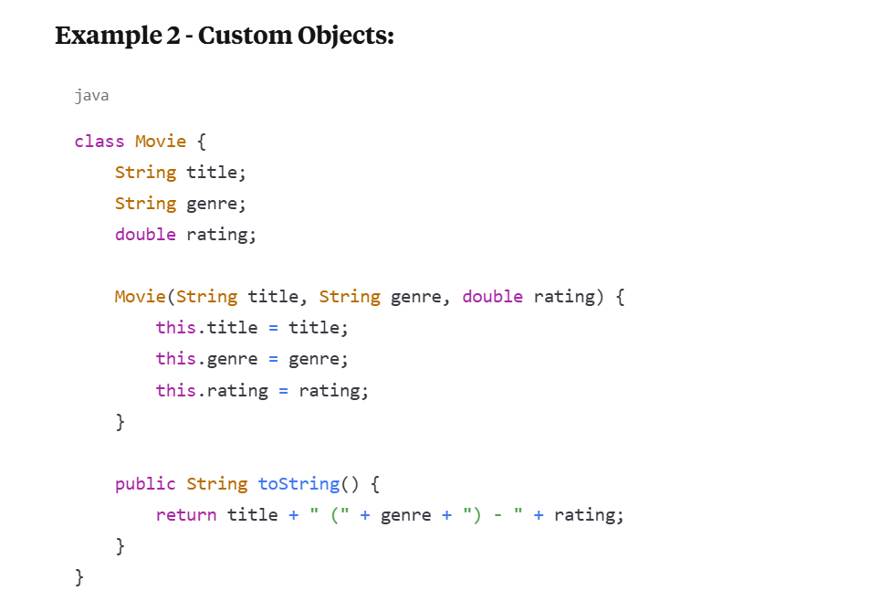

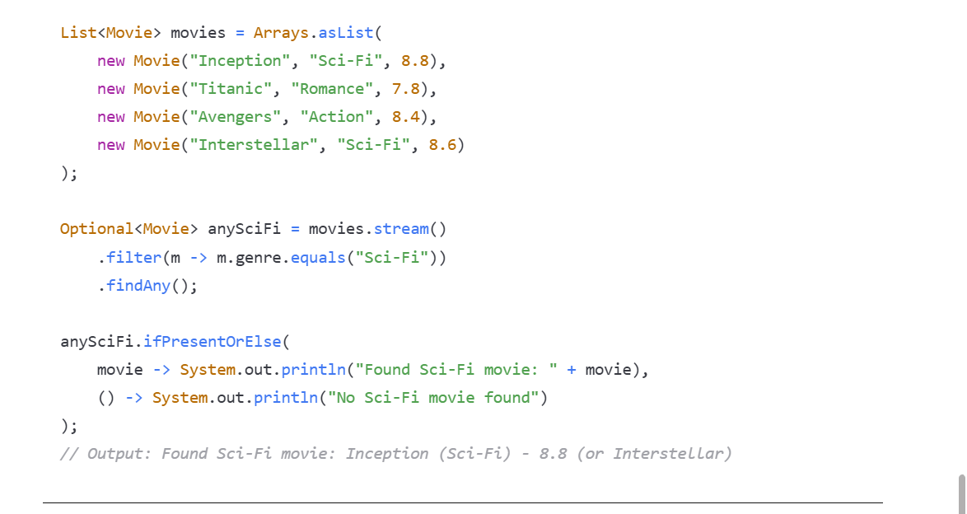

**Key Points to Remember:**

1. Short-circuiting: anyMatch(), allMatch(), noneMatch(), and findAny() are short-circuiting operations - they don't need to process all elements.
2. Empty Streams:
   * anyMatch() returns false for empty streams
   * allMatch() returns true for empty streams
   * noneMatch() returns true for empty streams
   * count() returns 0 for empty streams
   * findAny() returns empty Optional for empty streams
3. Parallel Streams: findAny() is more efficient than findFirst() in parallel streams as it doesn't need to maintain encounter order.
4. collect() is the most versatile - it can create Lists, Sets, Maps, or perform grouping and partitioning operations.
5. All these operations are terminal operations - they consume the stream and produce a final result.

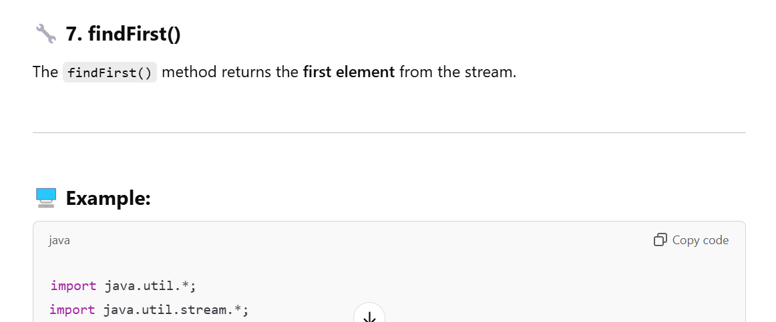

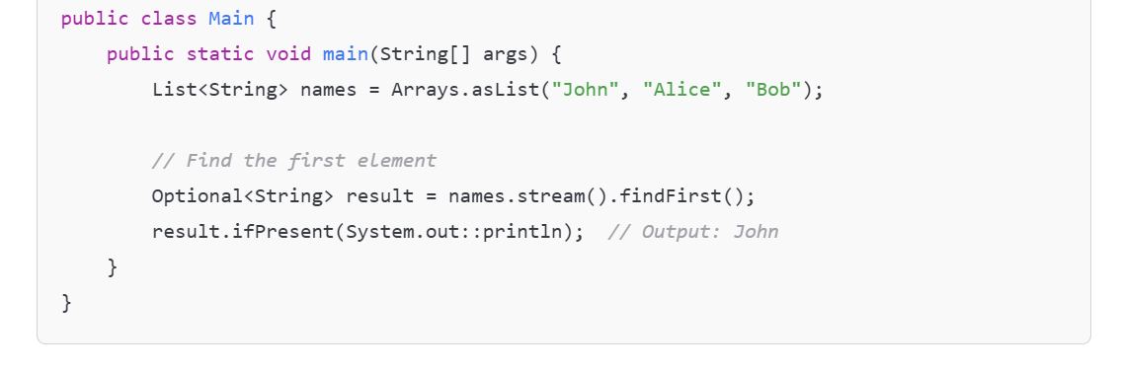

**Purpose:** Returns an Optional describing the first element of the stream, or empty Optional if stream is empty.

**Syntax:** Optional<T> findFirst()

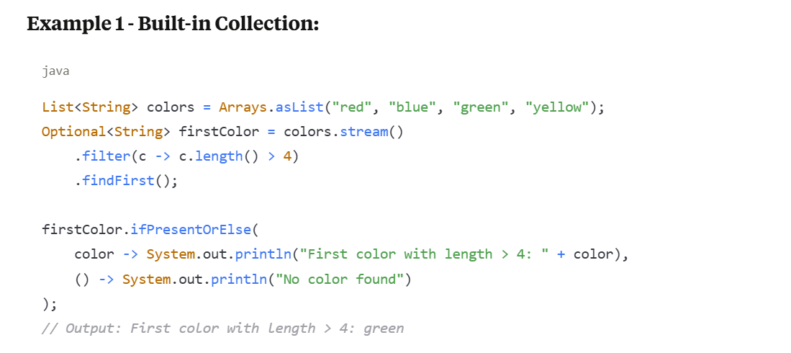

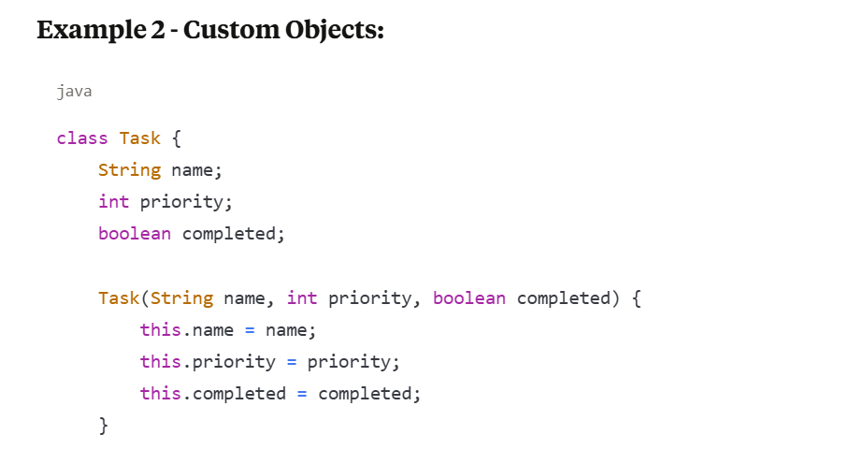

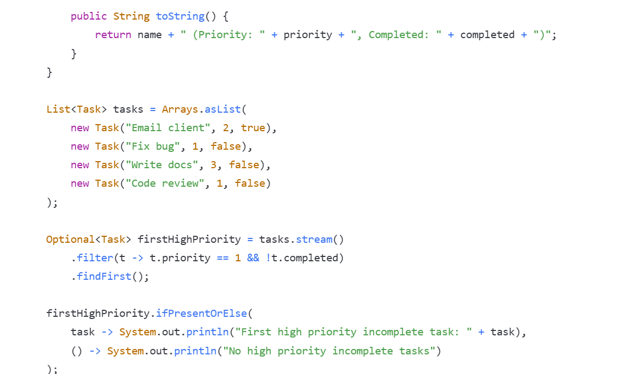



**8. forEach()**

**Purpose**: Performs an action for each element of the stream. This is a terminal operation.

**Syntax**: void forEach(Consumer<? super T> action)

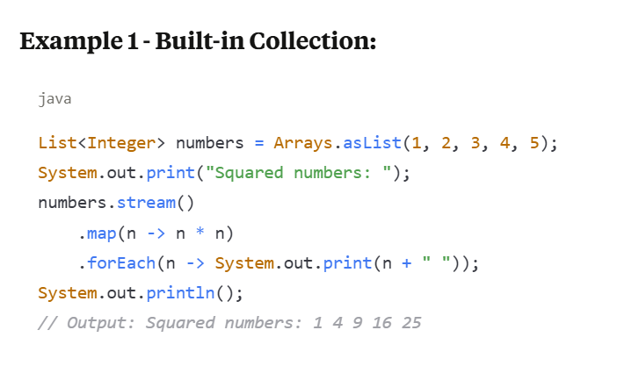

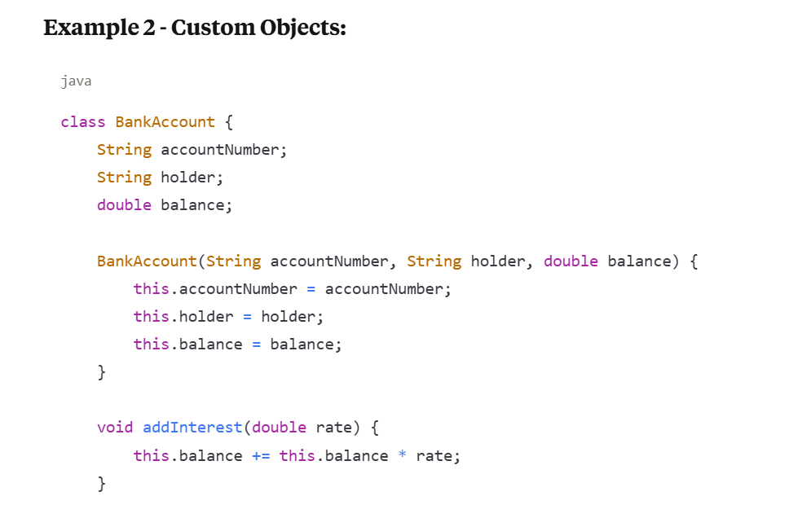

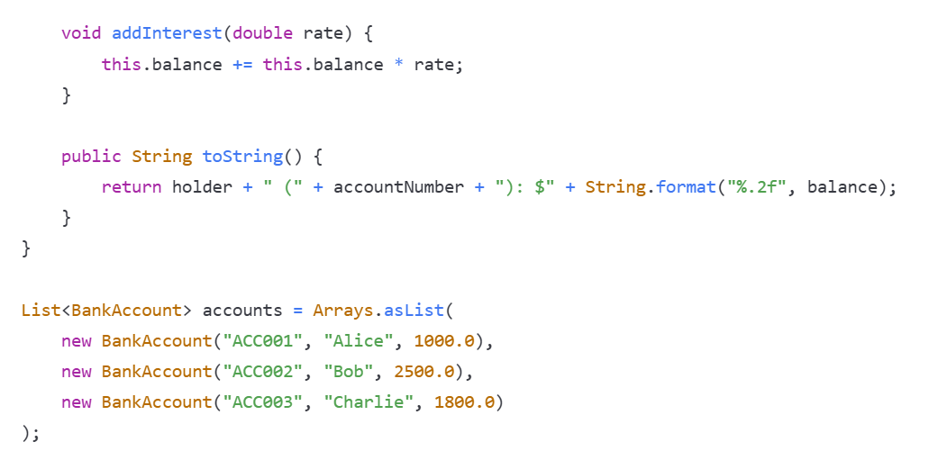

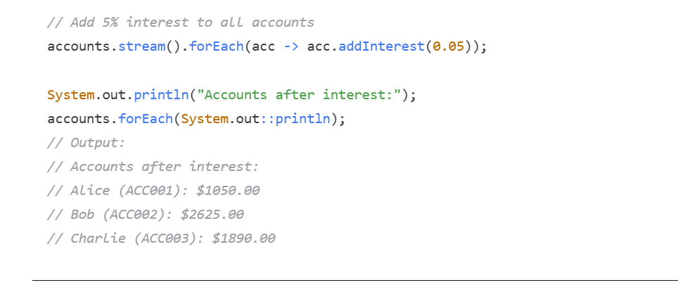

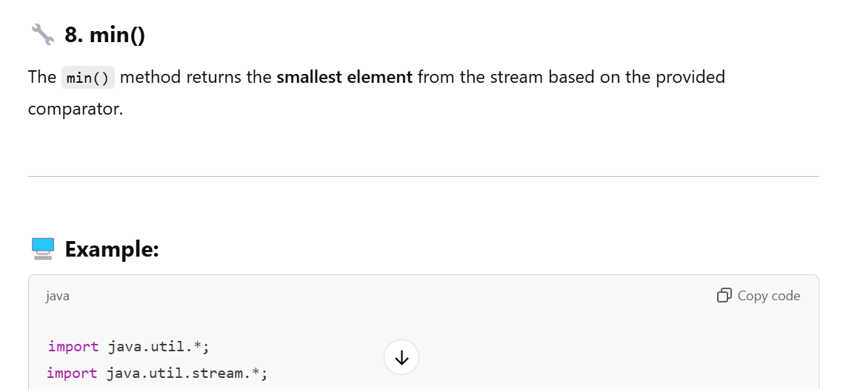

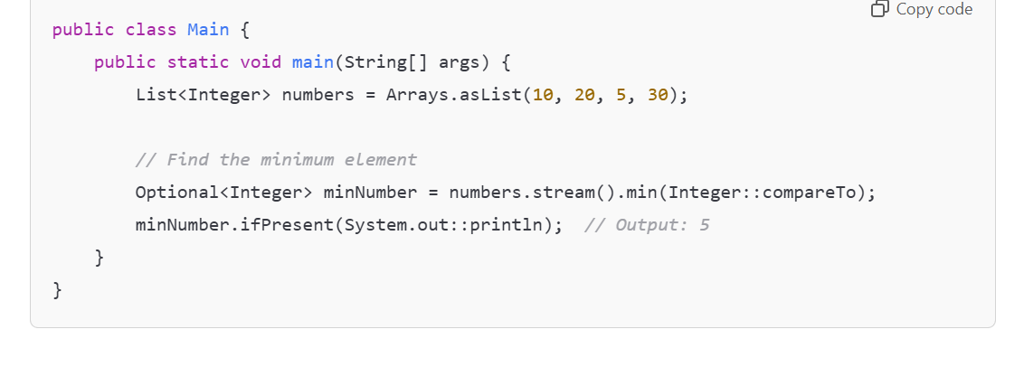

**Purpose: Returns the minimum element of the stream according to the provided Comparator.**

**Syntax: Optional<T> min(Comparator<? super T> comparator)**

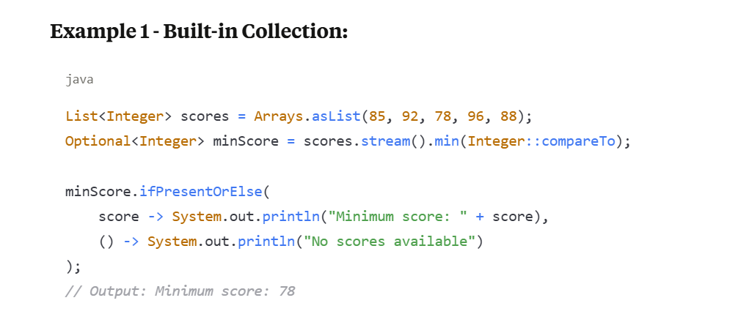

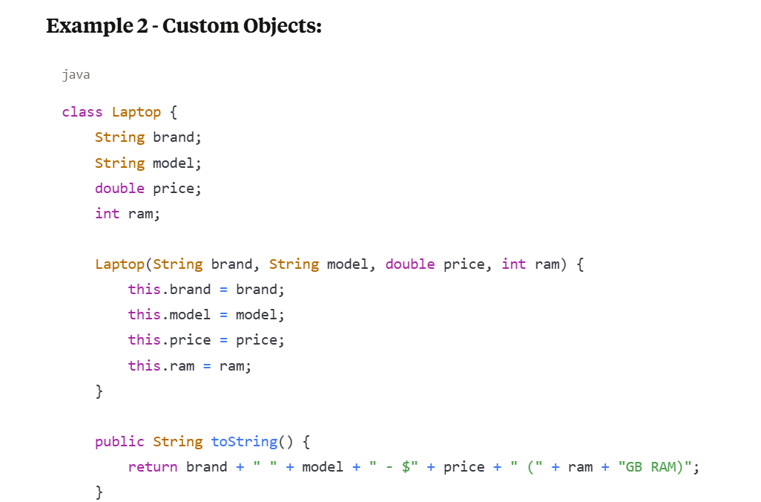

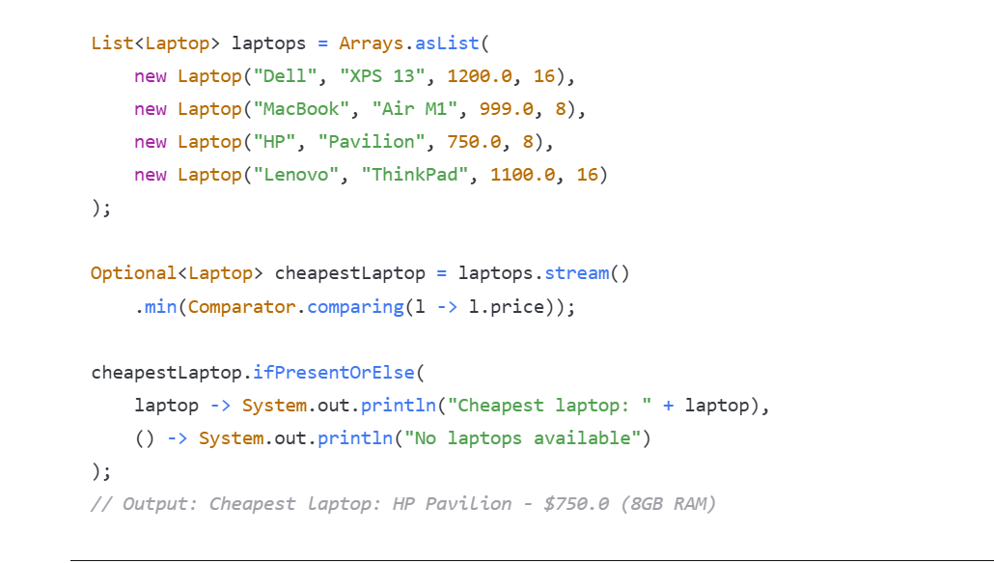

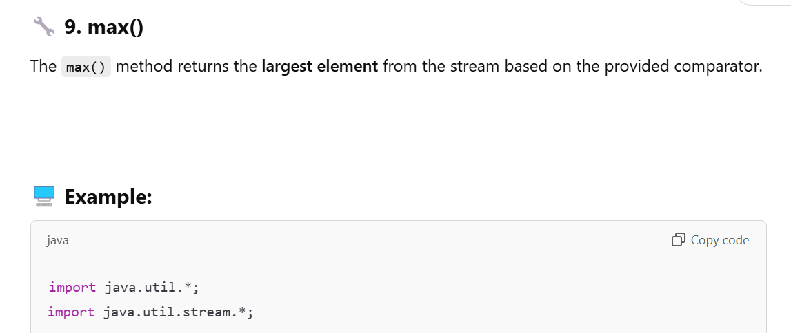

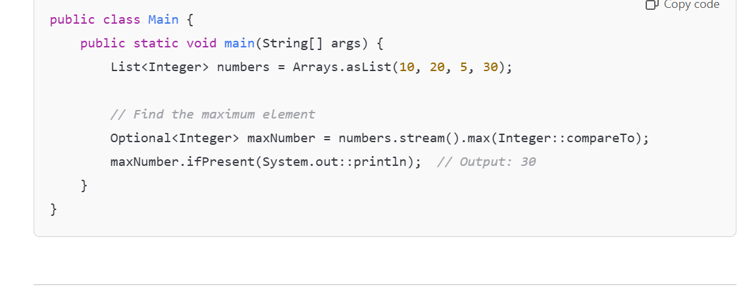

**Purpose: Returns the maximum element of the stream according to the provided Comparator.**

**Syntax: Optional<T> max(Comparator<? super T> comparator)**

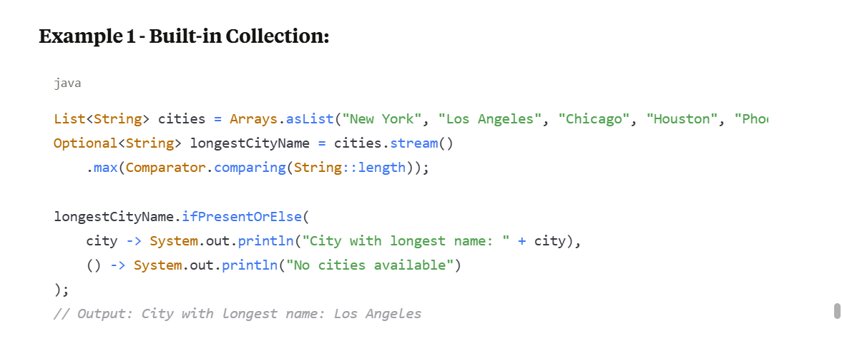

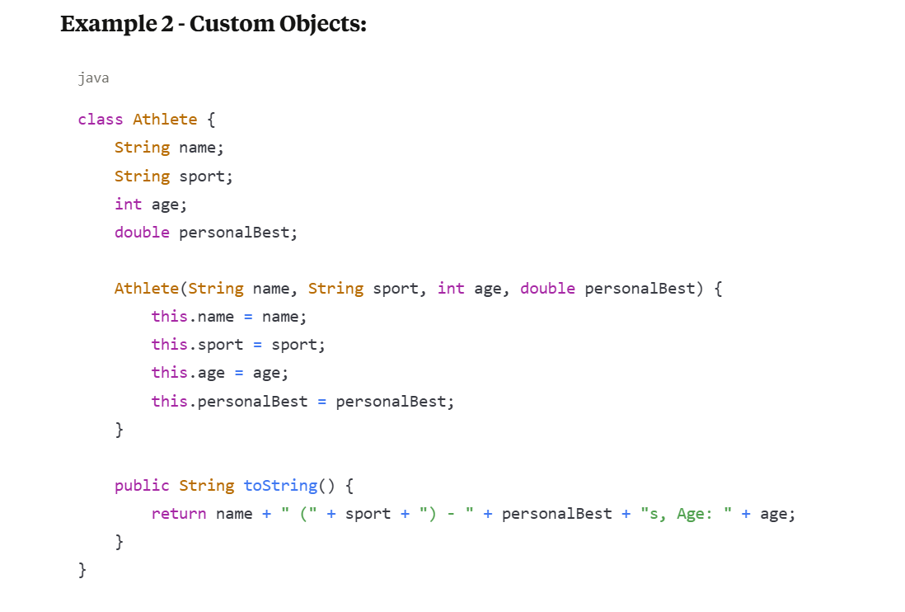

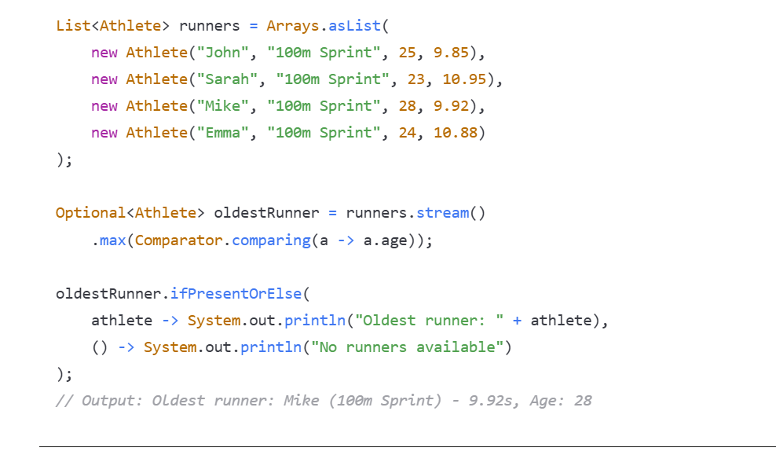

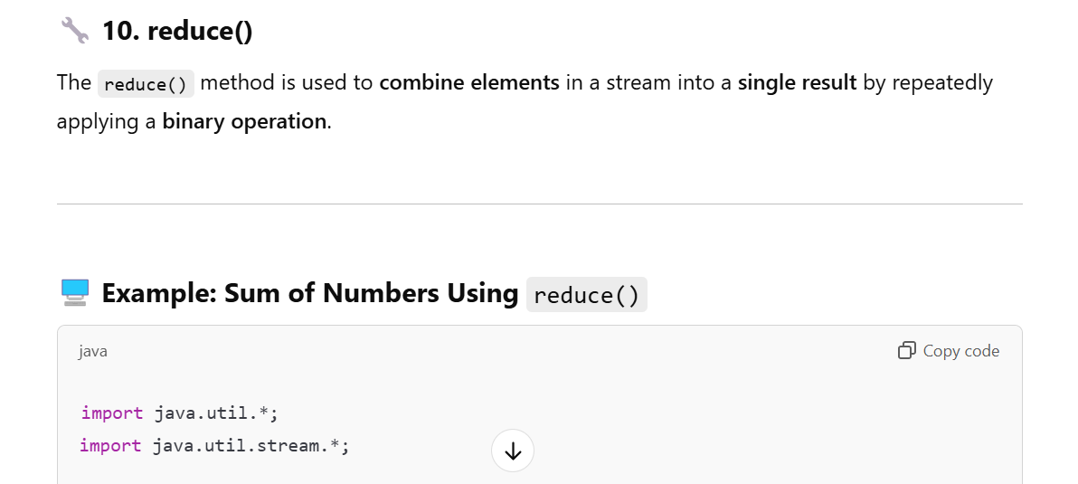

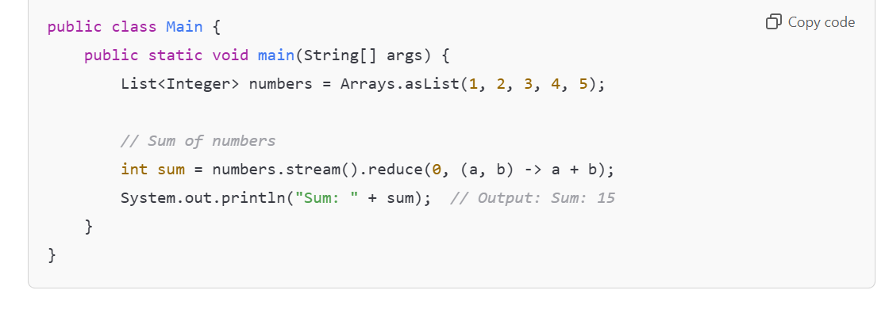

**Purpose: Performs a reduction on the elements using an associative accumulation function and returns an Optional or a value.**

**Syntax:**

* **Optional<T> reduce(BinaryOperator<T> accumulator)**
* **T reduce(T identity, BinaryOperator<T> accumulator)**
* **<U> U reduce(U identity, BiFunction<U, ? super T, U> accumulator, BinaryOperator<U> combiner)**

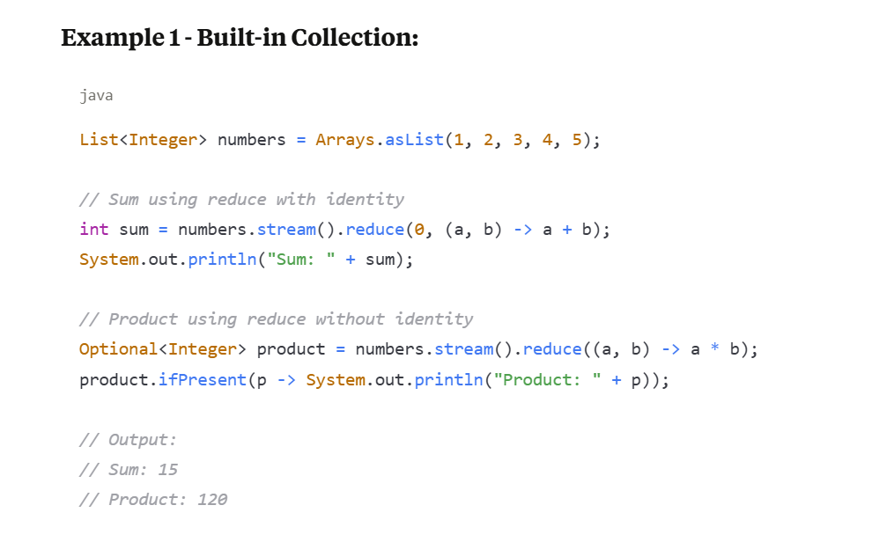

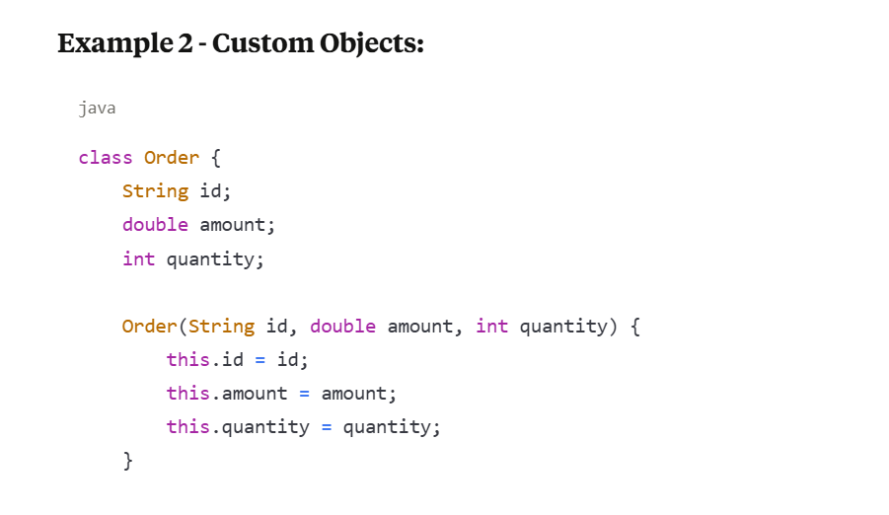

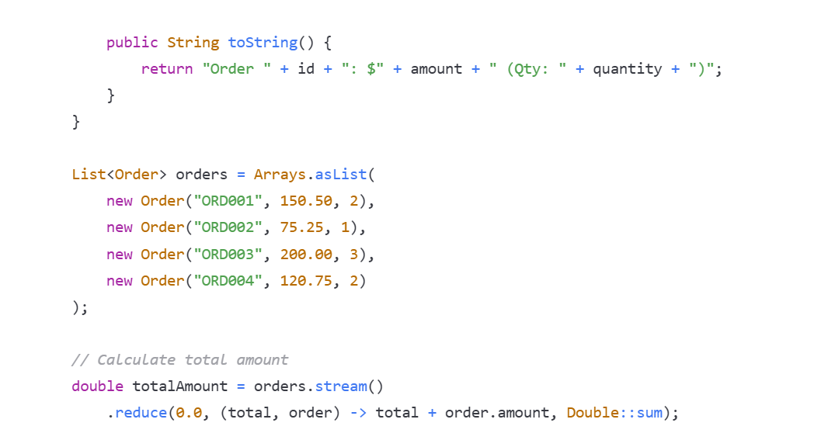

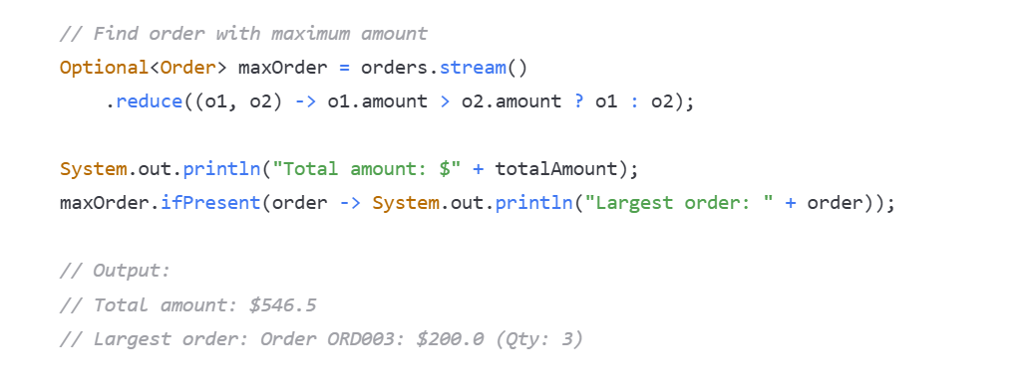

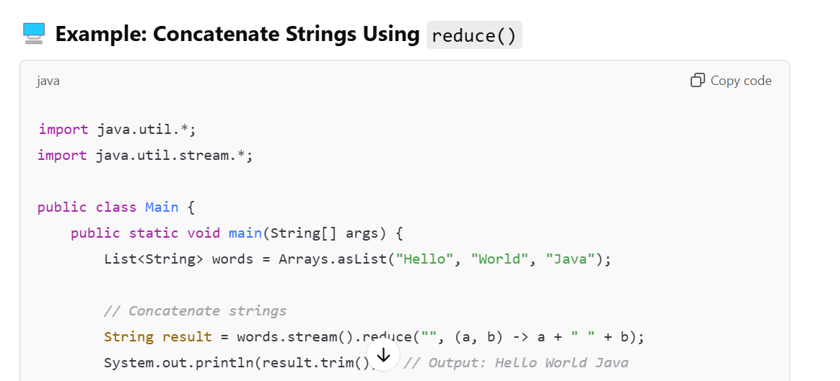

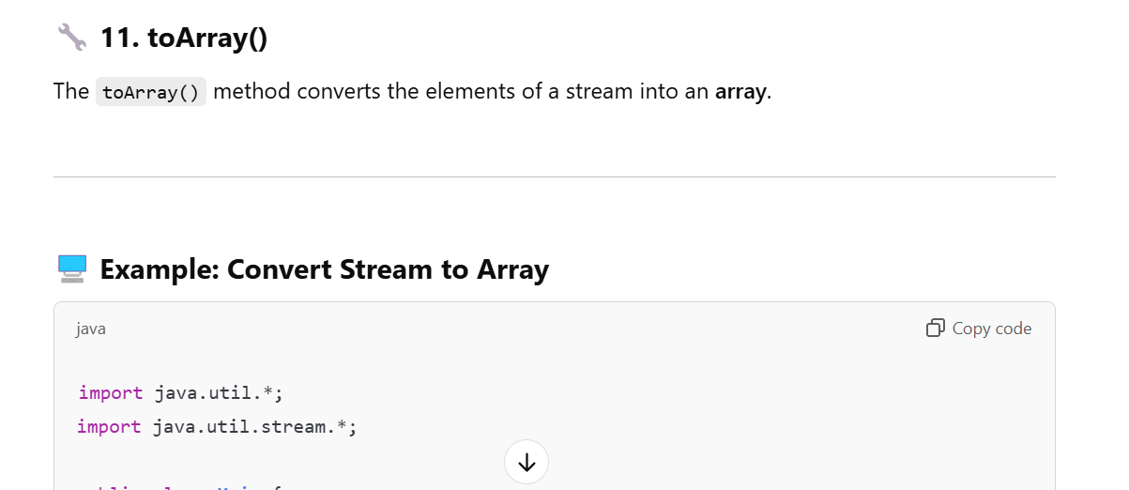

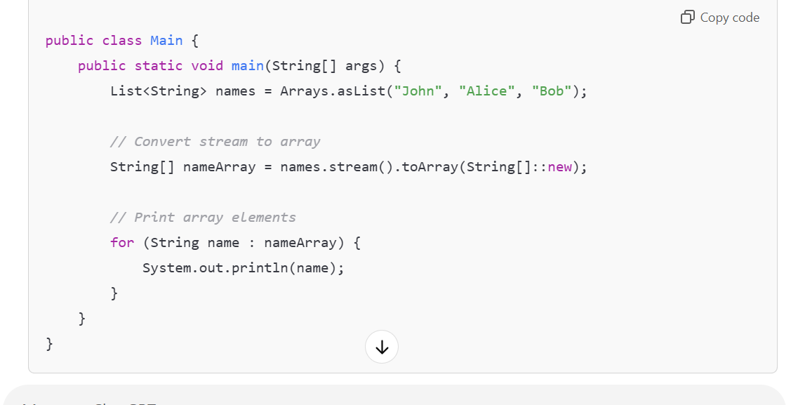

**Purpose: Returns an array containing the elements of the stream.**

**Syntax:**

* **Object[] toArray()**
* **<A> A[] toArray(IntFunction<A[]> generator)**

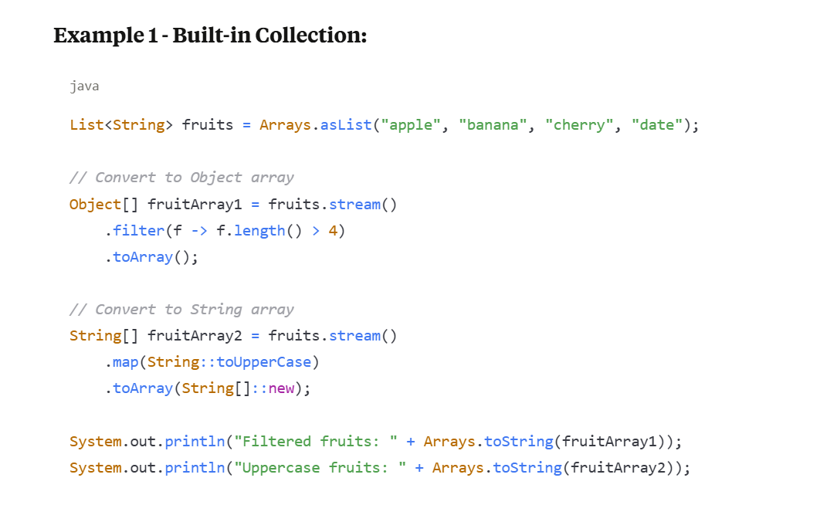

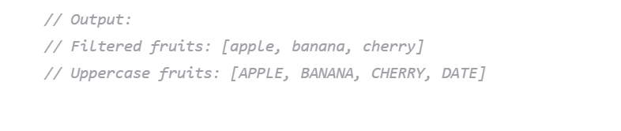

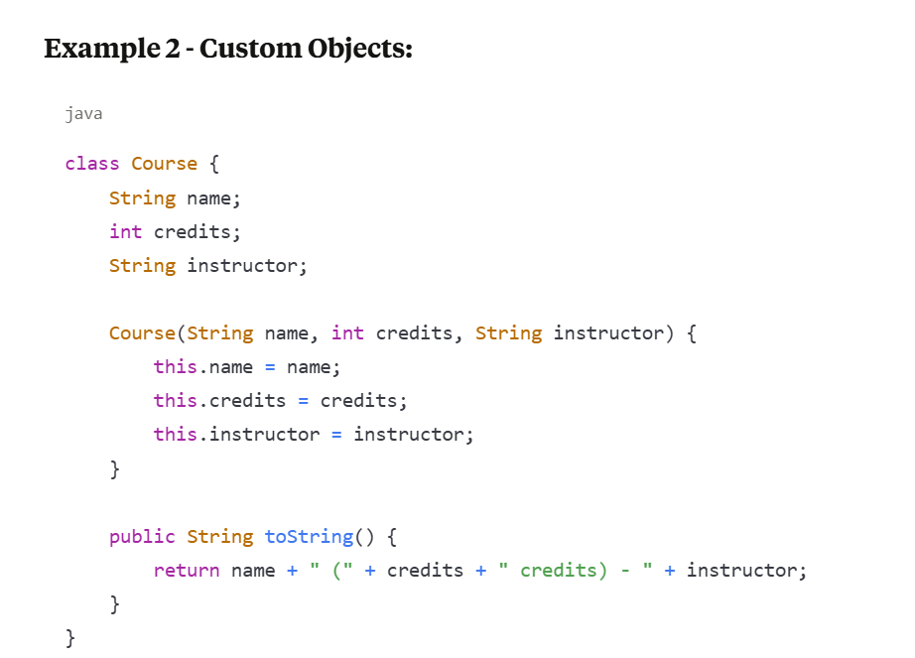

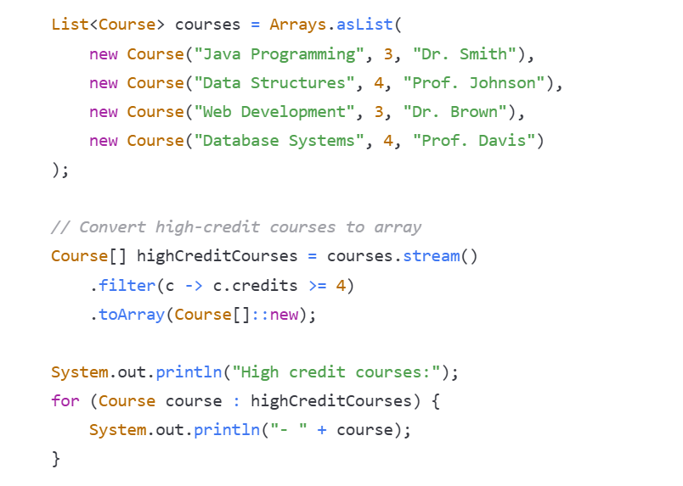

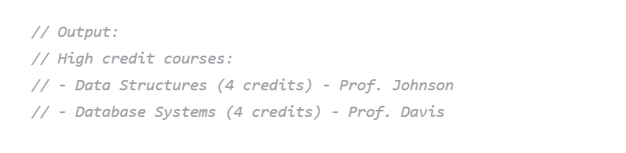

**Additional Key Points:**

1. **findFirst() vs findAny():** findFirst() guarantees encounter order, while findAny() is more efficient in parallel streams.
2. **forEach() vs forEachOrdered():** forEach() doesn't guarantee order in parallel streams, while forEachOrdered() maintains encounter order.
3. **min() and max():** Always return Optional because the stream might be empty. Use appropriate Comparator for custom objects.
4. **reduce():** Very powerful for custom aggregations. The three-parameter version is useful for parallel processing.
5. **toArray():** Use the generator function version for type-safe arrays. Without it, you get Object[].
6. **Performance:** Terminal operations like min(), max(), and reduce() process all elements, while findFirst() and findAny() are short-circuiting.

**✅ Concatenate Streams**

**You can concatenate two or more streams using the Stream.concat() method.**

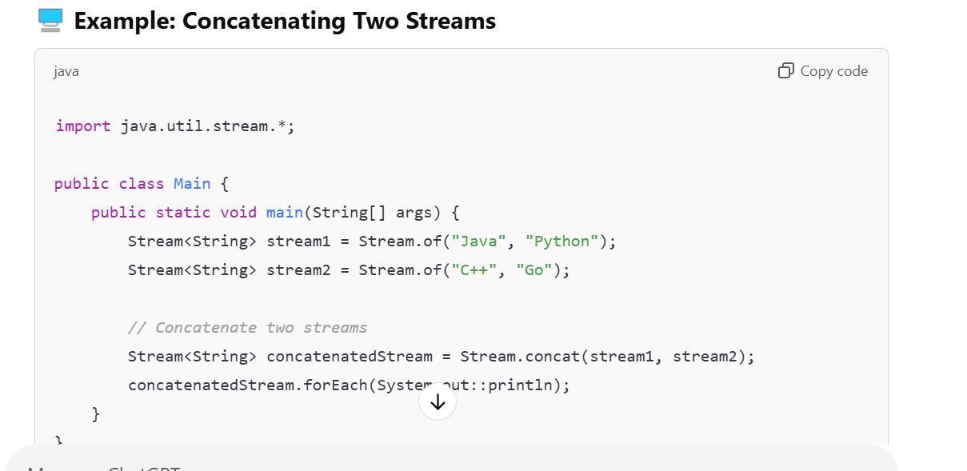

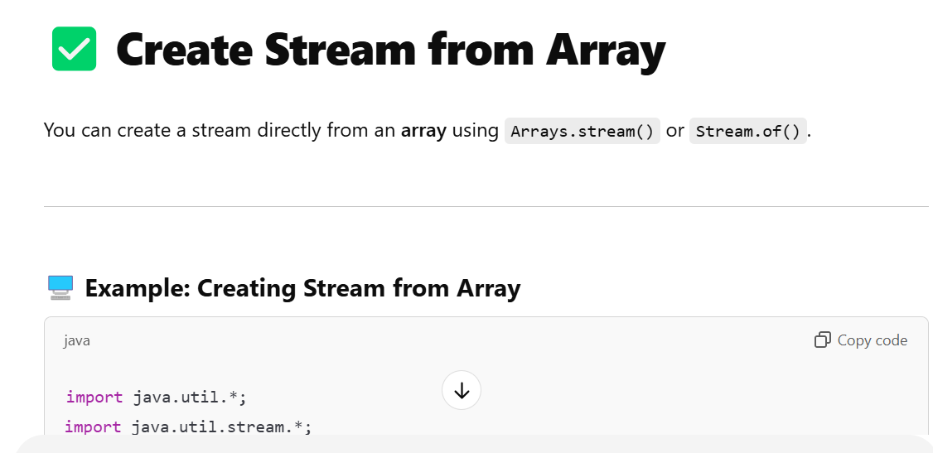

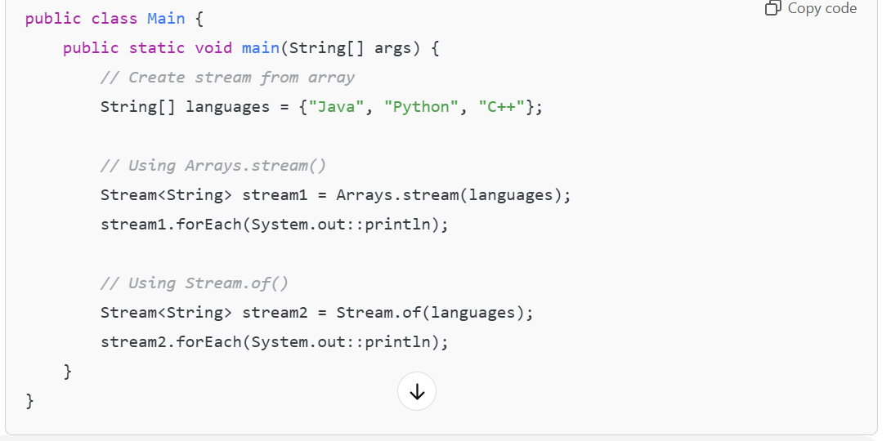

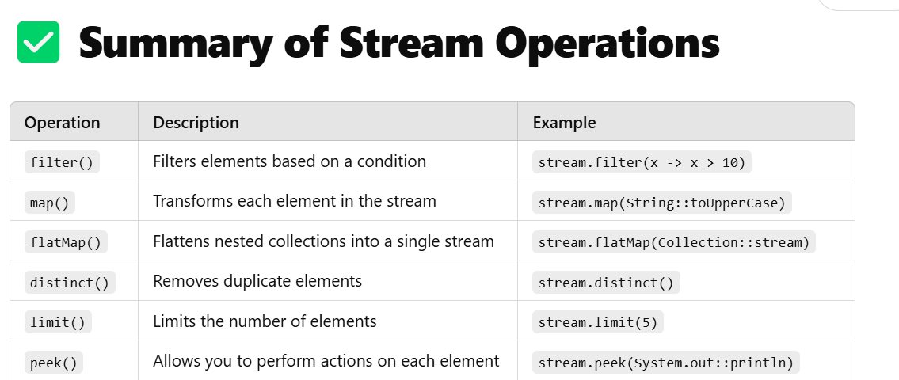

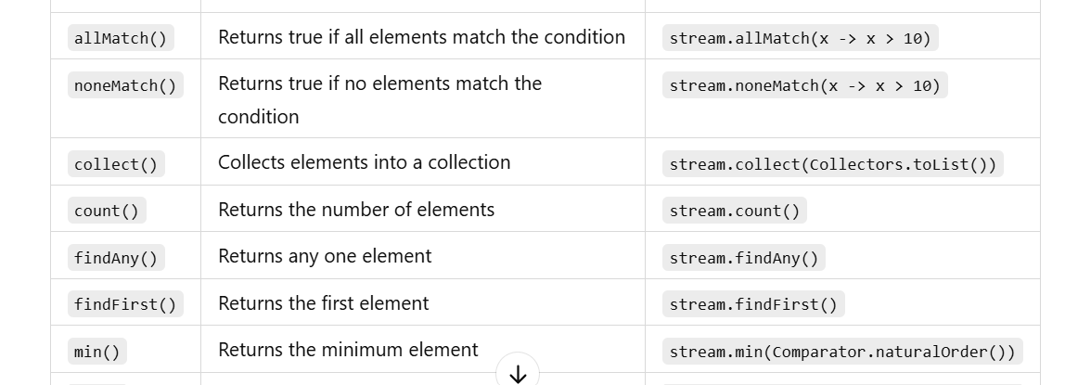

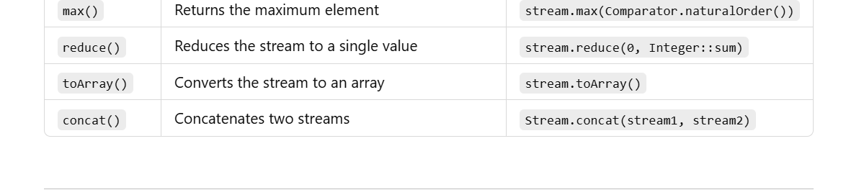

**Java Stream Collectors Methods Study Notes**

**Overview**

Collectors are used with the collect() terminal operation to perform mutable reduction operations. They provide a way to accumulate stream elements into collections, maps, or other data structures.

**Import Statement**: import static java.util.stream.Collectors.*;

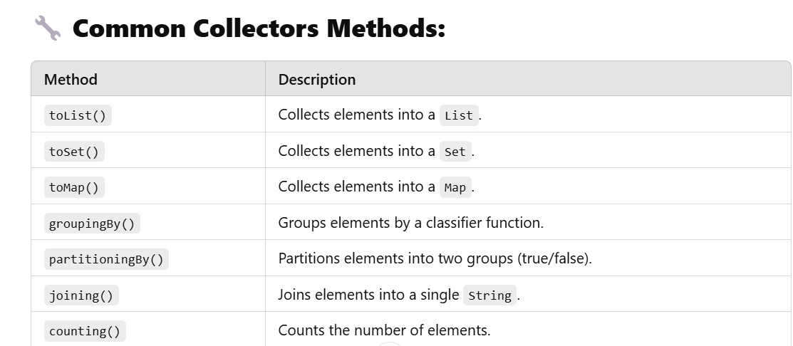

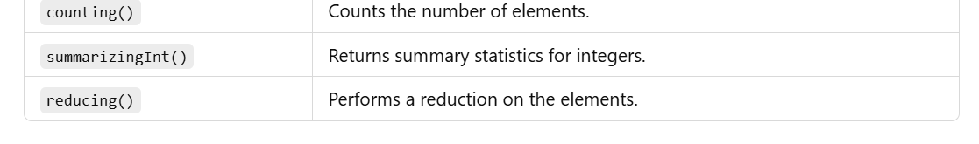

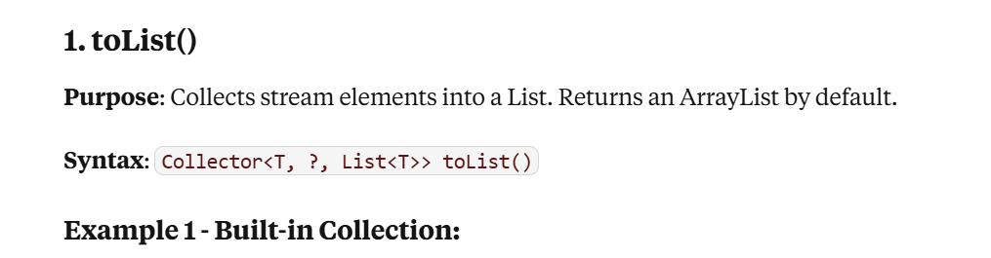

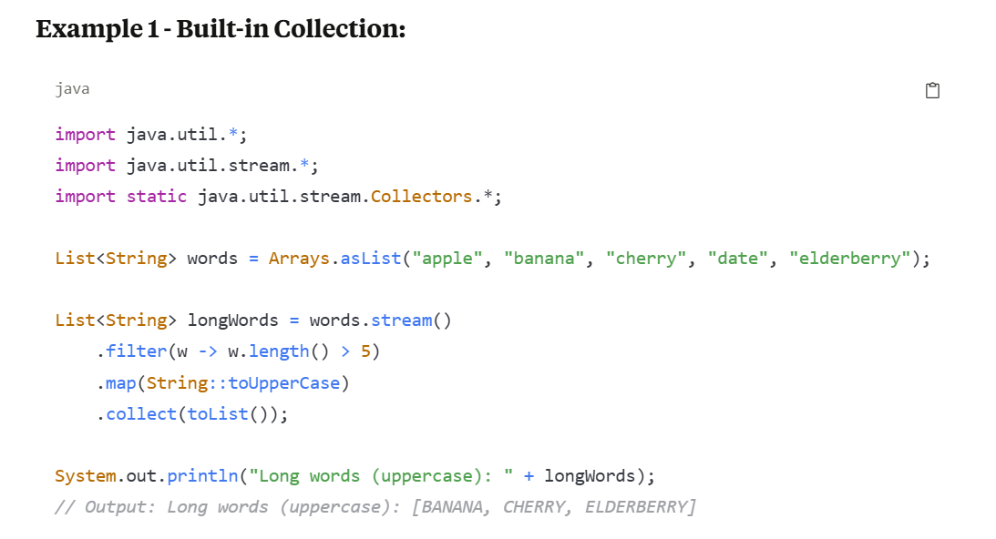

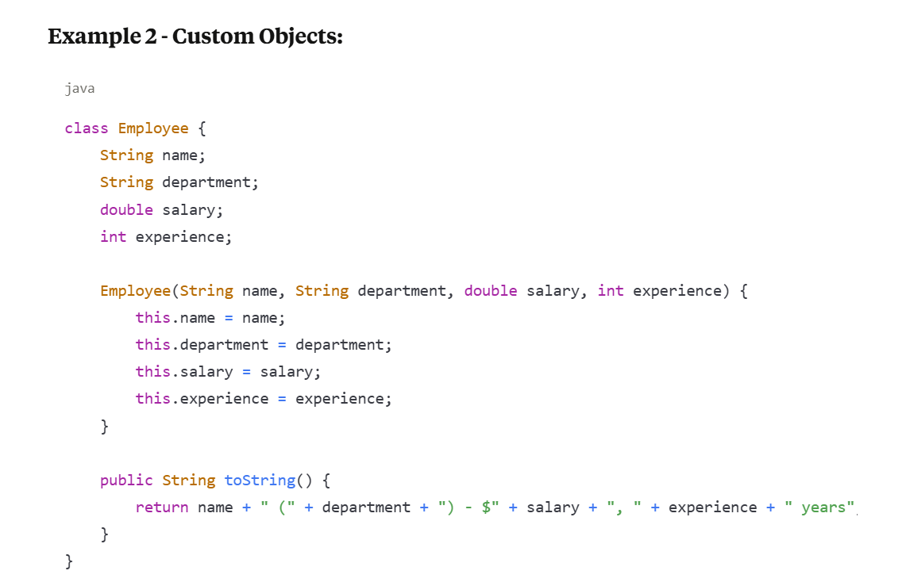

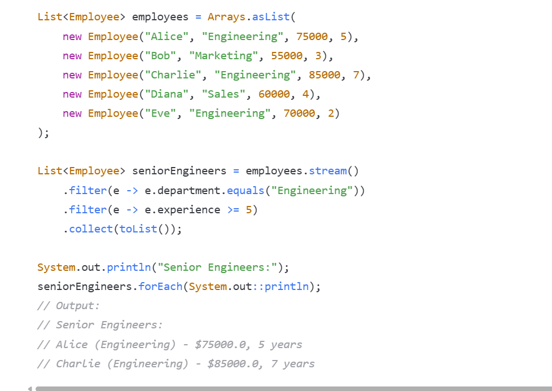

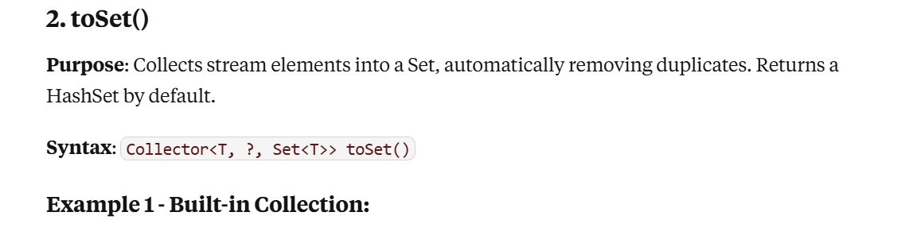

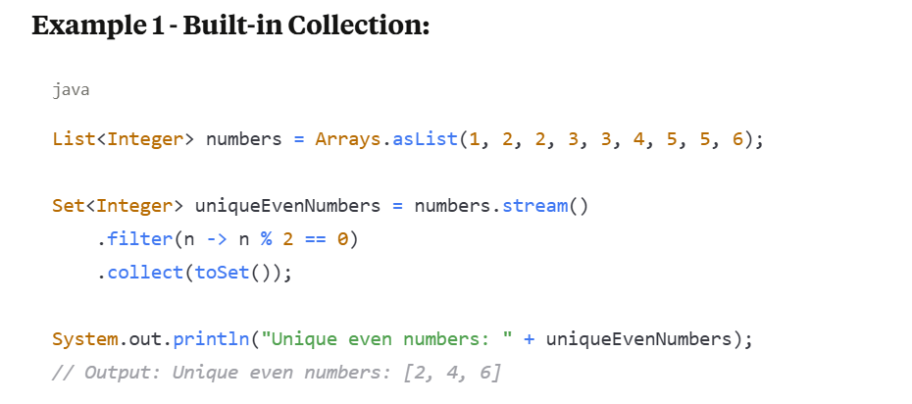

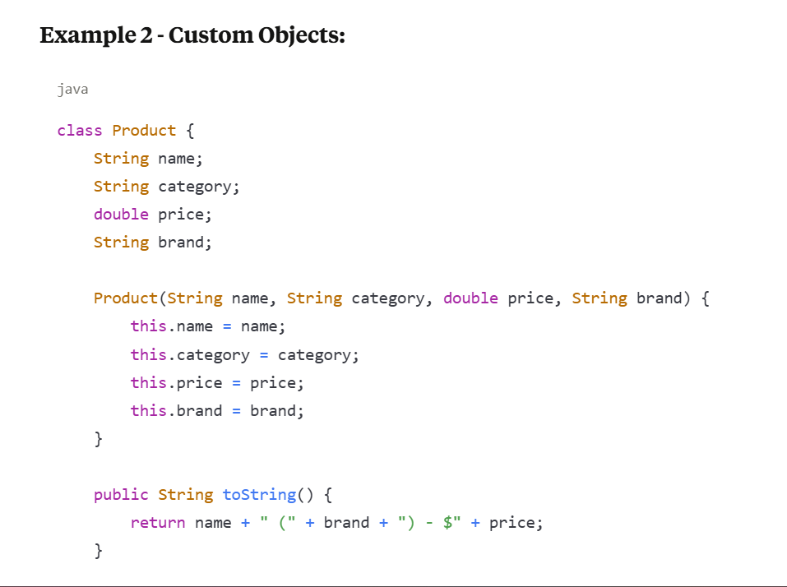

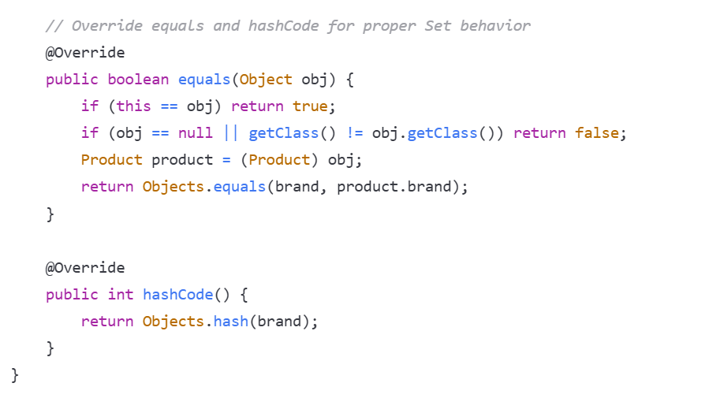

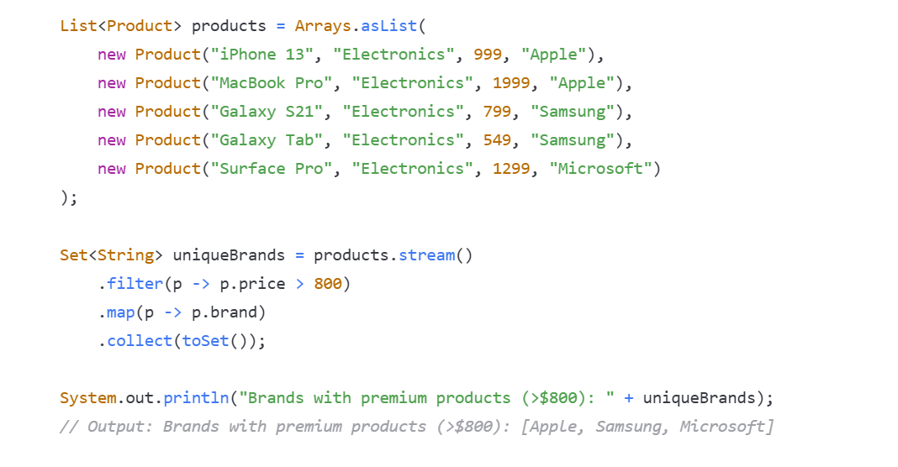

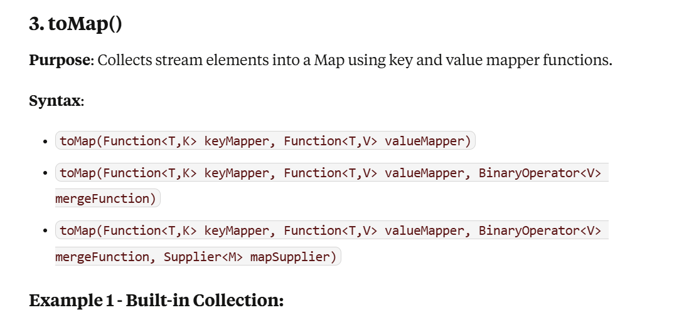

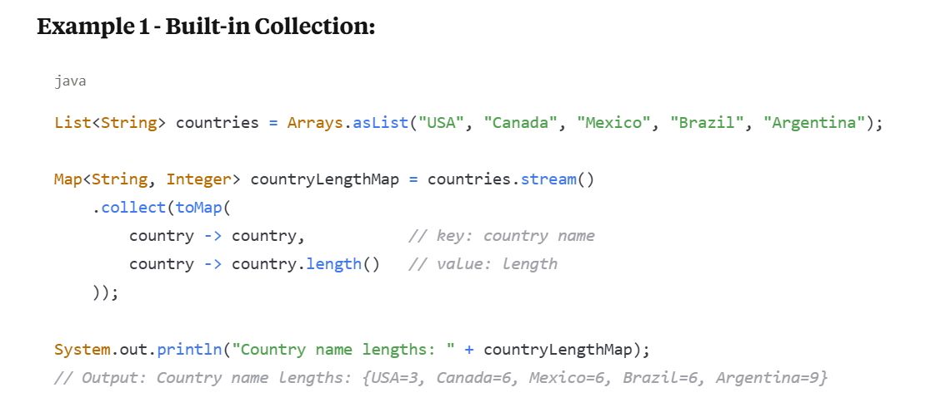

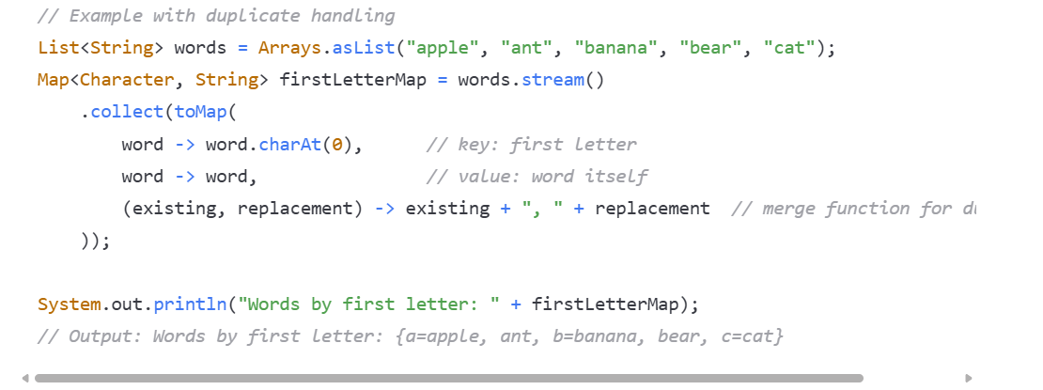

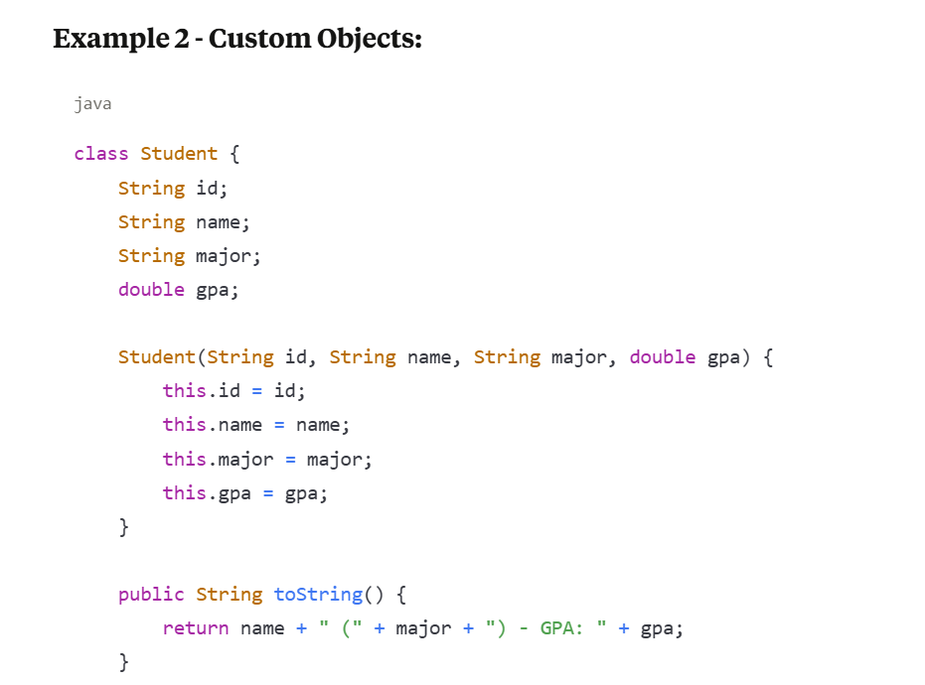

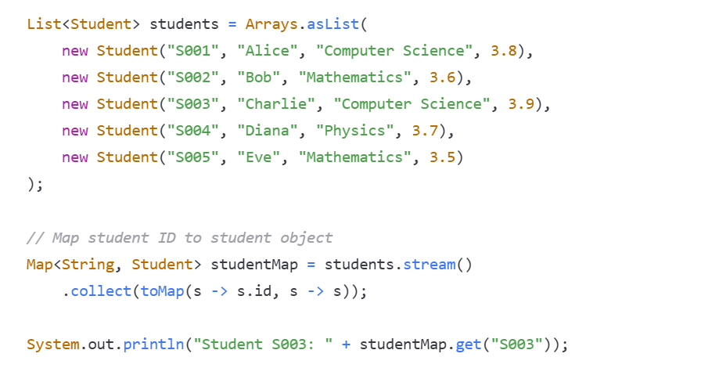

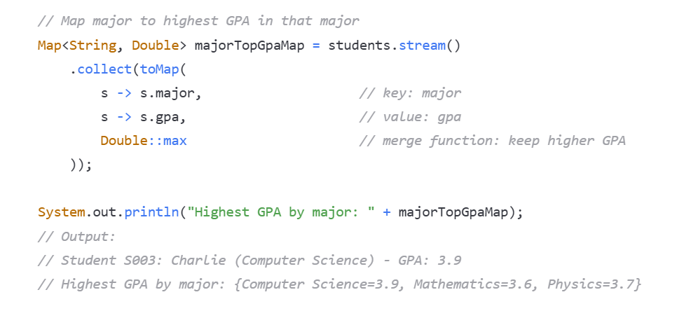

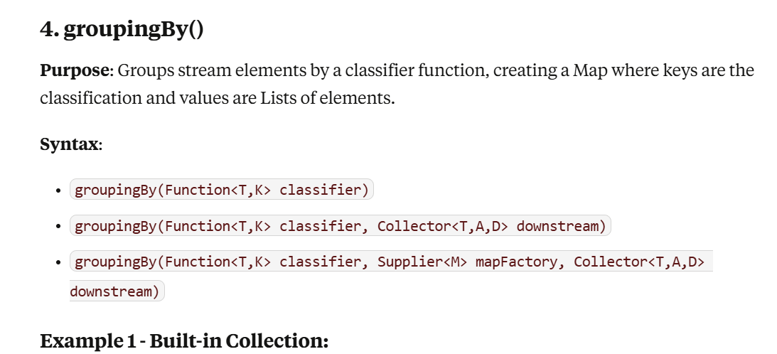

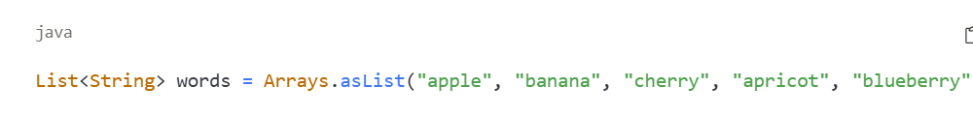

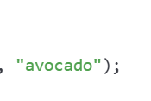

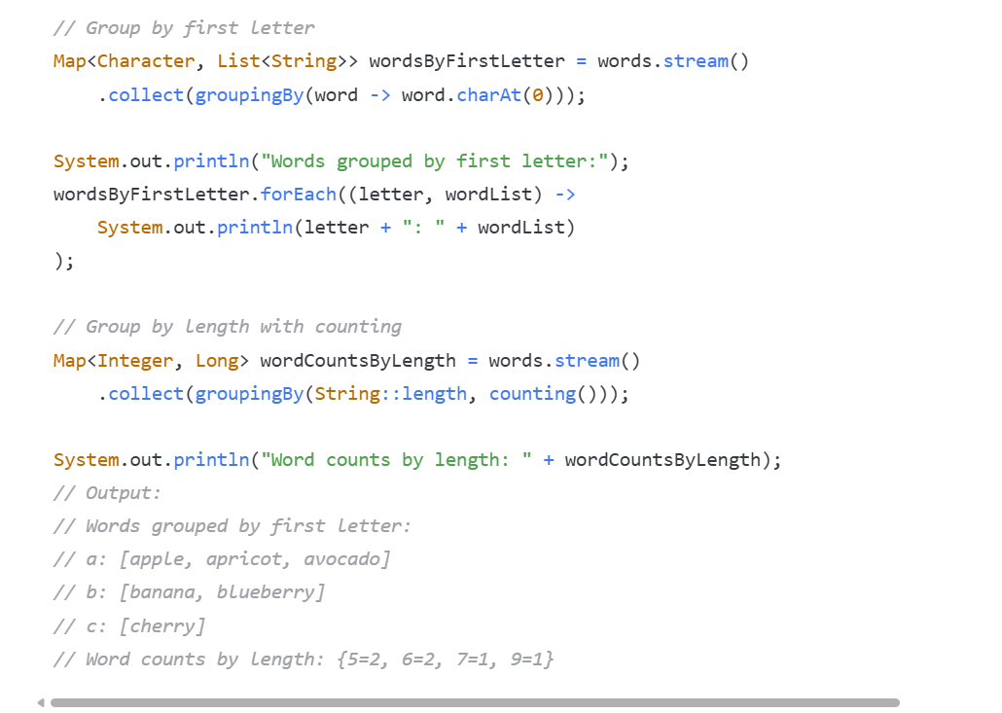

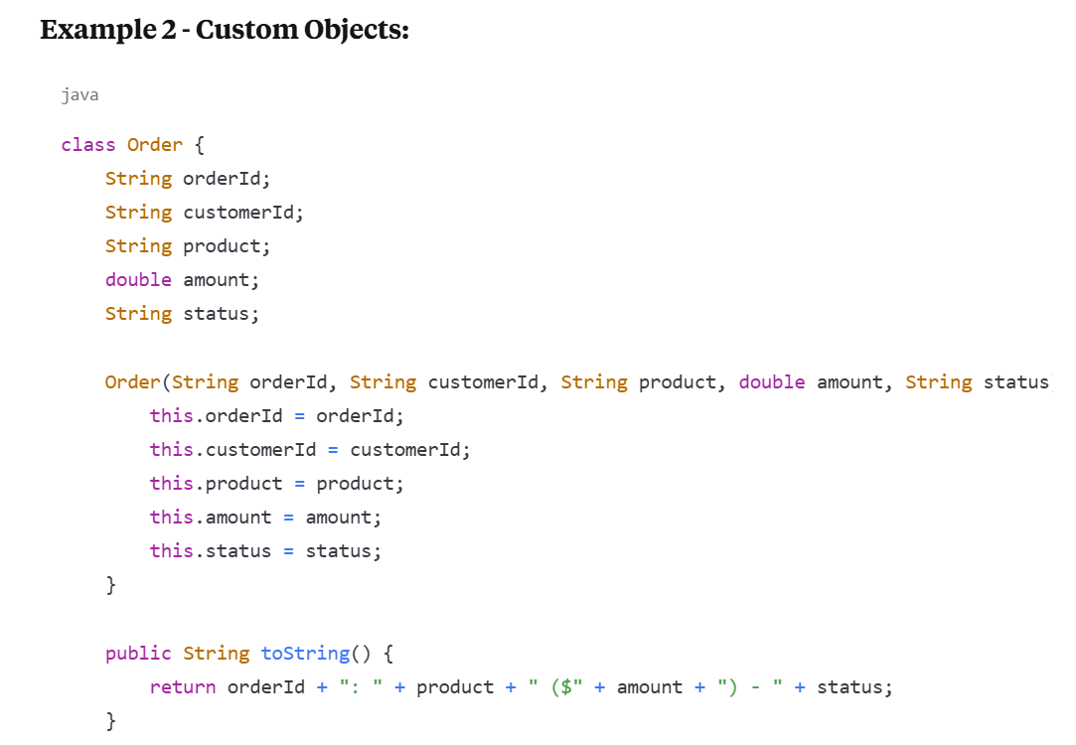

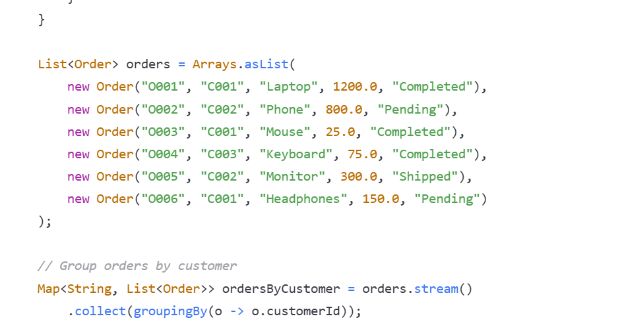

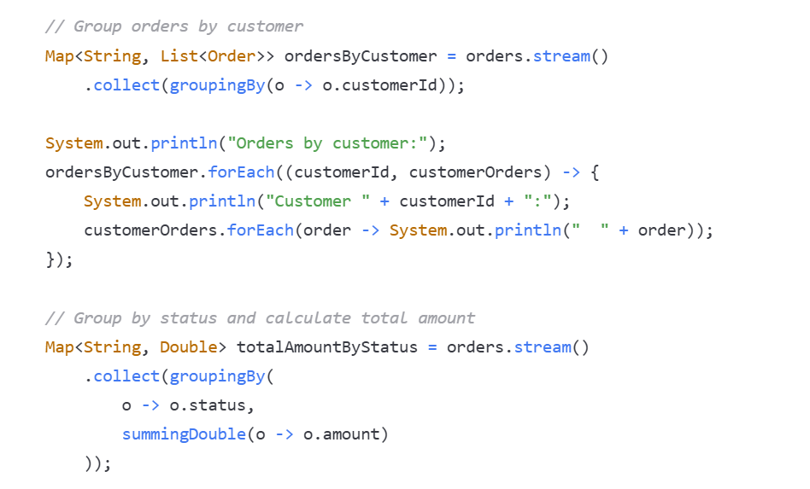

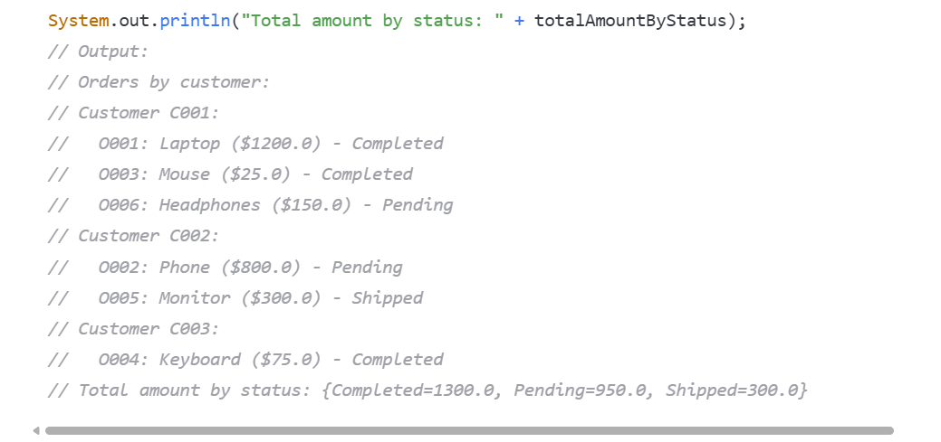

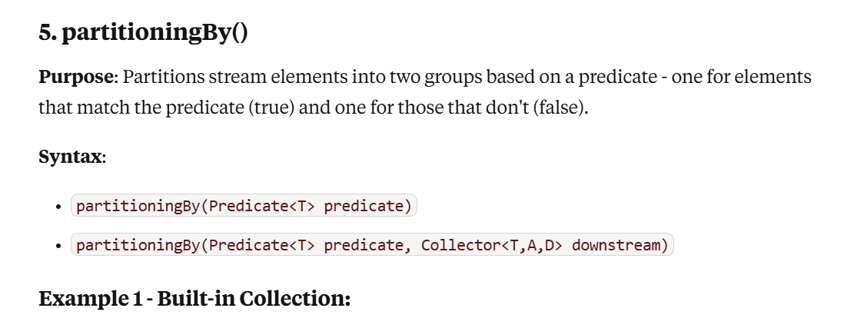

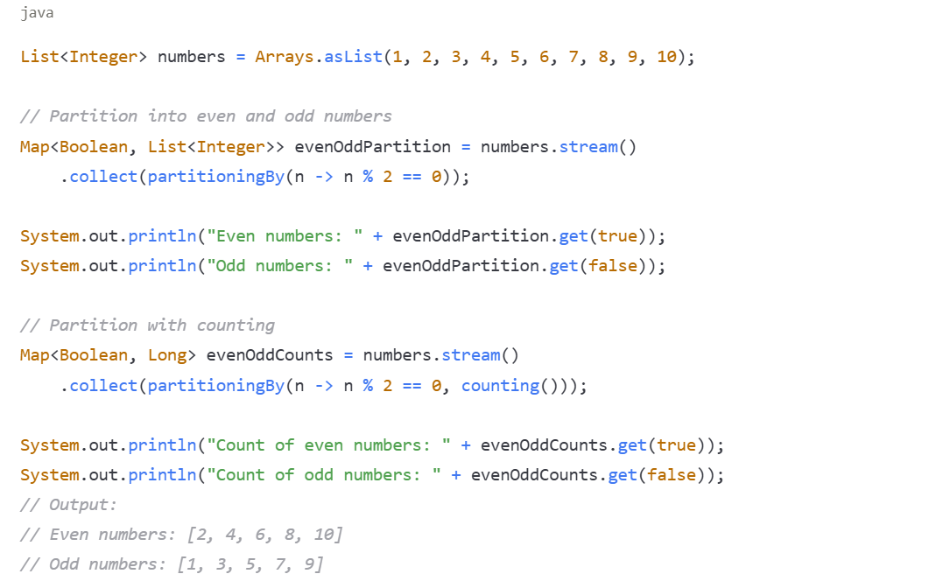

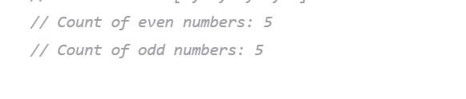

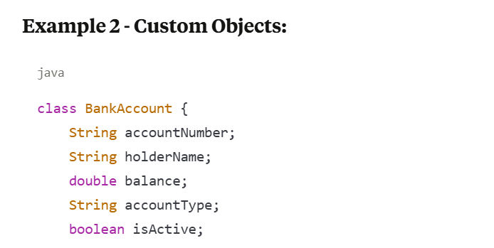



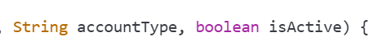

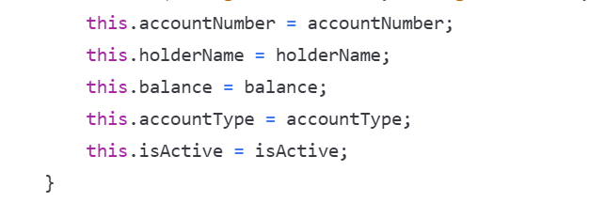

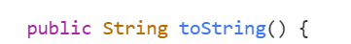

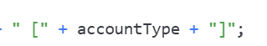

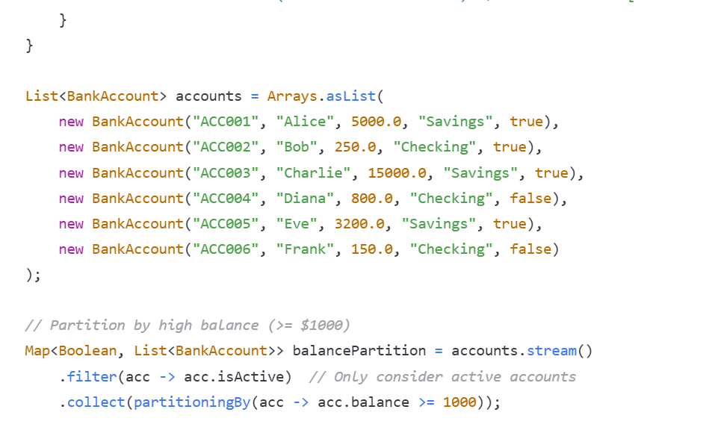

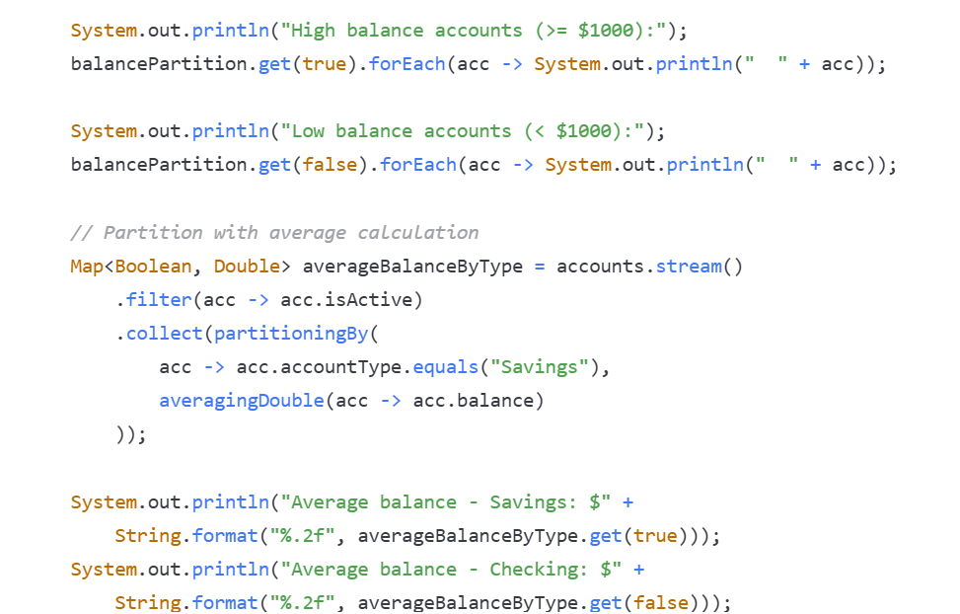

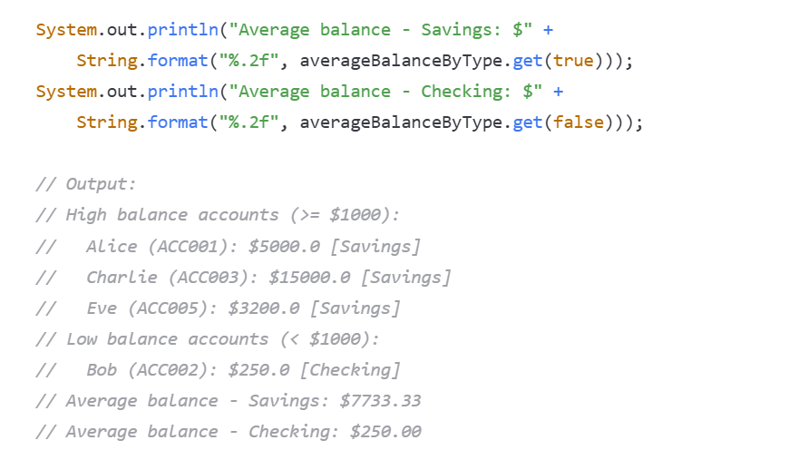

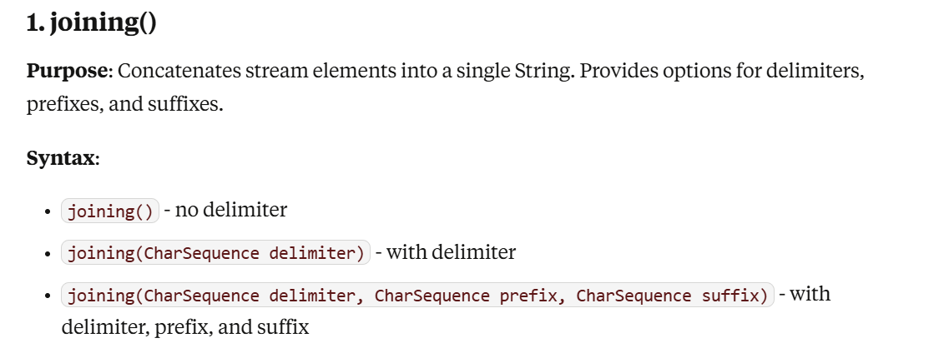

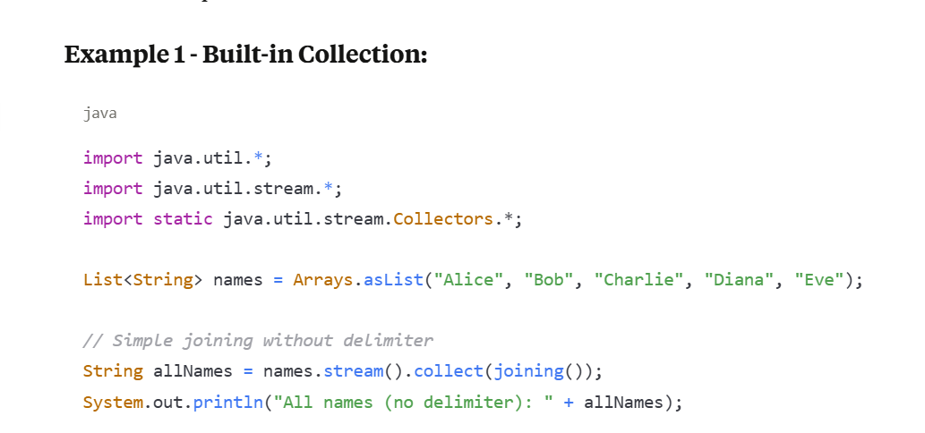

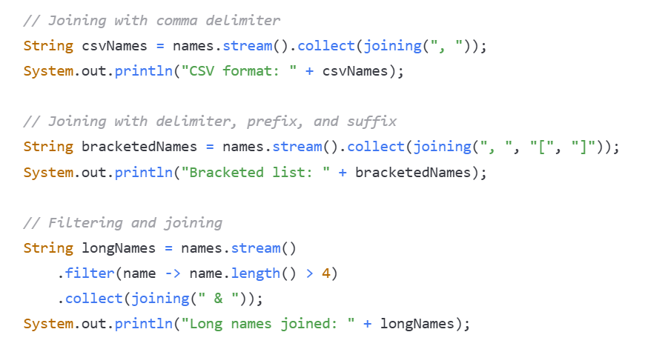

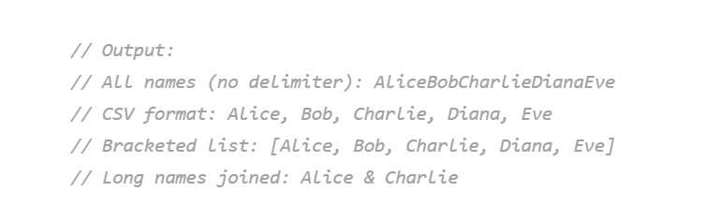

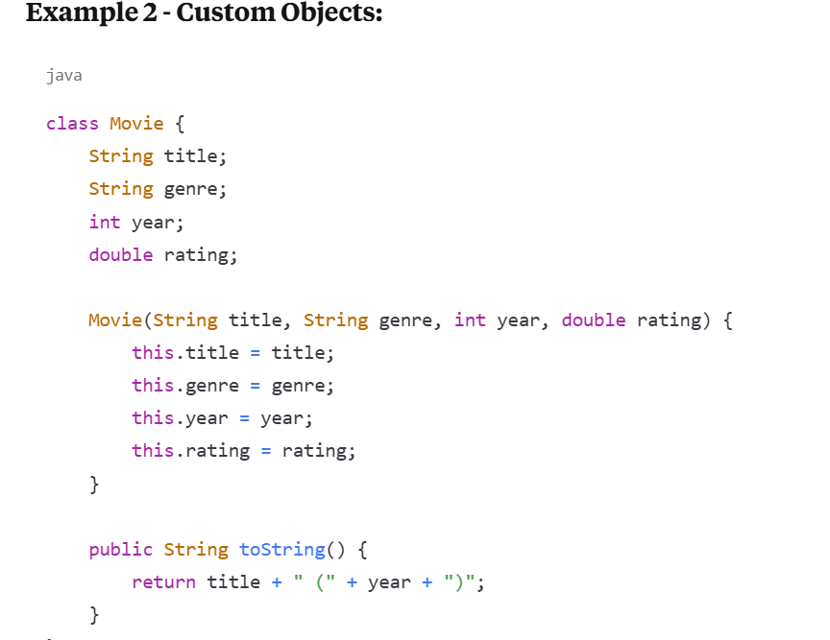

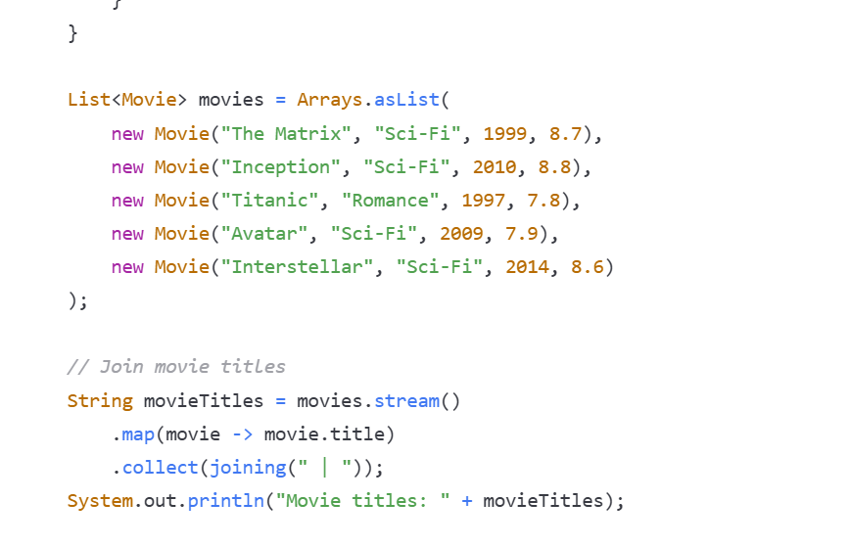

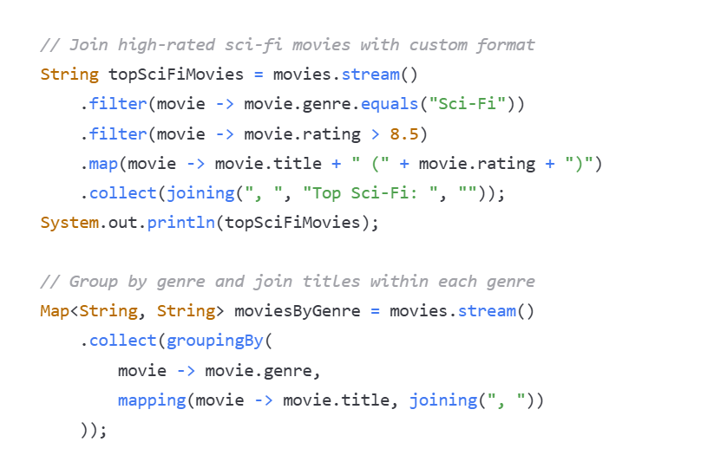

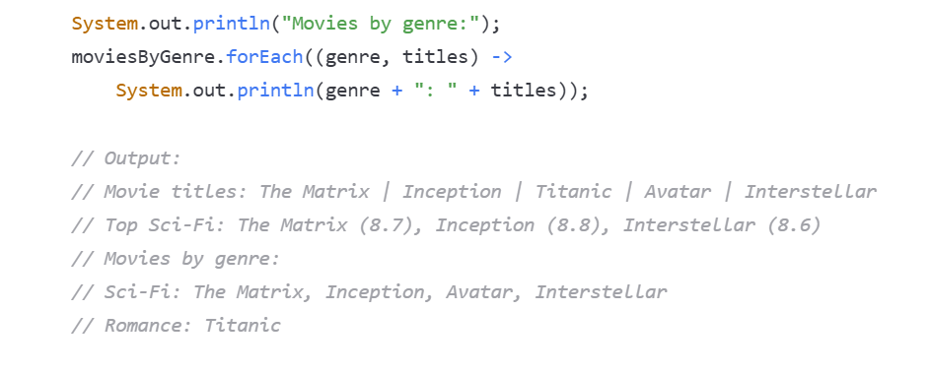

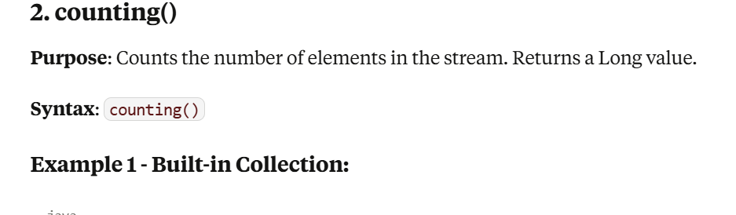

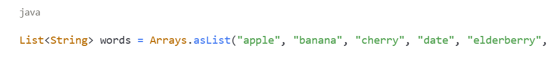

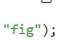

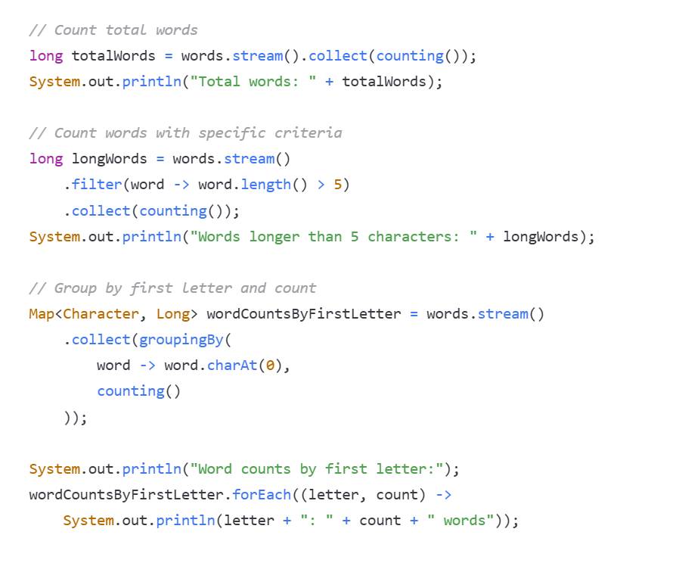

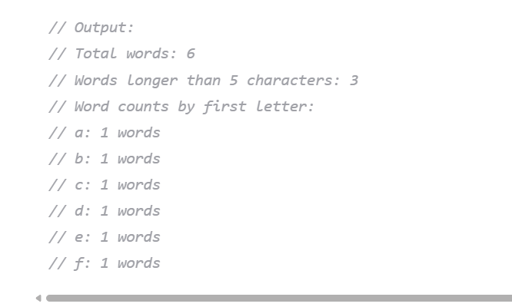

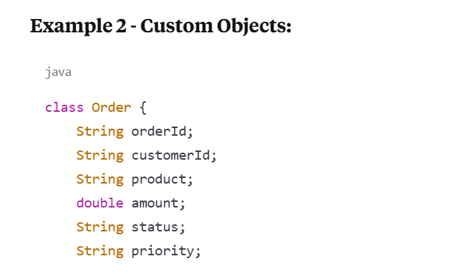





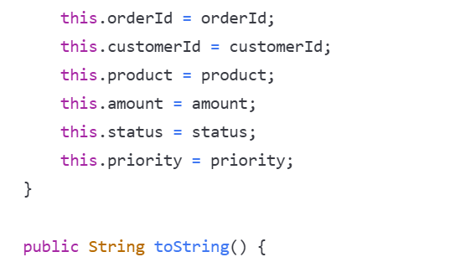



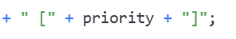

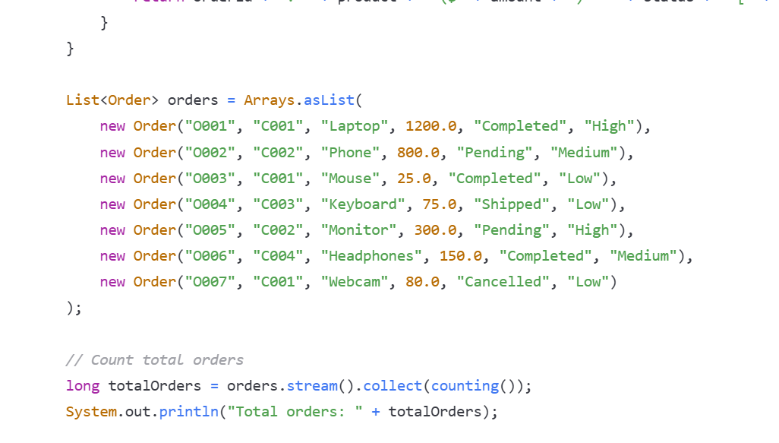

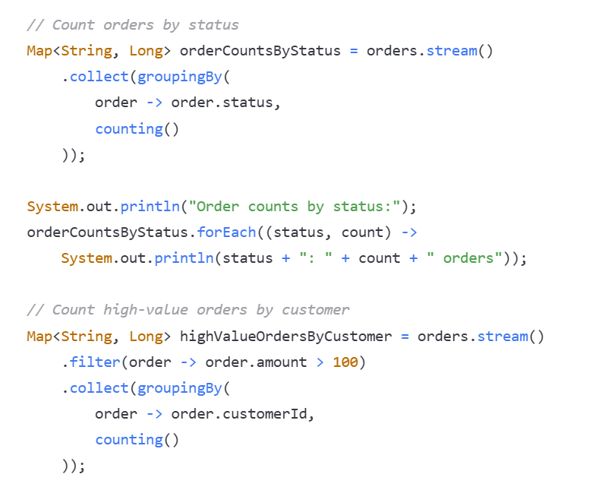

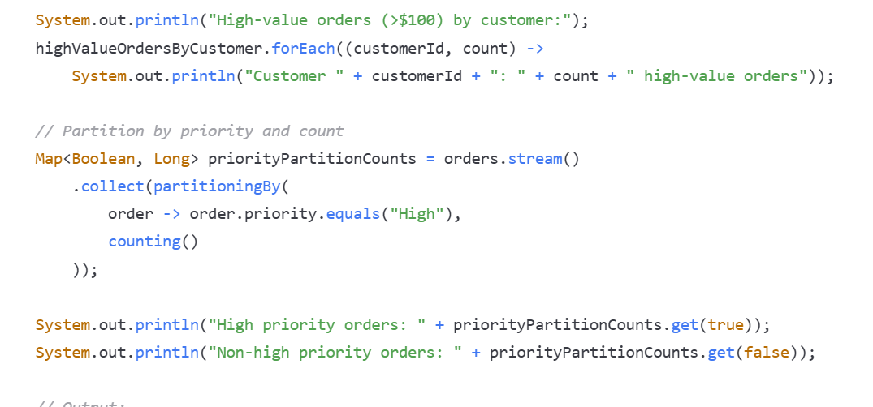

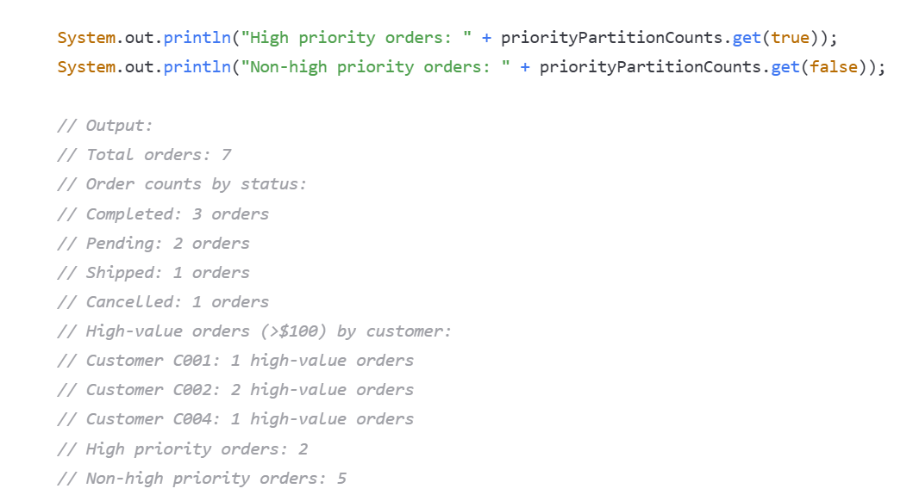

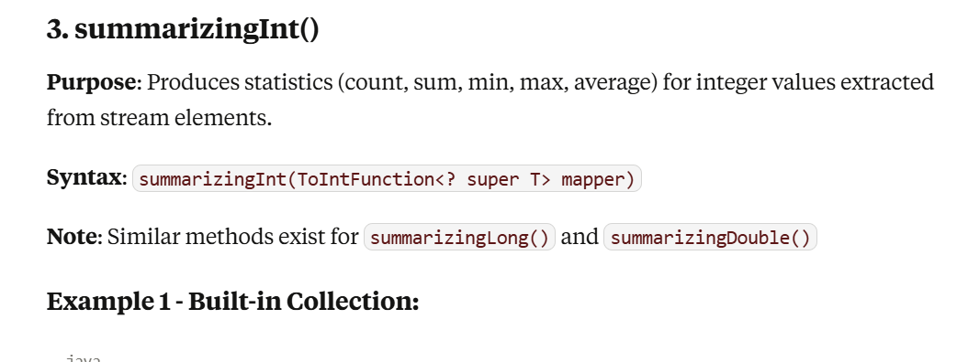

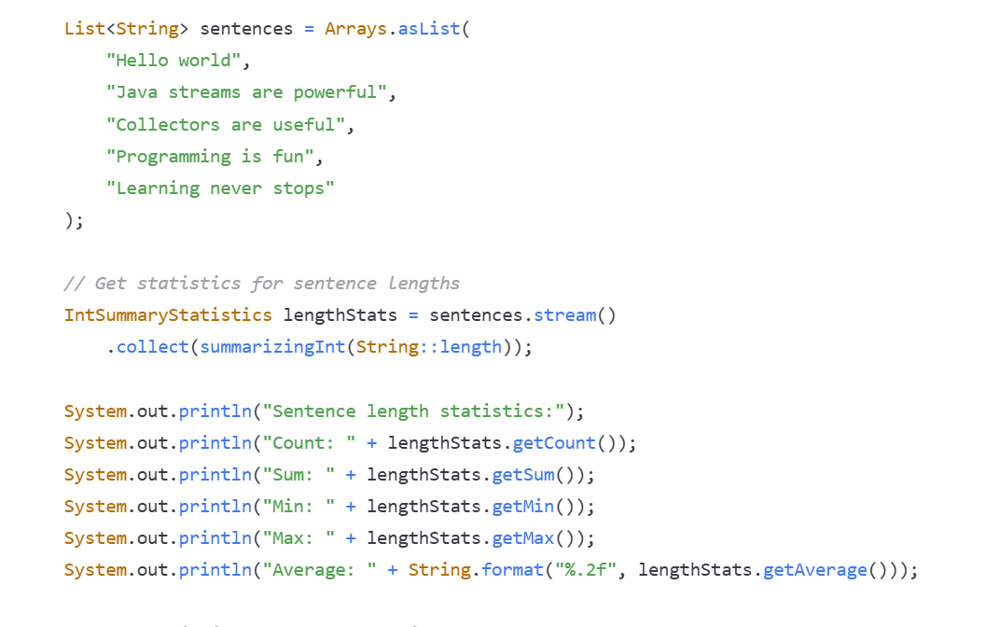

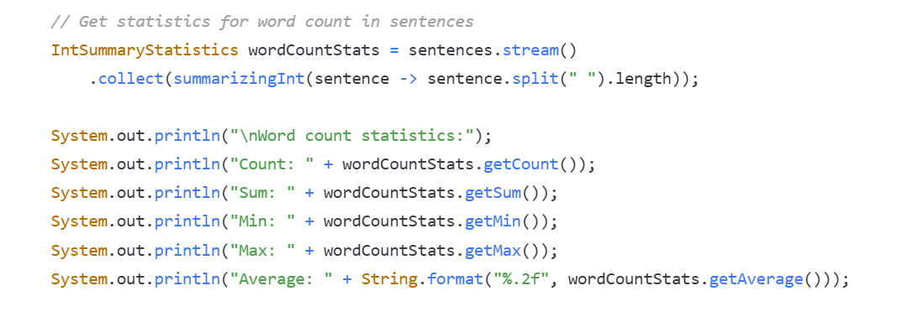

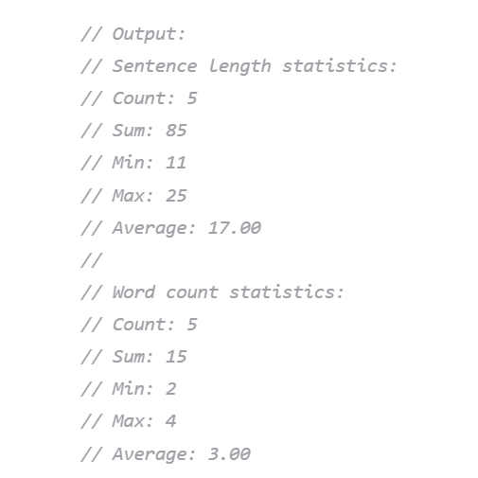

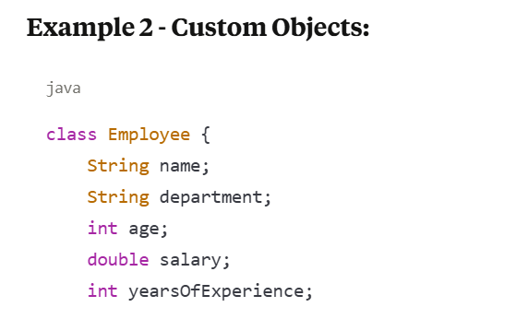



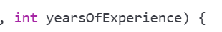

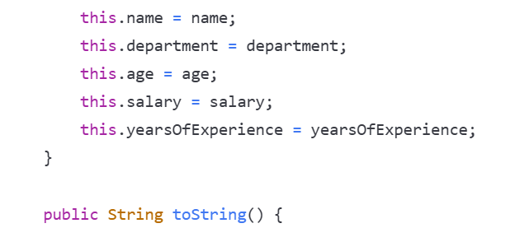





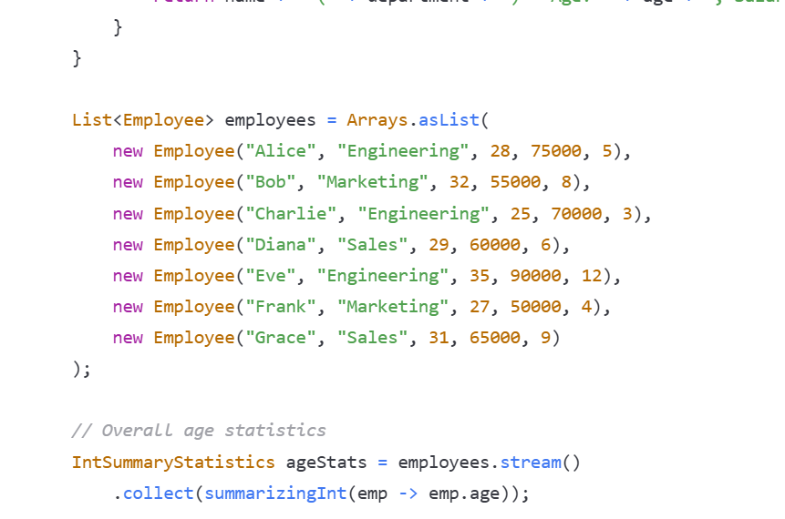

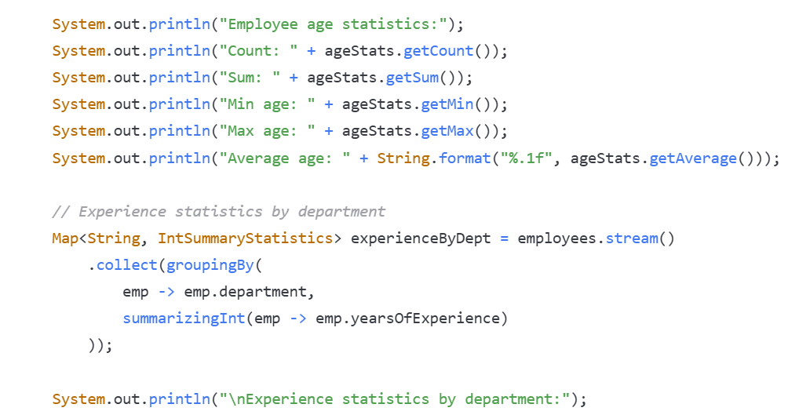

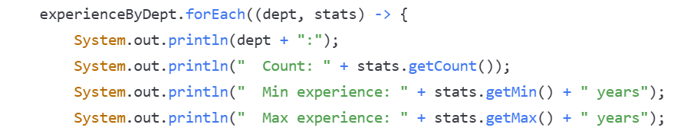





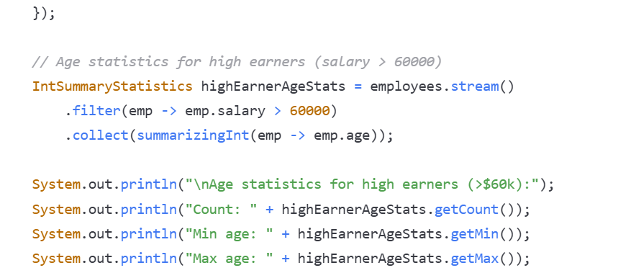





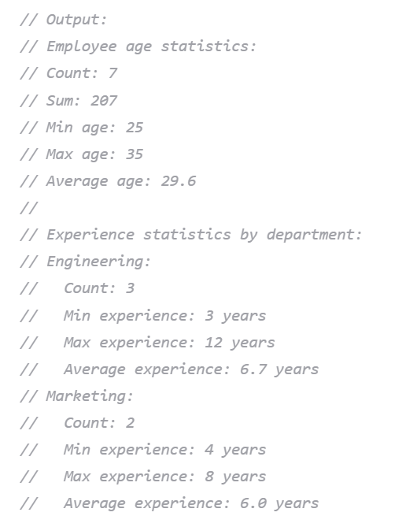

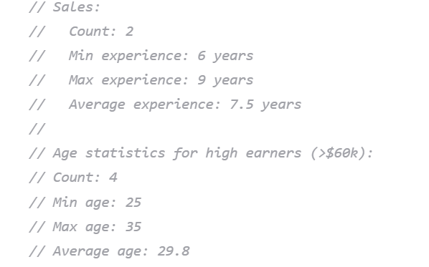

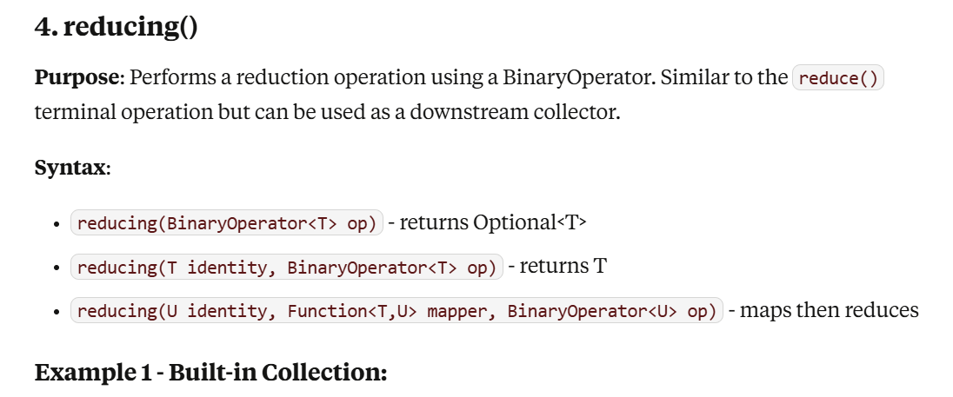

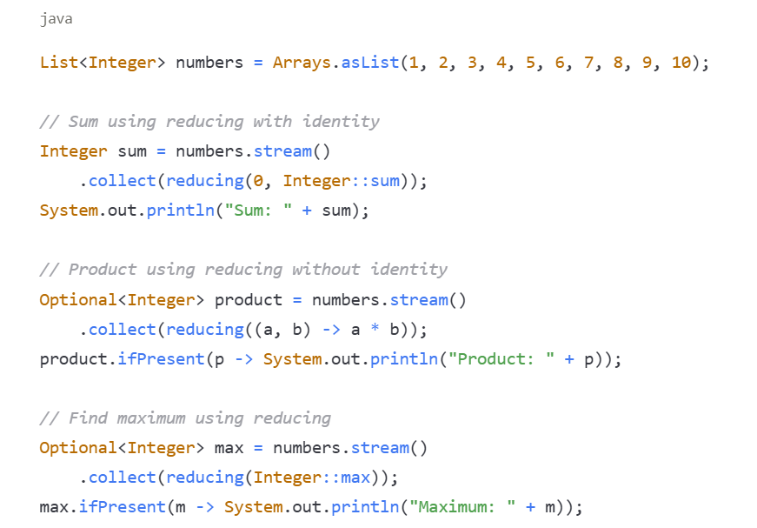

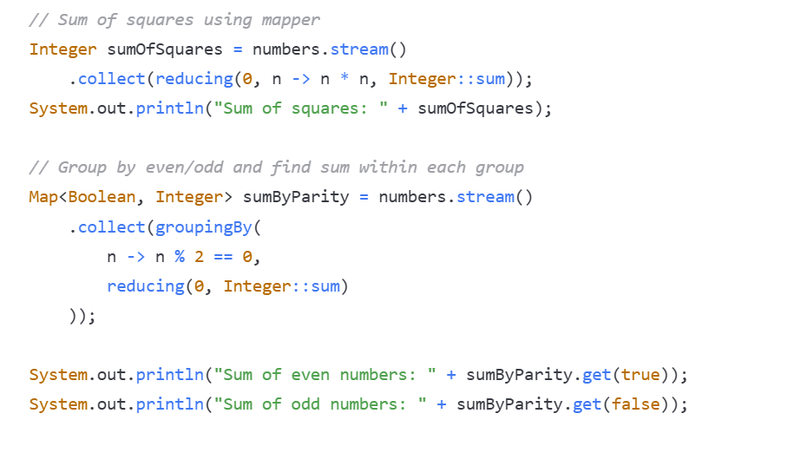

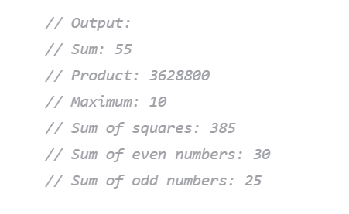

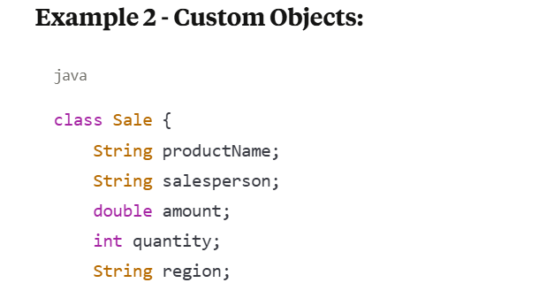





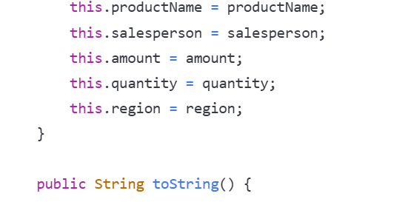



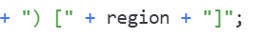

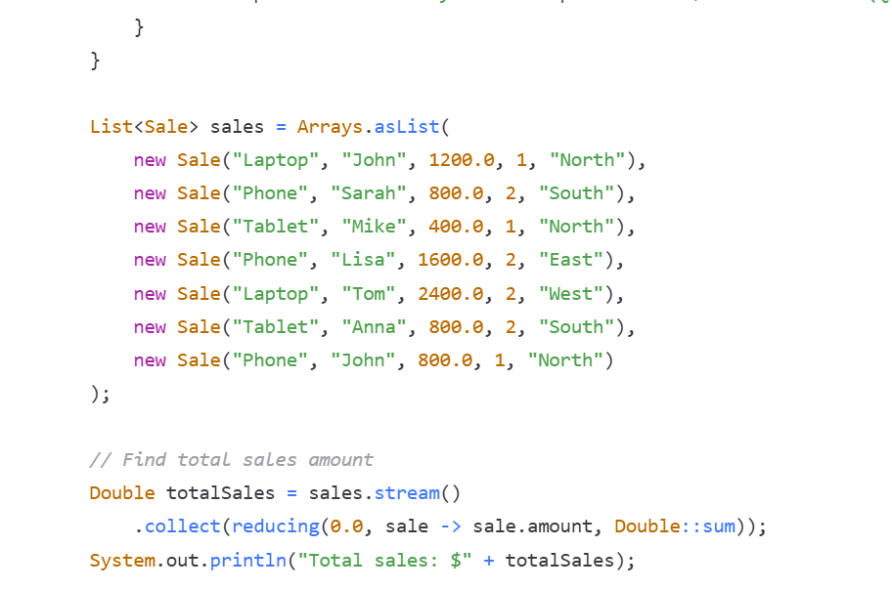

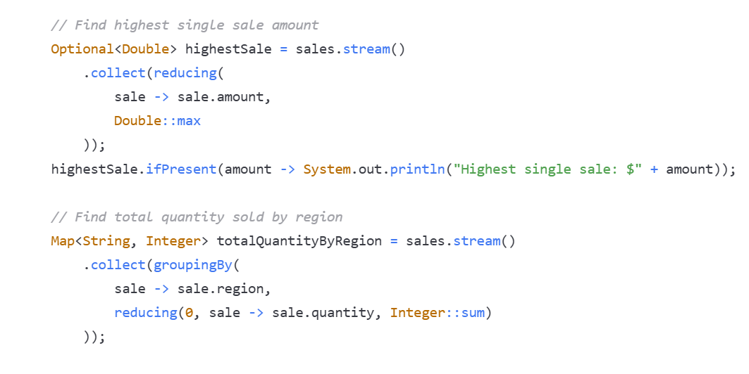

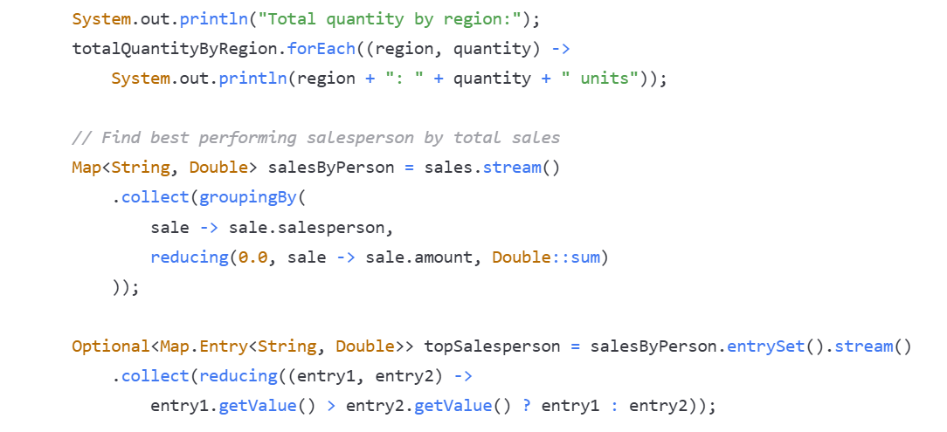





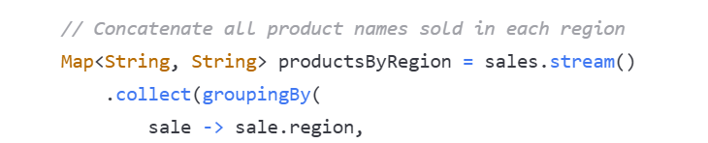





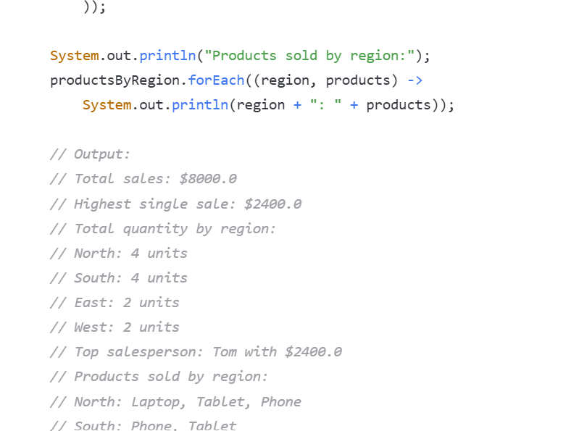

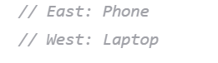

**Key Points to Remember:**

1. **toList() vs toSet():** 
   * toList() preserves order and allows duplicates
   * toSet() removes duplicates and doesn't guarantee order
2. **toMap() Duplicate Keys:** 
   * Throws exception if duplicate keys found without merge function
   * Use merge function to handle duplicates appropriately
3. **groupingBy() Flexibility:** 
   * Can be combined with other collectors (counting, summingDouble, averagingInt, etc.)
   * Returns Map<K, List<V>> by default, but can be customized with downstream collectors
4. **partitioningBy() vs groupingBy():** 
   * partitioningBy() always returns Map<Boolean, List<T>> (exactly 2 groups)
   * groupingBy() can create any number of groups based on classifier function
5. **Performance:** 
   * These collectors are optimized for parallel processing
   * Use appropriate initial capacity hints when possible
6. **Null Handling:** 
   * Most collectors handle null values, but behavior varies
   * toMap() doesn't allow null keys by default (HashMap restriction)
7. **Common Downstream Collectors:** 
   * counting() - counts elements in each group
   * summingDouble/Int/Long() - sums numeric values
   * averagingDouble/Int/Long() - calculates averages
   * maxBy()/minBy() - finds max/min in each group

**Key Points to Remember:**

1. **joining()**:
   * Works only with CharSequence (String) elements or after mapping to String
   * Very efficient for creating delimited strings
   * Commonly used with mapping() downstream collector
2. **counting()**:
   * Returns Long, not int
   * Often used as downstream collector with groupingBy() and partitioningBy()
   * Equivalent to .mapToLong(e -> 1L).sum() but more readable
3. **summarizingInt/Long/Double()**:
   * Returns specialized summary statistics objects
   * Provides count, sum, min, max, and average in one pass
   * More efficient than calculating each statistic separately
   * Use appropriate version based on your data type
4. **reducing()**:
   * Most flexible collector for custom reductions
   * Three overloaded versions for different use cases
   * Can be used standalone or as downstream collector
   * The three-parameter version (identity, mapper, combiner) is most powerful
5. **Performance Considerations**:
   * These collectors are optimized for parallel streams
   * summarizing*() collectors are more efficient than separate min/max/average calculations
   * reducing() with identity avoids Optional wrapping
6. **Common Patterns**:
   * Use joining() for creating CSV, JSON-like strings, or formatted output
   * Use counting() for frequency analysis
   * Use summarizing*() for comprehensive numeric analysis
   * Use reducing() for complex custom aggregations
7. **Downstream Usage**:
   * All these collectors work well as downstream collectors with groupingBy() and partitioningBy()
   * This enables powerful group-based analytics and reporting

**Parallel Streaming**

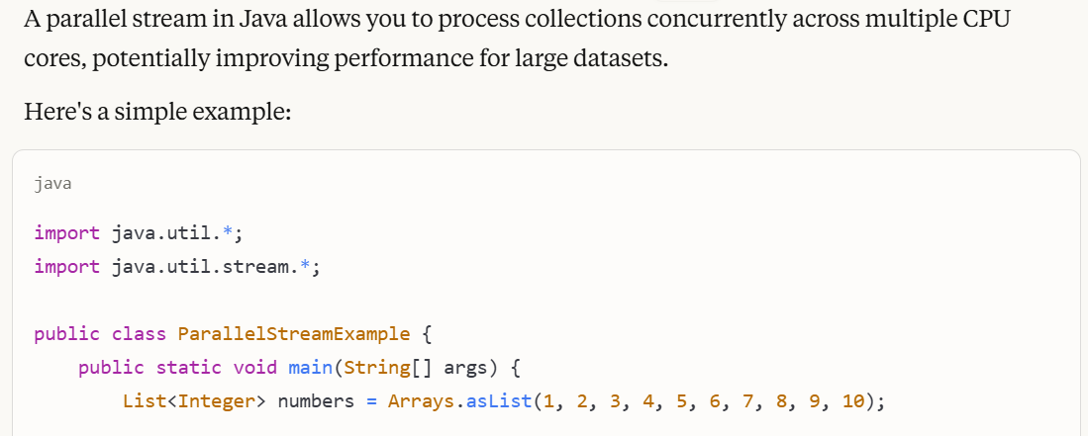

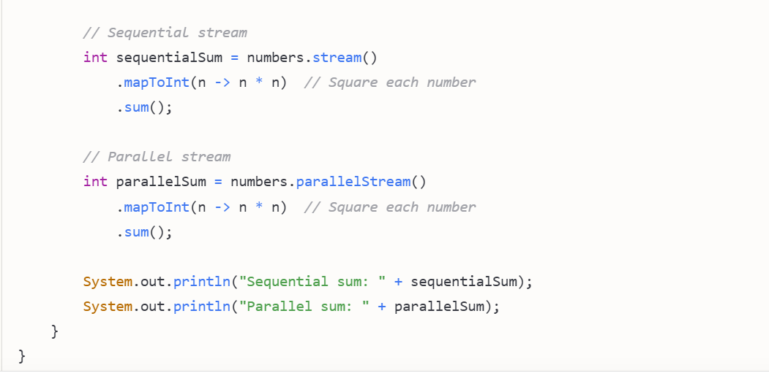

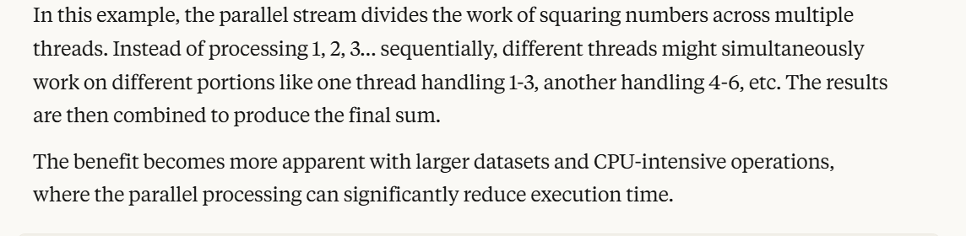

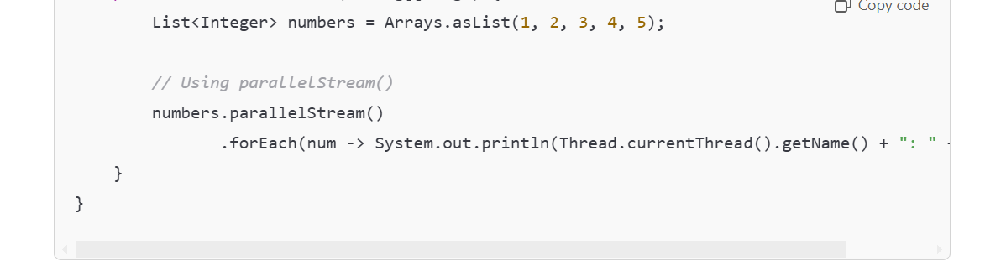

**🔧 When to Use Parallel Streams?**

* Use Parallel Streams when you need to process large collections of data and want to reduce processing time.
* Do not use Parallel Streams when the task is I/O bound or involves shared mutable state.